adidas and Porsche Design join forces to reveal co-created Porsche Design Sport 16 FG boot

- Two iconic brands collaborate to create premium performance boot -
- Porsche Design Sport 16 FG boot stays true to the heritage of both German brands -
- Initial inspiration a cross between Porsche Design DNA and adidas Copa boot -

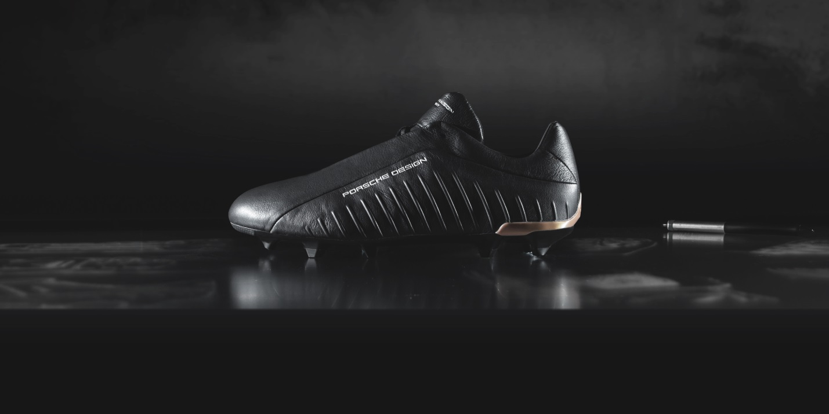

Herzogenaurach, Monday 21st March – Two of the most recognised German brands have collaborated to make a co-created performance boot – the Porsche Design Sport 16 FG. The boot is the latest to be released from the Limited Collection as adidas continues to partner with the hottest brands to create unique products.

The Limited Collection is a range of exclusive footwear, released in very limited quantities from the brand to show the latest in footwear innovation and creative spirit. The Porsche Design Sport 16 FG boot follows the release of the Fluid and Etch boots earlier this month.

The initial inspiration for the boot came as a cross between the Porsche Design heritage and adidas most renowned product – the unique adidas Copa boot – showcasing the finest in shape, precision and style. The colourway of the boot was selected to create a distinctive, clean and premium product that would stay true to the history and philosophy of adidas and Porsche Design.

The personalities of both brands are demonstrated by the balance of the three stripe adidas branding on the medial side and Porsche Design branding on the lateral side.

Jacques Chassaing who is adidas Senior Design Director Porsche Design Sport by adidas said: “Both brands have very similar values when it comes to creating each and every product. It is always about premium engineering to create the highest level of performance – whether that is on the pitch or on the road. This boot is a celebration of these values.”

As with all Porsche Design creations, only the finest and highest quality materials were used when constructing the Sport 16 FG boot. The main material used throughout the boot is the full K Leather upper. This provides the highest level of precision to allow the perfect fit and comfort, whilst still maintaining a high level of performance. The black K Leather upper also includes a surface treatment to give it a unique satin metal effect, with the additional tan heel clip for aesthetics.

On the production of this unique boot, Chassaing said: “To create this product we used the same approach as building a car. We looked at the design to create the optimum bodywork, the technology to provide the engine and comfort for the interior.”

A small number of the Porsche Design Sport 16 FG boot will be available to purchase from today.

For further information please visit adidas.com/football or adidas.com/porschedesignsport or porsche-design.com and go to facebook.com/adidasfootball or follow @adidasfootball on twitter to join the conversation.

- END -
For further media information please visit http://news.adidas.com/GLOBAL/PERFORMANCE/FOOTBALL or contact:

Simon Bristow  PR Director – Herzo Newsroom  Email: simon.bristow@adidas.com  Tel: +49/9132/84-73 703 | Alan McGarrie  Global Director PR & Social Media, adidas Football  Email: alan.mcgarrie@adidas.com  Tel: +49/9132/84-4686

Nadine Cornehl
Head of PR - Porsche Design Group
Email: nadine.cornehl@porsche-design.de
Tel: +49 711 911 12919

Notes to editors:
About adidas Football
adidas is the global leader in football. It is the official sponsor / official supplier partner of the most important football tournaments in the world, such as the FIFA World Cup™, the FIFA Confederations Cup, the UEFA Champions League, the UEFA Europa League and the UEFA European Championships. adidas also sponsors some of the world’s top clubs including Manchester United, Real Madrid, FC Bayern Munich, Juventus, Chelsea and AC Milan. Some of the world’s best players also on the adidas roster are Leo Messi, Gareth Bale, Thomas Müller, Luis Suárez, James Rodríguez, Diego Costa and Mesut Özil.

About Porsche Design Sport by adidas
Porsche Design Sport by adidas stands for a contemporary, minimalist look and innovative materials. The collaboration between adidas and the luxury brand Porsche Design was launched in 2006 with a collection of apparel, footwear and accessories that defined a new era of Engineered Luxury Sportswear. Since then, the brand has continued to pioneer a signature style that fuses function with iconic design.

