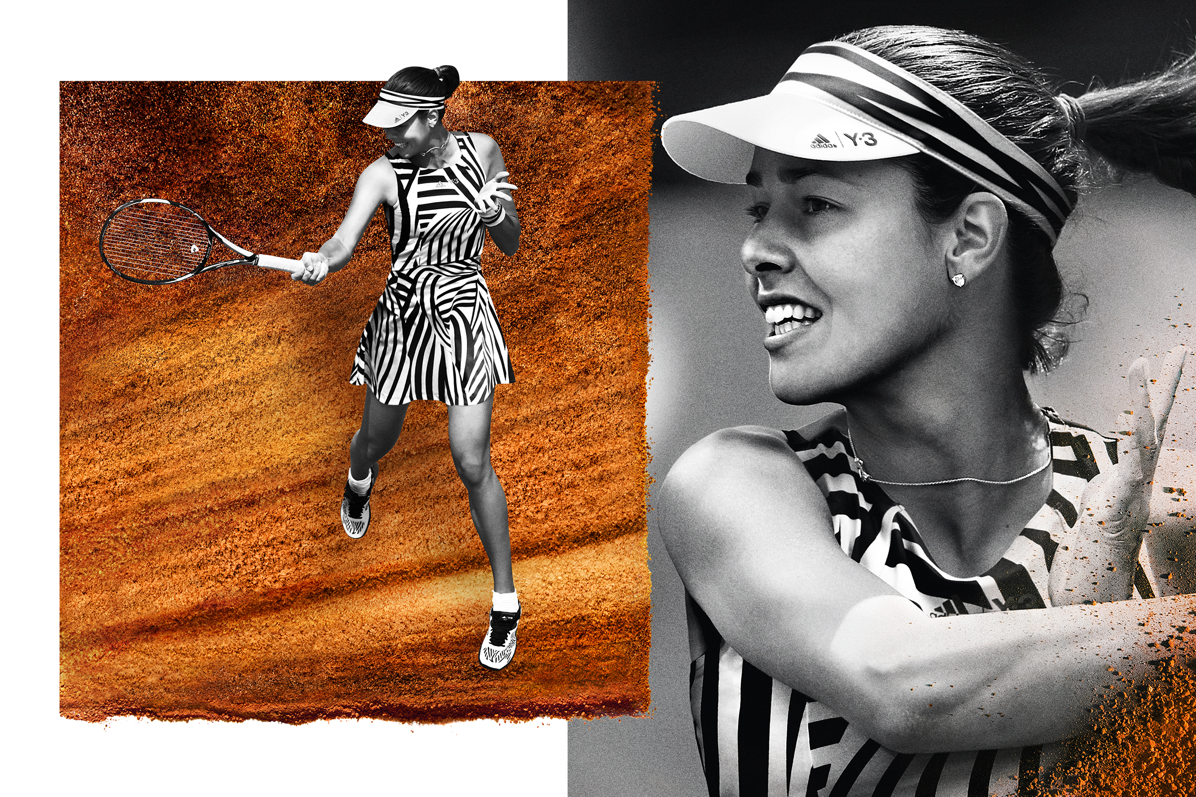
adidas Tennis and Y-3 Set to Rock Roland Garros with a Standout Collection

- For the second year, adidas Tennis teams up with Y-3 to launch a highly distinctive collection for Roland Garros -
- Designed to create a mark, this year’s look is unquestionably one of tennis’ boldest to hit the court -

13-03-2016 – Herzogenaurach, Germany

Following last year’s highly acclaimed collection, adidas Tennis and Y-3 has once again joined forces to create another standout collaboration ahead of Roland Garros 2016. The collection, which is performance-driven as well as visually striking, has been created from by a unique collaboration of designers, product engineers and athletes. The result is an audacious one-of-a-kind range made to disrupt and inspire.

The eye-catching collection is inspired by dazzle camouflage from the 40s and 50s. Given a more fluid and stripe-driven twist, the stripes in motion motif was designed not to conceal, but to disrupt. The 2016 adidas Roland Garros collection by Y-3 evokes a sense of movement, even when standing still between points.

The collection was designed to provide a uniquely sophisticated approach to tennis attire, while enhancing performance. As such, the 2016 adidas Roland Garros collection by Y-3 best suits confident players who seek performance, boldness and aesthetics in one powerful mix.

Graham Williamson, senior director tennis, explains:
“We have developed the collection in close cooperation with our top athletes. From concept through on-court testing and ultimately wearing it in Paris, Jo-Wilfried Tsonga, Ana Ivanovic, Tomas Berdych, Kristina Mladenovic, Sasha Zverev, Dominik Thiem and many other players have played a key role in perfecting both the clothing and footwear.”

“We designed the apparel as to minimise distractions for the players. The result is a very athlete-focused, functional approach to tennis attire. The tops are cut to provide optimal freedom of movement when serving or smashing. The shoes deliver incredible resilience and energy return for those hard-fought rallies. A flowing midsole that incorporates adidas’ Bounce technology complements the new herringbone outsole profile for ultimate traction. The breathability of the upper mesh further adds to the feeling of comfort and the promise of performance.”

Lawrence Midwood, Design Director Y-3 elaborates:
“We were honoured to be part of the Roland Garros collection again this year, and to be given the opportunity to create something truly special for one of tennis’ biggest stages. Tennis attire seems to be a predefined category, which is something we wanted to disrupt. And while collaborations like these are only successful when there is a certain level of discomfort between the parties involved, in the end we managed to create a collection that truly excels functionally and visually.”

At Roland Garros, Ana Ivanovic, Jo-Wilfried Tsonga, Angelique Kerber, Simona Halep and Tomáš Berdych among others will sport the 2016 adidas Roland Garros collection by Y-3, and so will the ball boys and girls. The collection launches on adidas.com, Y-3.com and in adidas stores globally on the 2nd of April.

– END –

For further information please contact:

Matthias Fischer
Communication Manager Tennis
Germany
Matthias.Fischer@adidas.com
+ 49 9132 84 6847

Notes to editors:
About adidas Tennis
adidas Tennis is represented by top players such as Tomas Berdych, Ana Ivanovic, Garbiñe Muguruza, Caroline Wozniacki, Angelique Kerber, Simona Halep, Jo-Wilfried Tsonga and Novak Djokovic (Footwear Only). For more information on adidas Tennis, please visit www.adidas.com/tennis. For additional images please visit our media news room on news.adidas.com and follow us on Twitter or on Instagram under @adidasTennis.

About adidas
adidas is a global designer, developer and marketer of athletic footwear, apparel and accessories with the mission to be the leading sports brand in the world. Brand adidas is part of the adidas Group, a corporation that includes brands such as Reebok, TaylorMade and Rockport.

