adidas And Paul Pogba Join Creative Forces

- Paul Pogba signs long-term partnership with adidas -
- Pogba outlines he chose adidas due to brand having same vibe as him -
- Midfielder to co-create special laceless ACE 16+ PURECONTROL boot as his welcome to the brand –

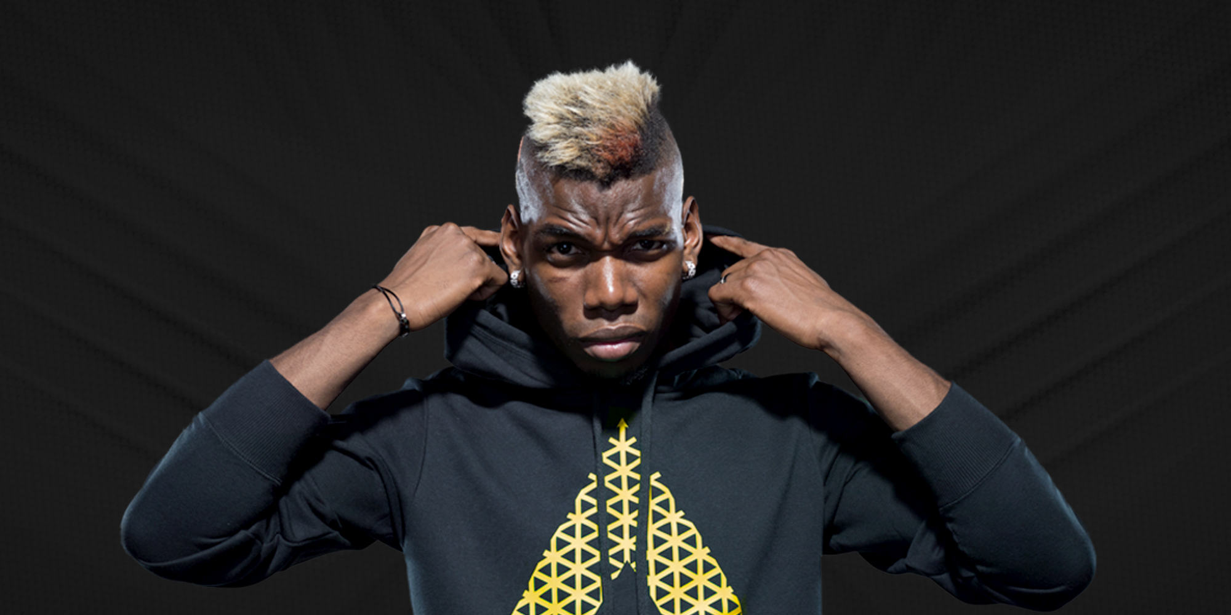

Herzogenaurach, 16th March 2016 – adidas is proud to announce that today (Tuesday 16 March) Paul Pogba, the world’s most in demand footballer, has chosen to sign a long term partnership with the world’s biggest football brand.

From his roots in district 77 of Paris, to the biggest stages in world football, Pogba has created hype with every strike, celebration, and hairstyle. One of the most creative athletes in world sport, on and off the pitch, Pogba has now chosen adidas as a reflection of a shared ambition.

Explaining why he chose adidas, Paul Pogba said:
“This is the first sponsor contract I’ve signed and it’s a very important decision for me. I chose adidas because we have shared passions and values. adidas has the same vibe as I do, on and off the pitch”.
Pogba also referenced adidas’ imagination and creativity as proof that it is the right brand for him.

He continued:
“I love music, dance and fashion but my biggest passion is football and I needed a brand that would give me the space to express myself and explore new frontiers. In adidas I found a partner with the same goals as me.”

Continuing on his extraordinary journey from the streets to superstar status, Pogba has already won three Italian league titles and three domestic cup trophies, the 2013 FIFA U20 World Cup, the FIFA World Cup Best Young Player award in 2014 and was named in the 2015 FIFPro World XI. He joins the brand’s global roster of football talent, which includes Leo Messi, James Rodriguez, Mesut Ozil, Luis Suarez and Gareth Bale.

adidas has also revealed that his first boot – co-created by the player and the brand – will be an exclusive ACE 16+ PURECONTROL model, in Pogba’s favourite black and gold colours. Only a small number of pairs of the special boot will be produced and given exclusively to the player.

Speaking about his new creation, Pogba said:
“adidas believes in my dream of building hype in the world of football. I hope I can leave a footprint and add something exciting and new to this iconic brand. The best is yet to come. This is Pogboom!”

The exclusive boot features a matt black upper and gold sole plate, with the iconic three stripes also picked out in gold. The in-sole carries a special message that speaks to the heart of adidas’ partnership with Pogba: “I’m Here to Create”.

For further information please visit adidas.com/football or go to facebook.com/adidasfootball or follow @adidasfootball on twitter to join the conversation.

- END -

For further media information please visit http://news.adidas.com/GLOBAL/PERFORMANCE/FOOTBALL or contact:

Simon Bristow  PR Director – Herzo Newsroom  Email: simon.bristow@adidas.com  Tel: +49/9132/84-73 703 | Alan McGarrie  Global Director PR & Social Media, adidas Football  Email: alan.mcgarrie@adidas.com  Tel: +49/9132/84-4686

Notes to editors:
About adidas Football
adidas is the global leader in football. It is the official sponsor / official supplier partner of the most important football tournaments in the world, such as the FIFA World Cup™, the FIFA Confederations Cup, the UEFA Champions League, the UEFA Europa League and the UEFA European Championships. adidas also sponsors some of the world’s top clubs including Manchester United, Real Madrid, FC Bayern Munich, Juventus, Chelsea and AC Milan. Some of the world’s best players also on the adidas roster are Leo Messi, Paul Pogba, Gareth Bale, Thomas Müller, Luis Suárez, James Rodríguez, Diego Costa and Mesut Özil.

