adidas reveals hot new limited collection Fluid & Etch pack

- Fluid and Etch boots the latest limited edition footwear releases from adidas -
- Fluid X 15 and ACE 16 constructed with magnetic design to embody movement -
- Etch X 15 and ACE 16 designed with unique k leather upper –

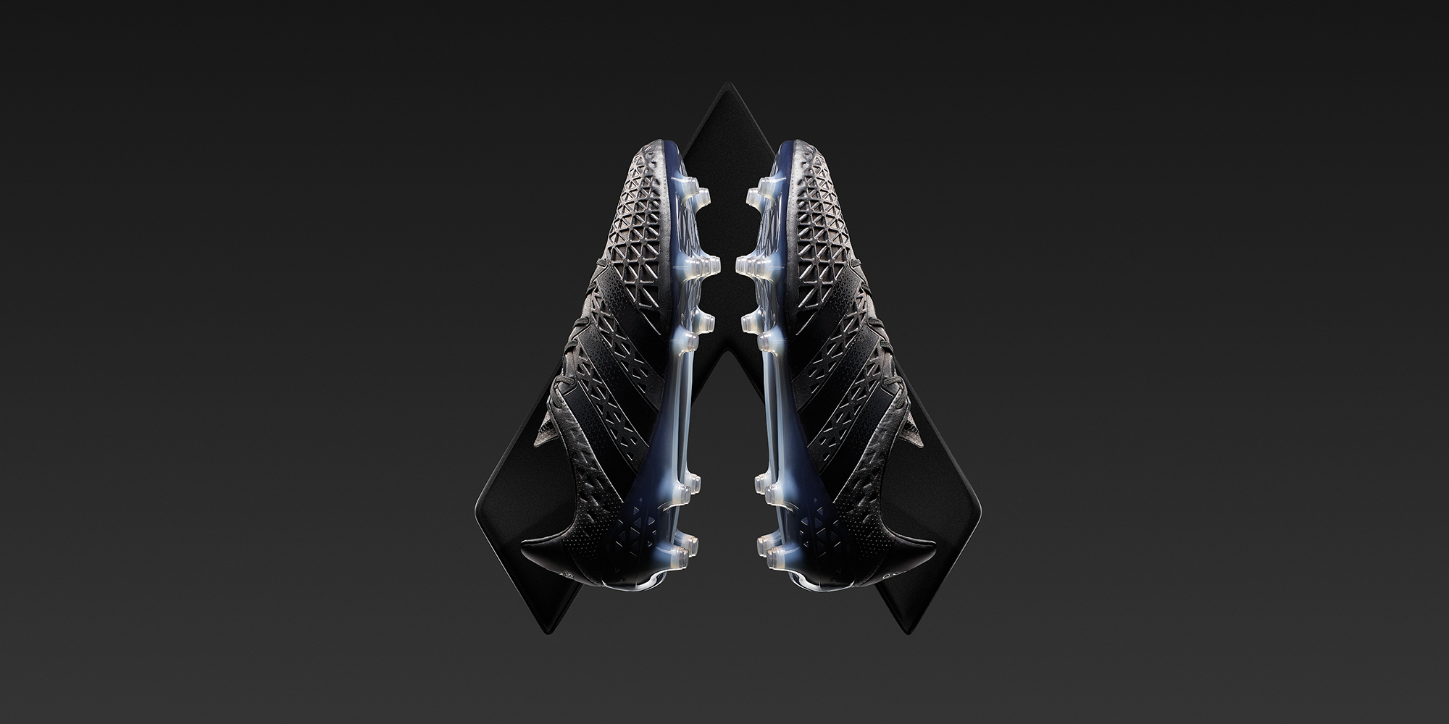

Herzogenaurach, Sunday 13th March – adidas continues to drive innovation in football in 2016. Fresh from the launch of the ACE 16+ PURECONTROL, the world’s first high performance laceless football boot, adidas today released their latest limited editions – the Fluid and the Etch packs. The Limited Collection products bring a distinct new look to the ACE 16 and X 15 silos using ground-breaking design processes.

The boots are part of the Limited Collection, a range of exclusive footwear released in very limited quantities from the brand to show the latest in innovation and creator spirit. A small number of both Fluid and Etch versions of the X 15 and ACE 16 will be available from today.

The Fluid boot embodies movement. The upper is created using an innovative process that takes a semi-fluid metallic pigment and runs magnets over the boot to manipulate the liquid and create distinctive patterns and textures. The pigment then freezes and sets to create a dark metallic, light-catching material.

The Etch boot has been designed to be the ultimate expression of a pure football boot. It is constructed using only K Leather, with no additional constructions or additions. As a result, the boot delivers unparalleled levels of comfort, with the material naturally light and soft to provide a snug fit as if moulded to the foot. The traditional K leather upper was then given a futuristic design by etching the surface for a unique texture.

When speaking about the Limited Collection, adidas Football Vice President of design Sam Handy said: “With the Limited Collection, we have the opportunity to showcase cutting edge techniques and try things that are not possible in the mass offerings. This could be done through design, product innovation or collaborations. We’ve seen an exciting rise in ‘sneaker culture’ permeating its way into football. The Limited Collection is about celebrating this culture.”

Specifically on the Fluid and Etch packs, Handy continued: “All key lines of the ACE and X on-field boots have been recreated as Fluid and Etch versions. For the Etch boot, the challenge was to create an affected surface but not to destroy the leather with the laser etching process. For the Fluid boot, we trialled various versions of the upper before landing on the perfect method of manipulating the metallic finish for the vision we had.”

For further information please visit adidas.com/football or go to facebook.com/adidasfootball or follow @adidasfootball on twitter to join the conversation.

- END -

For further media information please visit http://news.adidas.com/GLOBAL/PERFORMANCE/FOOTBALL or contact:

Simon Bristow  PR Director – Herzo Newsroom  Email: simon.bristow@adidas.com  Tel: +49/9132/84-73 703 | Alan McGarrie  Global Director PR & Social Media, adidas Football  Email: alan.mcgarrie@adidas.com  Tel: +49/9132/84-4686
Notes to editors:
About adidas Football
adidas is the global leader in football. It is the official sponsor / official supplier partner of the most important football tournaments in the world, such as the FIFA World Cup™, the FIFA Confederations Cup, the UEFA Champions League, the UEFA Europa League and the UEFA European Championships. adidas also sponsors some of the world’s top clubs including Manchester United, Real Madrid, FC Bayern Munich, Juventus, Chelsea and AC Milan. Some of the world’s best players also on the adidas roster are Leo Messi, Gareth Bale, Thomas Müller, Luis Suárez, James Rodríguez, Diego Costa and Mesut Özil.

