adidas Gamedayplus visits the Bernabeu in Real Madrid special

- Marcelo shows off his skills off the pitch with basketball freestyle -
- Alvaro Arbeloa describes playing under a club legend as manager -
- Keylor Navas demonstrates his unique goalkeeping training routine -

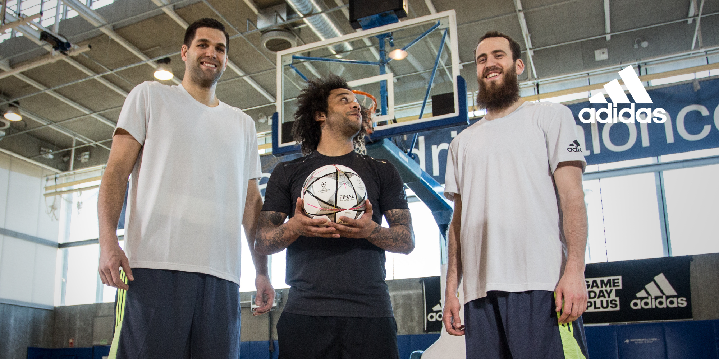

Herzogenaurach, Monday 15th February – Today adidas Gamedayplus launched a Real Madrid special with a behind-the-scenes look into one of the world’s biggest clubs.

The episode features some of the club’s most influential defensive players – with Keylor Navas, Marcelo and Alvaro Arbeloa starring – and a chance to win a Finale Milan, the Official Match Ball for the UEFA Champions League knock-out stages and final.

First to feature in the episode is Madrid left-back Marcelo who showcases his skills on the basketball court alongside players from the club’s basketball team, before discussing what it means to play for one of the world’s biggest clubs.

Next up, Arbeloa tells Gamedayplus what it’s like to play for a manager who is widely considered as one of the world’s greatest players and a legend in Madrid.

The episode finishes with an exclusive look into one of the most rigorous goalkeeper training sessions, as Keylor Navas demonstrates his training regime in front of the cameras.

Watch Gamedayplus at – https://www.youtube.com/watch?v=IVzSWljk7cE&feature=youtu.be

About adidas Gamedayplus:
- New episodes of Gamedayplus will be released every UEFA Champions League match week this season
- Subscribe to adidas football on Youtube to ensure you never miss an episode. To join the conversation, visit facebook.com/adidasfootball or follow @adidasfootball on twitter.

- END -

For further media information please visit http://news.adidas.com/GLOBAL/home/FOOTBALL or contact:

Simon Bristow
Global PR Director
Email: simon.bristow@adidas.com
Tel. +49 160 485 1388

Alan McGarrie
Global Football PR Manager
Email: http://alan.mcgarrie@adidas.com
Tel: +49/9132/84-4686

Notes to Editors:

About adidas Football:

adidas is the global leader in football. It is the official sponsor / official supplier partner of the most important football tournaments in the world, such as the FIFA World Cup™, the FIFA Confederations Cup, the UEFA Champions League, the UEFA Europa League and the UEFA European Championships. adidas also sponsors some of the world’s top clubs including Real Madrid, FC Bayern Munich, AC Milan, Flamengo and Chelsea. Some of the world’s best players also on the adidas roster are Leo Messi, Gareth Bale, Thomas Müller, Arjen Robben, James Rodriguez, Karim Benzema and Bastian Schweinsteiger.

