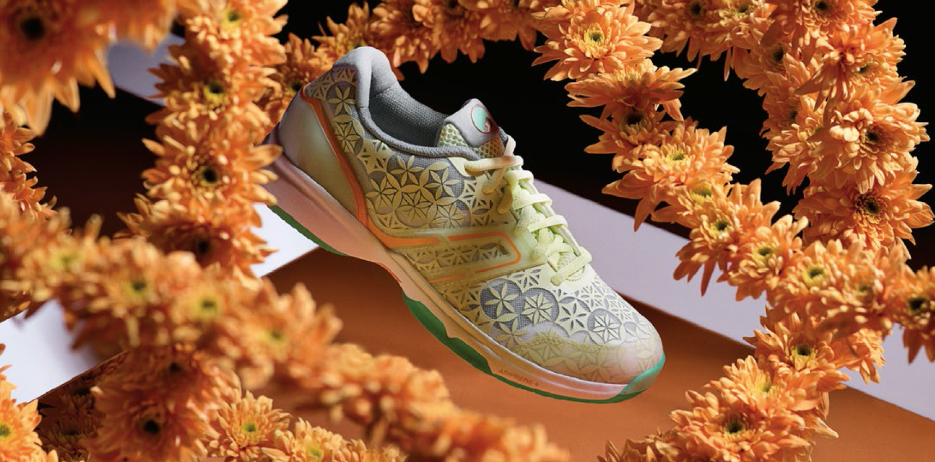

adidas Tennis Releases The adizero Ubersonic Aphrodite.

As the first of the SS16 Energy Pack limited edition series of tennis footwear, adidas launches the adizero Ubersonic Aphrodite. Create emotions with this shoe that’s perfect for those who are wild at heart and light on their feet.

2-14-2016 – Herzogenaurach, Germany

The adidas SS16 tennis limited edition collection hits the courts with the adizero Ubersonic Aphrodite. Part of a footwear range inspired by goddesses and conquerors, the adizero Ubersonic Aphrodite is named after the Greek goddess of love. Aphrodite embodied beauty and passion, but at the same time was impulsive and quick to act.

The adizero Ubersonic Aphrodite best suits players looking for lightweight shoes that allow them to sprint to the far corners of the court with goddess like speed. It comes with details inspired by Aphrodite herself, such as the color way that represents the ocean foam she was born in and the geometric pattern that symbolizes pomegranates – the fruit of Aphrodite.

The woven speed mesh upper with supportive overlays guarantees optimal comfort and ultimate performance. The TPU heel and midfoot elements perfectly support the foot during lightning quick direction changes. Passion meets performance for those who want to play with divine inspiration.

Find your inner goddess with the adizero Ubersonic Aphrodite, available from February 14th, 2016. Next releases in the SS16 Energy Pack are the Barricade Alexander and Barricade Hannibal for the men and adizero Ubersonic Artemis for the women.

– END –

For further information please contact:

Matthias Fischer
Communication Manager Tennis
Germany
Matthias.Fischer@adidas.com
+ 49 9132 84 6847

Notes to editors:
About adidas Tennis
adidas Tennis is represented by top players such as Tomas Berdych, Ana Ivanovic, Garbiñe Muguruza, Caroline Wozniacki, Angelique Kerber, Simona Halep, Jo-Wilfried Tsonga and Novak Djokovic (Footwear Only). For more information on adidas Tennis, please visit www.adidas.com/tennis. For additional images please visit our media news room on news.adidas.com and follow us on Twitter or on Instagram under @adidasTennis.

About adidas
adidas is a global designer, developer and marketer of athletic footwear, apparel and accessories with the mission to be the leading sports brand in the world. Brand adidas is part of the adidas Group, a corporation that includes brands such as Reebok, TaylorMade and Rockport.

