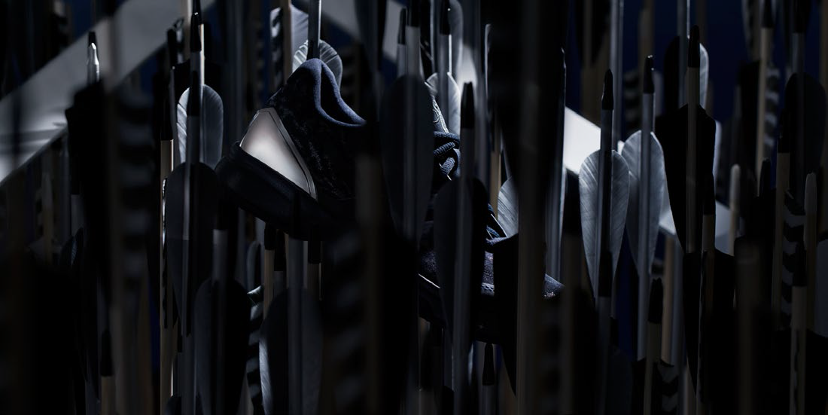

adidas tennis launches unique limited edition footwear range.

Dominate the court with shoes fit for gods and conquerors.

1-28-2016 – Herzogenaurach, Germany

No one has mastered the art of world domination like the ancient Romans and Greeks. Inspired by their excellence in battle, adidas has developed a truly unique limited edition footwear range for both men and women.

This one-of-a-kind collection lets players take on their opponents with shoes whose very names alone demand respect: the Barricade Alexander, the Barricade Hannibal, the adizero Ubersonic Aphrodite and adizero Ubersonic Artemis.

Anyone lacing up these shoes will command the game with the vision of the greatest military strategists and the invincibility of the gods. Each of the four models offers modern players different means to rise above the competition. Whether they want to break down their opponents with relentless power play, outsmart them with brilliant tactics or overrun them with lightning-fast strikes.

The first silhouette of the SS16 limited edition collection – the adizero Ubersonic Aphrodite - drops on February 14th, 2016, followed closely by the Barricade Alexander, Barricade Hannibal and adizero Ubersonic Artemis.

Follow in the footsteps of greatness.

– END –

For further information please contact:

Matthias Fischer
Communication Manager Tennis
Germany
Matthias.Fischer@adidas.com
+ 49 9132 84 6847

Notes to editors:
About adidas Tennis
adidas Tennis is represented by top players such as Tomas Berdych, Ana Ivanovic, Gabrine Muguruza, Angelique Kerber, Caroline Wozniacki, Simona Halep, Jo-Wilfried Tsonga and Novak Djokovic (Footwear Only). For more information on adidas Tennis, please visit www.adidas.com/tennis. For additional images please visit our media news room on news.adidas.com and follow us on Twitter or on Instagram under @adidasTennis.

About adidas
adidas is a global designer, developer and marketer of athletic footwear, apparel and accessories with the mission to be the leading sports brand in the world. Brand adidas is part of the adidas Group, a corporation that includes brands such as Reebok, TaylorMade and Rockport.

