Mesut Ozil takes chewing trick to boss level in the new Ace 16+ Purecontrol

- adidas release clip to celebrate Ozil bossing the game -
- Video part of a series of ”Boss the game” clips with adidas assets -

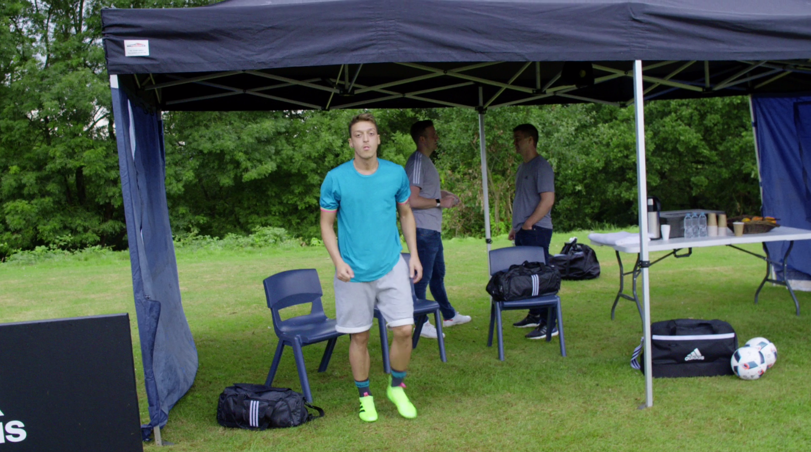

Herzogenaurach, 18th of January 2016 – adidas stars all over the world have been bossing the game in the ACE 16+ PURECONTROL since January. In the latest video clip released by adidas, Ozil pays homage to his famous chewing-gum warm-up routine by taking it to boss level in the new laceless boots.

Starting off with the familiar juggling of his chewing gum, Ozil then volleys it at a nearby cameraman lodging the gum onto the lens.

Watch the clip at: https://youtu.be/pwF74hxbs6o

- END -

For further media information please visit http://news.adidas.com/GLOBAL/PERFORMANCE/FOOTBALL or contact:

Robert Hughes  Managing Editor – Herzo Newsroom  Email: robert.hughes@adidas.com  Tel: +49/9132/84-6856 | Alan McGarrie  adidas Senior Global Football PR Manager  Email: alan.mcgarrie@adidas.com  Tel: +49/9132/84-4686

Notes to editors:
About adidas Football
adidas is the global leader in football. It is the official sponsor / official supplier partner of the most important football tournaments in the world, such as the FIFA World Cup™, the FIFA Confederations Cup, the UEFA Champions League, the UEFA Europa League and the UEFA European Championships. adidas also sponsors some of the world’s top clubs including Manchester United, Real Madrid, FC Bayern Munich, Juventus, Chelsea and AC Milan. Some of the world’s best players also on the adidas roster are Leo Messi, Gareth Bale, Thomas Müller, Luis Suárez, James Rodríguez, Diego Costa and Mesut Özil.

