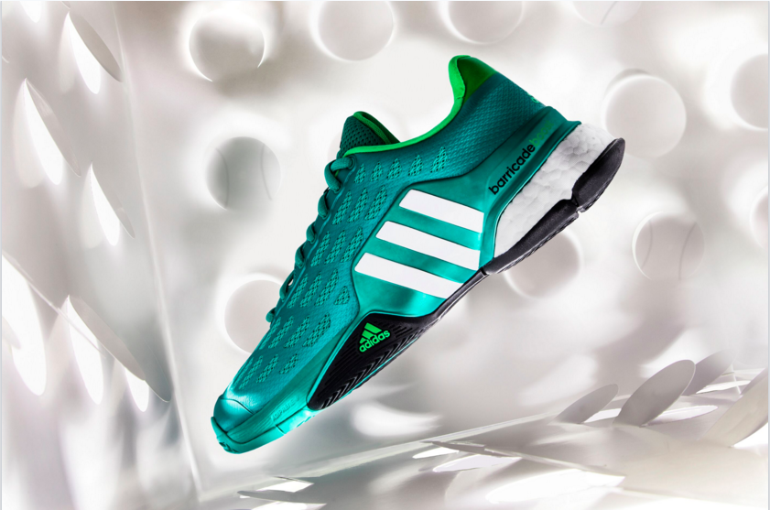
The Barricade Boost 2016

Adidas expands its Boost franchise in tennis with two new silhouettes.
Boost technology set to take over tennis courts around the world.

1-09-2016 – Herzogenaurach, Germany

Building on the success of the Barricade 2015 Boost, adidas Tennis broadens the Boost footwear range with the Barricade 2016 Boost, adidas by Stella McCartney Barricade Boost women’s shoe and the Tennis Energy Boost.

The Barricade 2016 Boost is the weapon of choice of Jo-Wilfried Tsonga. It’s the perfect shoe for players looking for more energy return in their footwork, while maintaining superior stability. Equipped with an extremely durable outsole, the Barricade 2016 Boost delivers incredible traction in every direction. Its Boost Capsules are responsible for an unparalleled responsive energy return that allows you to go all out at every single point.

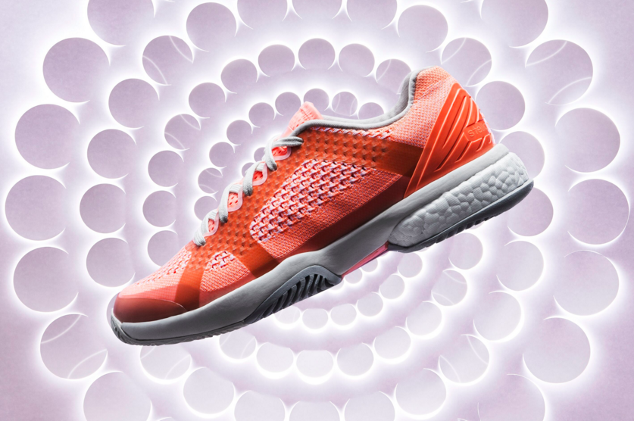

The women’s adidas by Stella McCartney Barricade Boost is designed by long-term adidas partner Stella McCartney. This performance-meets-fashion silhouette offers high-level players such as Caroline Wozniacki a cushioned feeling that’s second to none.

A stylish Primeknit upper adds supreme comfort to cutting-edge performance. Combining premium materials and thoughtful detailing with the latest sports technologies, adidas by Stella McCartney Barricade Boost lets you dominate the court, and look the part while you’re at it.

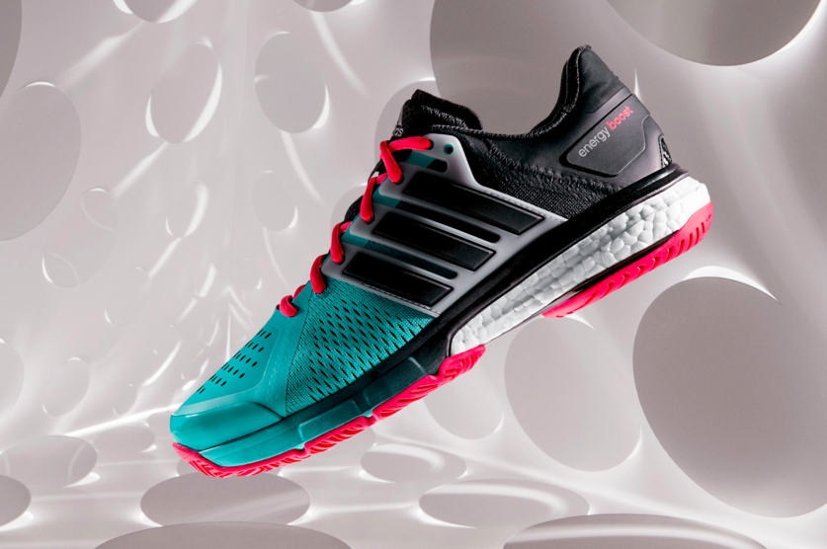

Completing the 2016 Boost range is the all-new Tennis Energy Boost. This model provides the sensational full-length boost feeling, backed up by the stability many club level players are looking for. Launch yourself around the court in extreme comfort and with powerful energy return in your every move.

A durable outsole rubber for abrasive courts delivers rock solid grip. The lightweight Tennis Energy Boost brings durability, stability and comfort to your game, so you can charge towards victory with power and precision.

Alexander Chan, adidas Category Director Tennis - “Boost has proven to be one of our most innovative footwear technologies ever. We’ve seen it revolutionise the running and basketball industries, and now we have integrated boost in tennis where we feel it provides an incredible benefit for players looking for a truly unique feel of energy return. We built upon the insight that athletes want to be able to play with the same intensity at match point as when hitting the very first serve. You’ll still have to master that inside out forehand yourself, but Boost will really let you step up your footwork.”

The Boost 2016 collection features:

- BOOST technology, offering energy return with expanded TPU capsules that make up the shoe’s distinctive heel midsole unit. With their unique cell structure, BOOST capsules store and unleash energy more efficiently in every step
- Adiwear 6 – an extremely durable outsole rubber for abrasive courts provides the most agile of players with a secure grip in all directions
- AdiTuff 360 – a breathable, supportive upper material providing long-lasting durability for the extreme abrasion that occurs during tennis movements
- A revolutionary new Barricade chassis to support the midfoot and heel, providing maximum stability while offering flexibility and comfort in the forefoot
- Three new colour ways – Shock Mint for the Barricade Boost, Ultra Bright for the aSMC Barricade Boost and Shock Green for the Energy Boost.

The Boost 2016 range is out now and is available through adidas.com and selected retailers.

- END -

For further information please contact:

Matthias Fischer
Communication Manager Tennis
Germany
Matthias.Fischer@adidas.com
+ 49 9132 84 6847

Notes to editors:
About adidas Tennis
adidas Tennis is represented by top players such as Tomas Berdych, Ana Ivanovic, Gabrine Muguruza, Caroline Wozniacki, Simona Halep, , Jo-Wilfried Tsonga and Novak Djokovic (Footwear Only). For more information on adidas Tennis, please visit www.adidas.com/tennis. For additional images please visit our media news room news.adidas.com and follow us on Twitter or on Instagram under @adidasTennis.

About adidas
adidas is a global designer, developer and marketer of athletic footwear, apparel and accessories with the mission to be the leading sports brand in the world. Brand adidas is part of the adidas Group, a corporation that includes brands such as Reebok, TaylorMade and Rockport.

