ADIDAS TAKES THE FAST LANE WITH LAUNCH OF REVOLUTIONARY ADIZERO XVI SWIMSUIT

Game-changing apparel unites innovative materials and stroke-specific fit to enable athletes to unchain their fastest

Herzogenaurach, Germany, 18th November 2015 – Tonight adidas unveiled its cutting-edge adizero XVI, combining intelligent materials and intuitive fit to be its fastest swimsuit ever. Supported by the brand’s leading athletes, Cesar Cielo, Michael Andrew and Allison Schmitt, the adizero XVI was unveiled at an exclusive event at the Muller’sches Volksbad in Munich.
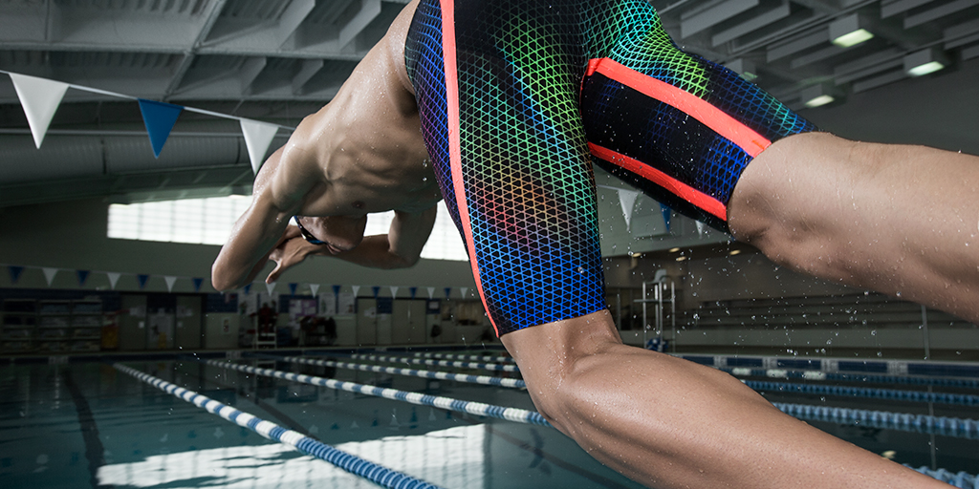

adidas worked with biomechanics, physiologists, fabric and pattern experts, plus a global pool of elite athletes to create the game-changing adizero XVI, enabling swimmers to achieve their maximum speed. The ground-breaking technology features three advancements; energy optimisation (X-TRA ENERGY), intelligent materials (X-TRA FLOW) and a stroke-specific biometric fit (X-TRA FIT).

X-TRA ENERGY: The adizero XVI works to optimise the swimmer’s energy, focusing it on propelling them through the water faster. The suit’s fabric, innovative bands and compressive fit work together to support the swimmer’s Kinetic Chain; the body’s series of interlocking joints, where one movement facilitates the next. The pioneering tape material offers 100% recovery, ensuring the swimmer’s expended energy is returned to optimise subsequent movements, for example pushing off the starting block.

X-TRA FLOW: Intelligent material and lightweight construction guarantee enhanced body position in the water. Strategically placed texturing of the fabric, the result of extensive wind tunnel testing, pushes water more smoothly over the swimmer’s body in the right direction so it doesn’t create as much turbulence.

X-TRA FIT: In an industry first, the adizero XVI offers bespoke design for the unique movements of different swimming strokes. Stroke-specific moderations ensure a precision fit, facilitating athletes’ transition through the water. For example, to cater for the unique kick of the breaststroke, adidas bands shaped to support the “insweep” phase, ensure free, non-restricted and supportive movement.

“Elite swimmers know that to create their best race, every millisecond counts. Correct body positioning, water flow and a smooth aerodynamic fit all combine to make the difference between a medal on the world’s stage and disappointment”, said Deborah Yeomans, Director Future for adidas. “With the adizero XVI we have deconstructed the swimsuit status quo and rebuilt it to optimise the natural movement of the human body. We look forward to seeing the swimsuit propel our athletes onto the podium this summer”.

Demonstrating the benefits of the adizero XVI at the Muller’sches Volksbad in Munich were adidas elite swimmers: Cesar Cielo, Michael Andrew, Allison Schmitt, Fernanda Gonzalez, Coralie Balmy, Chris Walker-Hebborn and recently signed Kyle Chalmers, who took part in a high speed relay alongside young competitors of the future.

“I believe swimming is one of the most physically demanding sports, given that it uses every muscle in the body in a different way” said Olympic Gold medallist Cesar Cielo. “When I put on the adizero XVI I can instantly feel that the suit gives me the extra edge.”

The adizero XVI, available for men and women will be on sale from February 2016 at adidasswim.com and selected speciality retail partners around the world

***

About adidas Swimming:
adidas is the global sports brand leading the charge in swimming’s technological revolution. Faster, smarter, better; the adidas swimwear range allows the best in the world to reach unparalleled times. Some of the world’s best athletes - Cesar Cielo, Michael Andrew and Allison Schmitt - wear adidas to reach their best, enabled by ground-breaking products such as the adidas adizero XVI swimsuit.

NOTE TO THE EDITOR

Present at the launch was elite athletes:

Cesar Cielo (BRA)
Allison Schmitt (USA)
Michael Andrew (USA)
Coralie Balmy (FRA)
Chris Walker-Hebborn (GB)
Kyle Chalmers (AUS)
Fernanda Gonzalez (MEX)

Media relations:
Bastian Jung
Brand Communications, Swim
+49.9132.84.75462
Bastian.jung@adidas.com

