EMBARGOED UNTIL MONDAY 21st SEPTEMBER, 10:00HRS CET

CREATE even MORE CHAOS with x 15 menace pack

more freedom for customisation than ever for the game’s most dangerous players

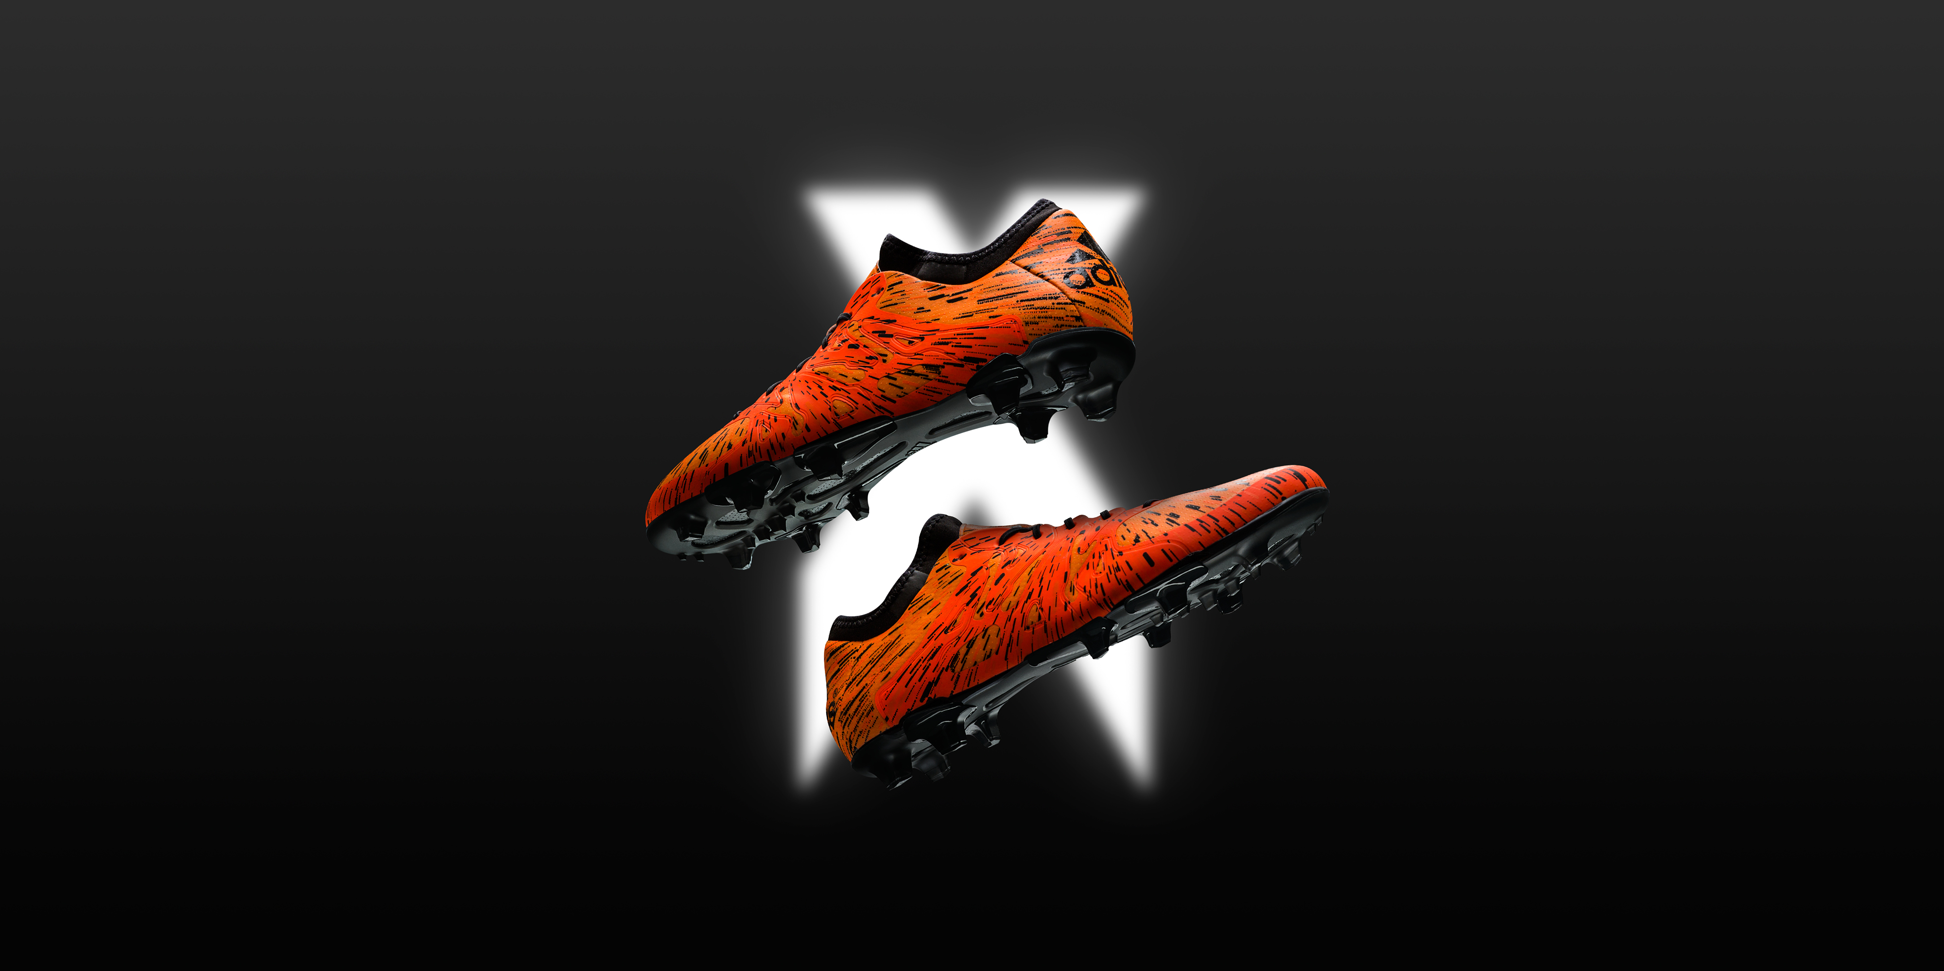

Herzogenaurach, Monday 21st September – The adidas X 15 is the ultimate weapon for the game’s most dangerous players. The players who break the rules and cause chaos. The players who change the game with one moment of genius.

The X player fits no structure and obeys no limits. These players now have more scope for chaos than ever before with hundreds of vivid new X 15 customisation options in the miadidas Menace Pack. The player known for the spectacular, the bold and the individual can now express this in their boots as well as on the pitch.

The Menace Pack takes the show-stopping graphic of the X 15 and explodes it across the X-SKIN upper for the ultimate show of exhibitionism. The new splatter graphic conveys the speed of turn, lightning quick thought, and unstoppable instinct of the X 15 player.

miadidas.com is a service allowing footballers to "Create Your Own" design and incorporate colour schemes and personal touches to their boots. The website contains a huge range of customisation options, meaning that it is easier than ever for 'designers' to purchase their creations or share them on social media.

X 15 is the ultimate weapon for the game’s most dangerous players. The TECHFIT COLLAR offers a compression fit around the ankle for superior support and fit. The X-CLAW base is built to give complete traction with a lightweight feel. The innovative X-CAGE is built for the most dynamic and agile players in the world. A fragmented and lightweight design gives ultimate support during the most agile movements. The X-SKIN is made up of a complex three layered system that delivers comfort, protection and performance in any conditions. A game changing product for game changing players.

. To join the conversation visit facebook.com/adidasfootball or follow @adidasfootball

- END -

For further media information please visit http://news.adidas.com/GLOBAL/PERFORMANCE/FOOTBALL or contact:

Robert Hughes  Managing Editor – Herzo Newsroom  Email: robert.hughes@adidas.com  Tel: +49/9132/84-6856 | Alan McGarrie  adidas Senior Global Football PR Manager  Email: alan.mcgarrie@adidas.com  Tel: +49/9132/84-4686
About adidas Football
adidas is the global leader in football. It is the official sponsor / official supplier partner of the most important football tournaments in the world, such as the FIFA World Cup™, the FIFA Confederations Cup, the UEFA Champions League, the UEFA Europa League and the UEFA European Championships. adidas also sponsors some of the world’s top clubs including Manchester United, Real Madrid, FC Bayern Munich, Juventus, Chelsea and AC Milan. Some of the world’s best players also on the adidas roster are Leo Messi, Gareth Bale, Thomas Müller, Luis Suárez, James Rodríguez, Diego Costa and Mesut Özil.

