adidas Outdoor footwear news fall/winter ‘15

In fall/winter ’15, adidas Outdoor will continue its new direction for terrex. Several new versatile and lightweight winter products will be added to established key products. They are made without compromise, with the finest materials and always with the purpose of supporting athletes. The new terrex range is made for athletes with unlimited imagination who want to constantly redefine their limits and set new targets – no matter how they explore the outdoors in winter: climbing, skiing, running, biking or flying.

terrex footwear news:
terrex Boost GTX
terrex Ultimate Boost Climaheat

terrex Boost GTX
The lightweight mountain running shoe terrex Boost GTX features the revolutionary cushioning technology BOOST™. It provides more energy return than any other cushioning material in the industry, which makes it an ideal shoe for long-distance mountain runs. Another big advantage of the terrex Boost GTX is its Continental® rubber outsole. It generates excellent grip even at the highest speeds – on dry as well as on wet ground. In order to keep your feet dry when running through wet or snowy surfaces, the terrex Boost GTX is equipped with a waterproof GORE-TEX® membrane.

Features & benefits:

- Lining: GORE-TEX® extended comfort membrane. Waterproof and breathable (100% PES)
- Upper:speed lacing construction for fast and snug lacing
- Torsion: Torsion bar/PRO-MODERATOR™ for midfoot stability
- Midsole: BOOST™ offers endless energy in the mountains and high adaptability on rocky surfaces
- Outsole: Continental® rubber for extraordinary grip
- Weight: 355g (men UK 8.5), 315g (women UK 5.5)
- Price: € 180.00

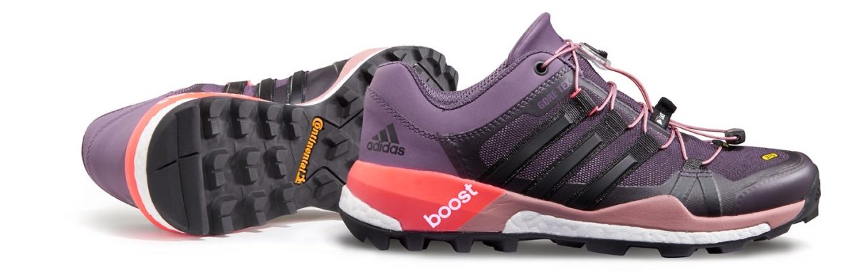

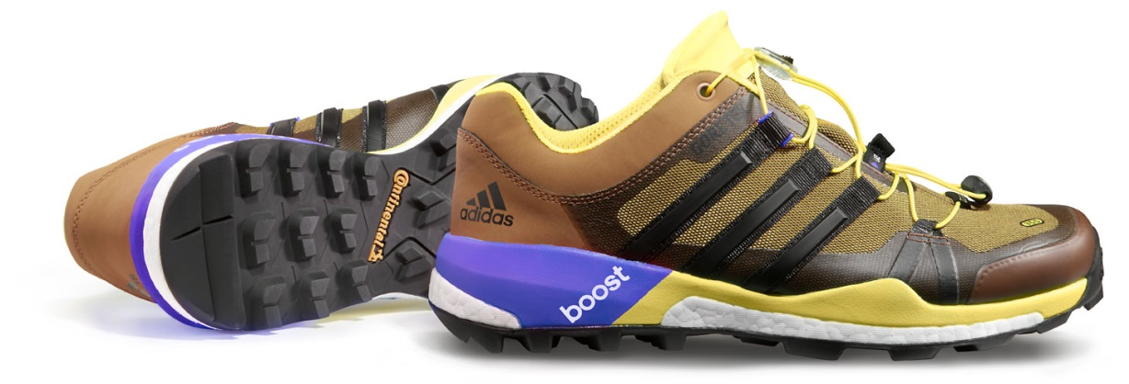

terrex Ultimate Boost Climaheat
This lightweight, waterproof winter hiking shoe offers everything you need in winter: insulation, comfort and grip. It has a minimalistic and reduced design combined with innovative technologies. The Climaheat™ technology combining Primaloft® insulation and an innovative collar execution keeps snow out and your feet warm. This goes along with a waterproof climaproof® membrane in order to guarantee dry feet.
Continental™ rubber on the outsole provides best grip on snow and ice. BOOST™ technology in the midsole offers endless energy and high adaptability on rocky surfaces.

Features & benefits:
- Upper: Climaheat™- combining Primaloft® insulation and an innovative stretchable collar execution – keeping snow and cold out
- Upper: PrimaLoft® insulation material for more warmth, even in wet conditions
- Upper: Climaproof® membrane for waterproof protection in wet conditions
- Sockliner: molded sockliner to enhance comfort and fit
- Midsole: BOOST™ offers endless energy in the mountains and high adaptability on rocky surfaces
- Outsole: Continental® rubber for extraordinary grip on icy surfaces
- Regular fit
- Weight: 480g (men UK 8.5)
- Price: € 180.00

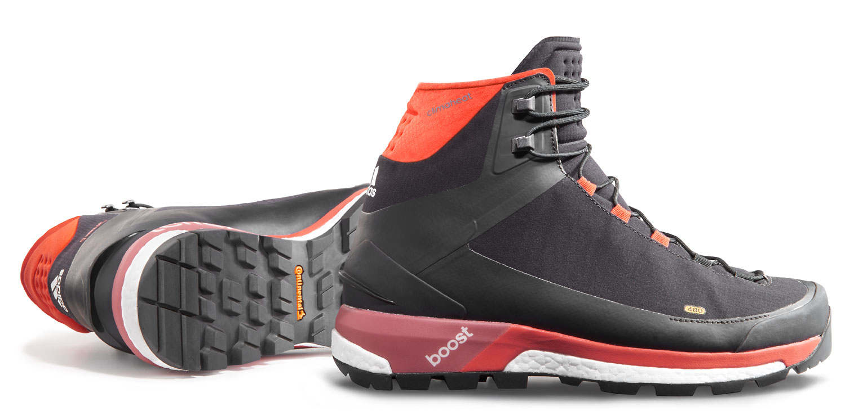

***

Imagery of the new terrex range:
http://news.adidas.com/GLOBAL/home/OUTDOOR

More information and regular updates about adidas Outdoor:
www.adidas.com/outdoor/
www.facebook.com/adidasoutdoor
www.instagram.com/adidasoutdoor
www.youtube.com/adidasoutdoortv
www.twitter.com/adidasoutdoor

Media contact:

Lena Hackforth
Senior PR & Social Media Manager adidas Outdoor
+49 9132 84 4380
+49 160 884 4380 (mobile)
lena.hackforth@adidas.com

