EMBARGOED UNTIL Monday 25th May 1600hrs CET
ADIDAS INTRODUCES X AND ACE
TO HELP YOU BE THE DIFFERENCE

Only two types of player define the modern game

Herzogenaurach, 25th May – Today, there are only two types of players - those that cause chaos and those that control everything. The game changers and the play makers. The best managers, players and minds have spoken – football has changed.
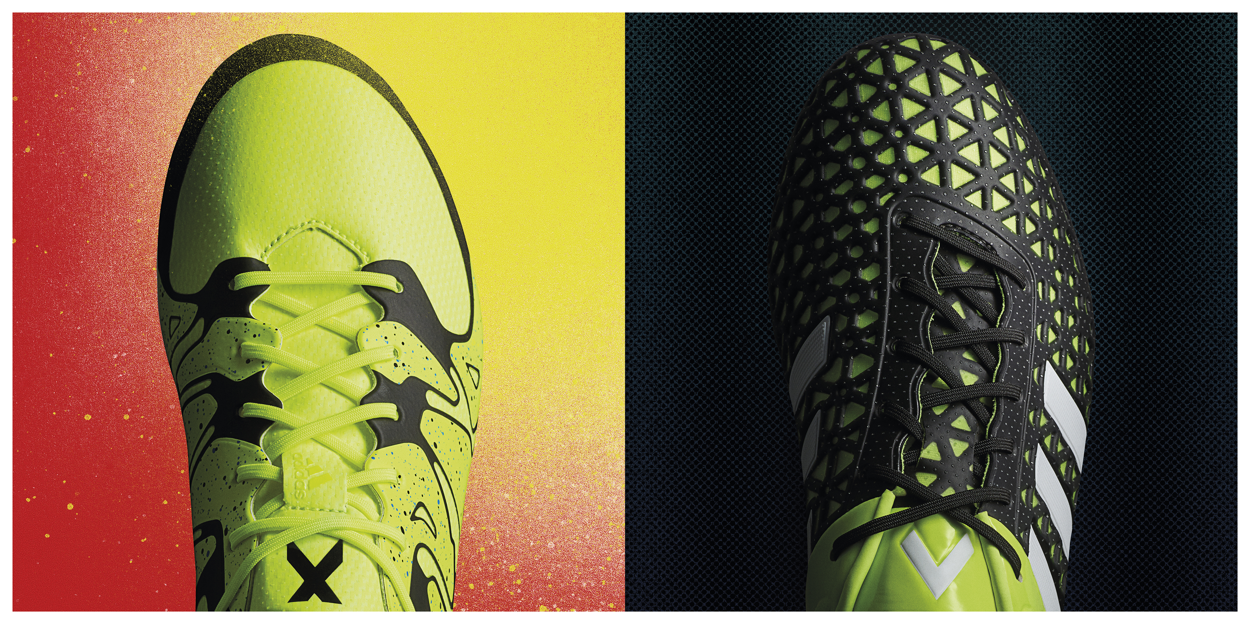
The new adidas X15 & Ace15

In the words of Pep Guardiola: “It’s chaos or control. There are players who think more about what the team needs and what is the best solution for the team. This kind of player is an intelligent player who has a vision about what the team needs. He controls.”

“Then there are the ones who cause chaos. The ones who play on instinct and on talent. They are a little outside of the field. They can create absolutely everything and you can’t control that. You cannot limit that.”

For the first time, these two distinct types of player will have their own boots. The old adidas silos have been discontinued. No more F50, no more Predator, no more 11pro and no more Nitrocharge. There is only chaos and control. There is only X and ACE.

INTRODUCING ACE15
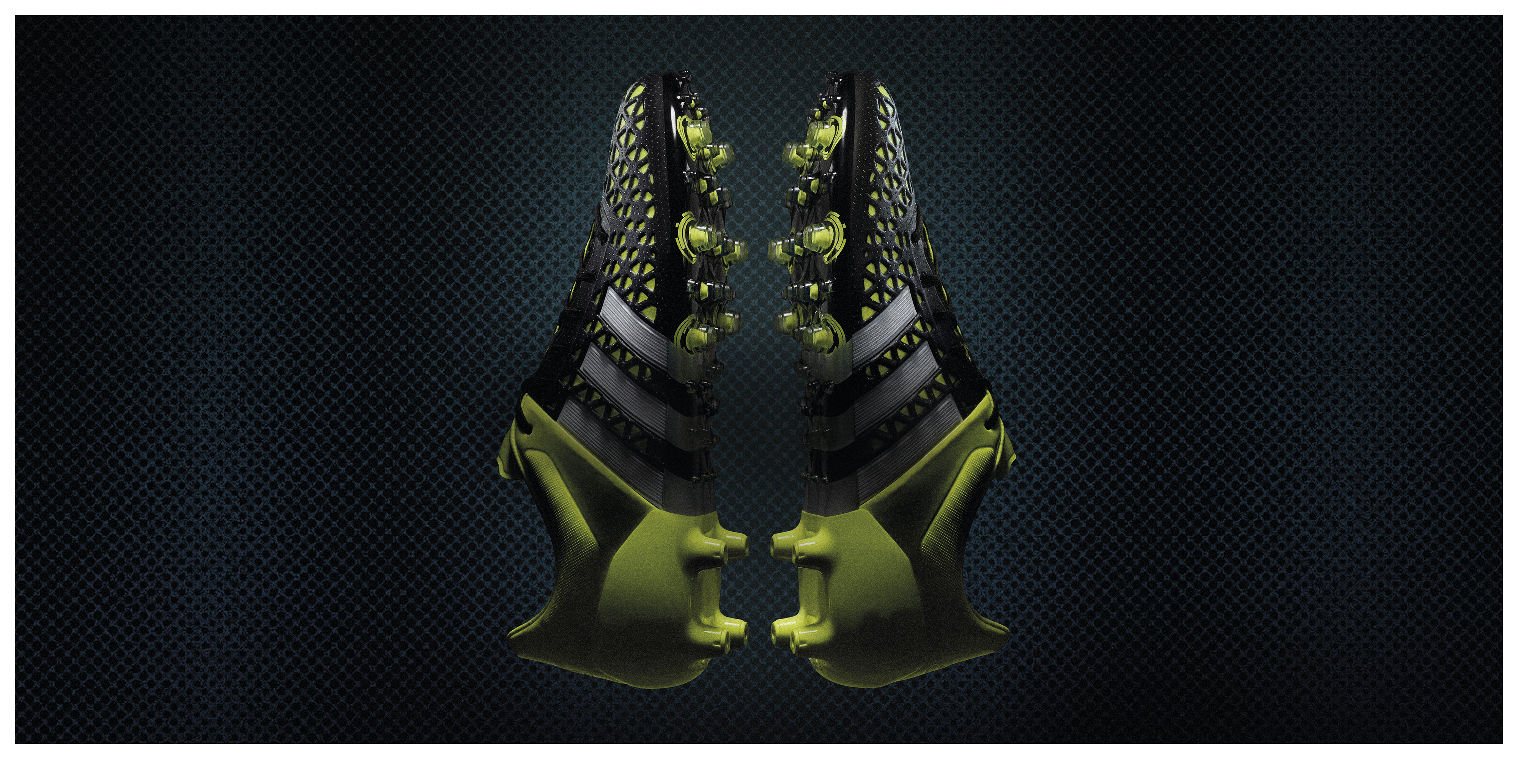
The new adidas Ace15

Some players are born to control. They are the ones that pull the strings and set the pace. Every great team needs the players that keep it on track. That bring the coaches plans into action. They bring order to a chaotic game. Players like Mesut Özil, James Rodríguez, Oscar, Manuel Neuer and Ivan Rakitić are the glue of some of the world’s best teams. For these players, adidas has designed ACE15.

ACE15 is built to control. The revolutionary CONTROL WEB gives ultimate ball control, thanks to an engineered 3D material. A 3-layer compound combines with grippy EVA for an unbeatable touch. A ground breaking new stud configuration puts more studs on the ball during foot-over moves to allow for complete ball control. The unique NSG (Non-stop grip) skin uses 3D dots for perfect control in all conditions. The players that run the show now have the boots to dominate.

INTRODUCING X15
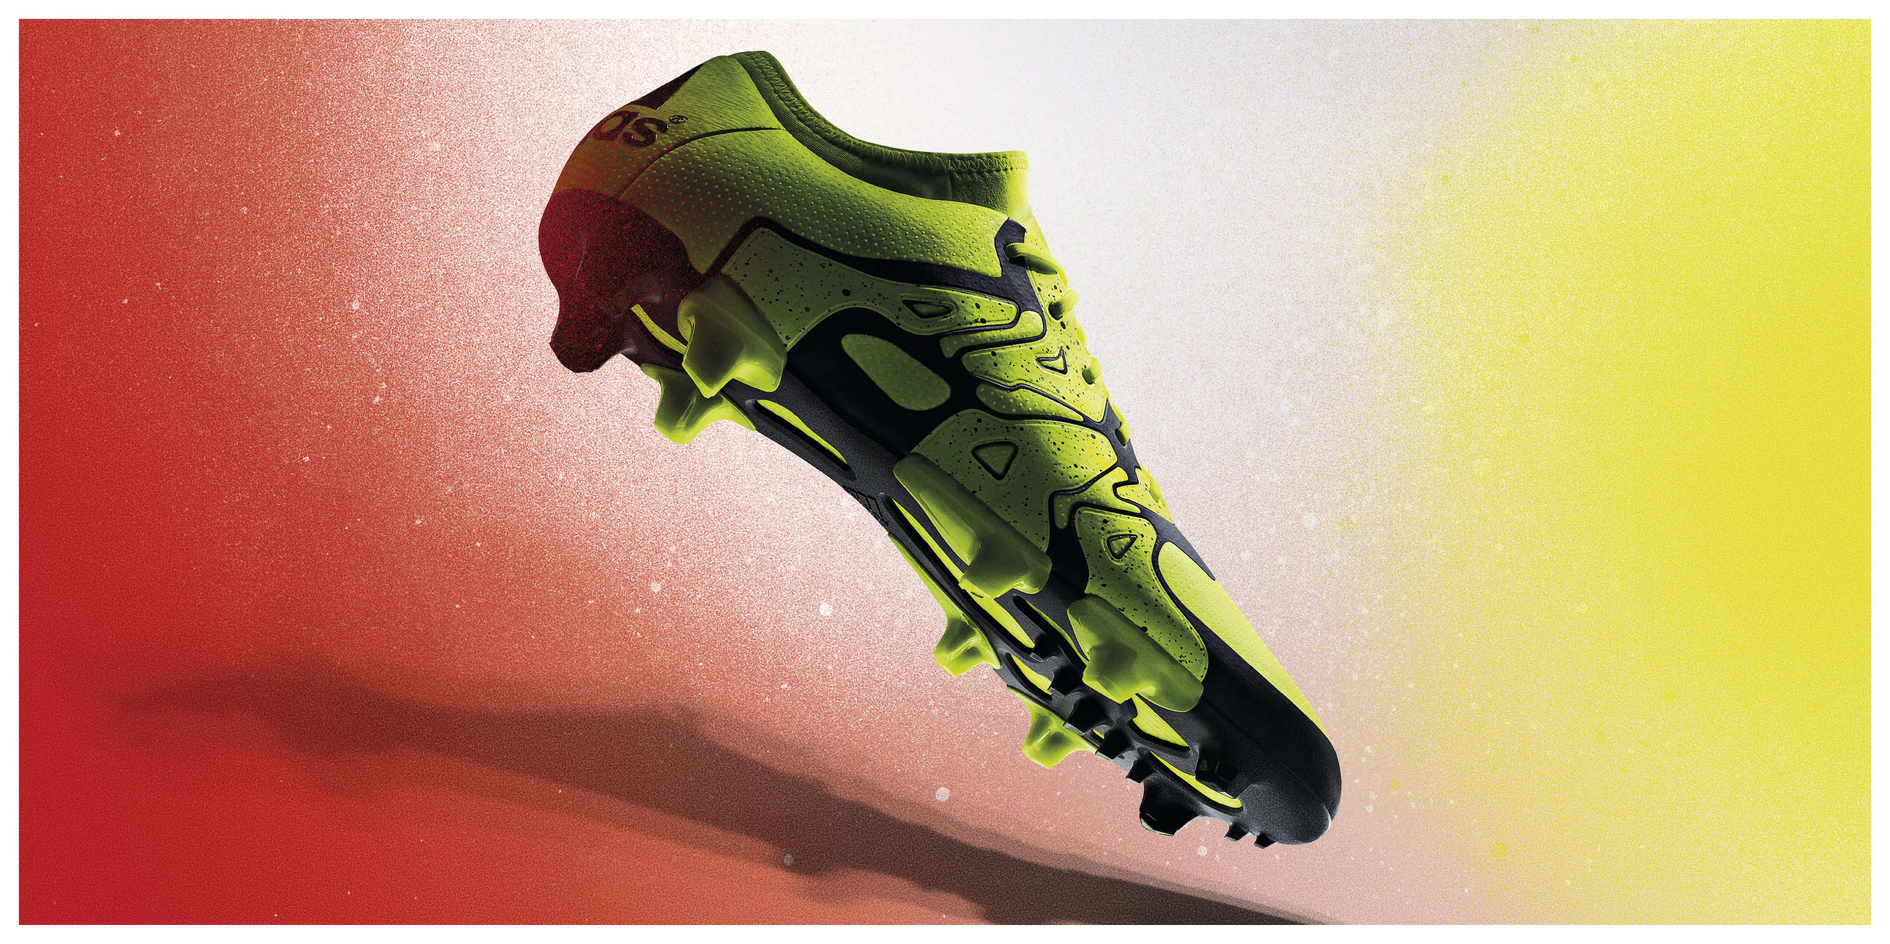
The new adidas X15

Some players can never be controlled. They are the spark that ignites a game. They defy rules and structure. The moment of genius that gets the crowd off their seat – that’s their speciality. There is no defence and no tactic that can control them. These players are specialists in chaos. Thomas Müller, Gareth Bale, Luis Suárez, Karim Benzema and Álvaro Morata, these players strike without a moment’s notice. For them, adidas has created X15.

X15 is the ultimate weapon for the game’s most dangerous players. The TECHFIT COLLAR offers a compression fit around the ankle for superior support and fit. The X-CLAW base is built to give complete traction with a lightweight feel. The innovative X-CAGE is built for the most dynamic and agile players in the world. A fragmented and lightweight design gives ultimate support during the most agile movements. The X-SKIN is made up of a complex three layered system that delivers comfort, protection and performance in any conditions. A game changing product for game changing players.

Some of the world’s best players will wear ACE15 and X15 for the first time at the UEFA Champions League Final in Berlin on Saturday 6th June, with the boots available to purchase from Wednesday 1st July at adidas own-retail outlets and specialist retailers worldwide.

For further information please visit www.adidas.com/bethedifference or go to facebook.com/adidasfootball or follow @adidasfootball #BETHEDIFFERENCE on twitter to join the conversation.

- END -

For further media information please visit http://news.adidas.com/GLOBAL/PERFORMANCE/FOOTBALL or contact:

Robert Hughes  adidas Global Football PR Director  Email: robert.hughes@adidas.com  Tel: +49/9132/84-6856 | Alan McGarrie  adidas Senior Global Football PR Manager  Email: alan.mcgarrie@adidas.com  Tel: +49/9132/84-4686

Notes to editors:
About adidas Football
adidas is the global leader in football. It is the official sponsor / official supplier partner of the most important football tournaments in the world, such as the FIFA World Cup™, the FIFA Confederations Cup, the UEFA Champions League, the UEFA Europa League and the UEFA European Championships. adidas also sponsors some of the world’s top clubs including Real Madrid, FC Bayern Munich, AC Milan, Flamengo and Chelsea. Some of the world’s best players also on the adidas roster are Leo Messi, Gareth Bale, Thomas Müller, Luis Suárez, James Rodríguez, Diego Costa and Mesut Özil.

