EMBARGOED UNTIL MONDAY 13TH APRIL, 1000HRS CET
ADIDAS LAUNCH the
lightest football boot ever

The dream becomes a reality as the adizero 99g
boot marks a new dawn in football innovation

Herzogenaurach, Monday 13th April - adidas has taken a historic step today in releasing the lightest boot of all time available for purchase, with the all new adizero 99g.

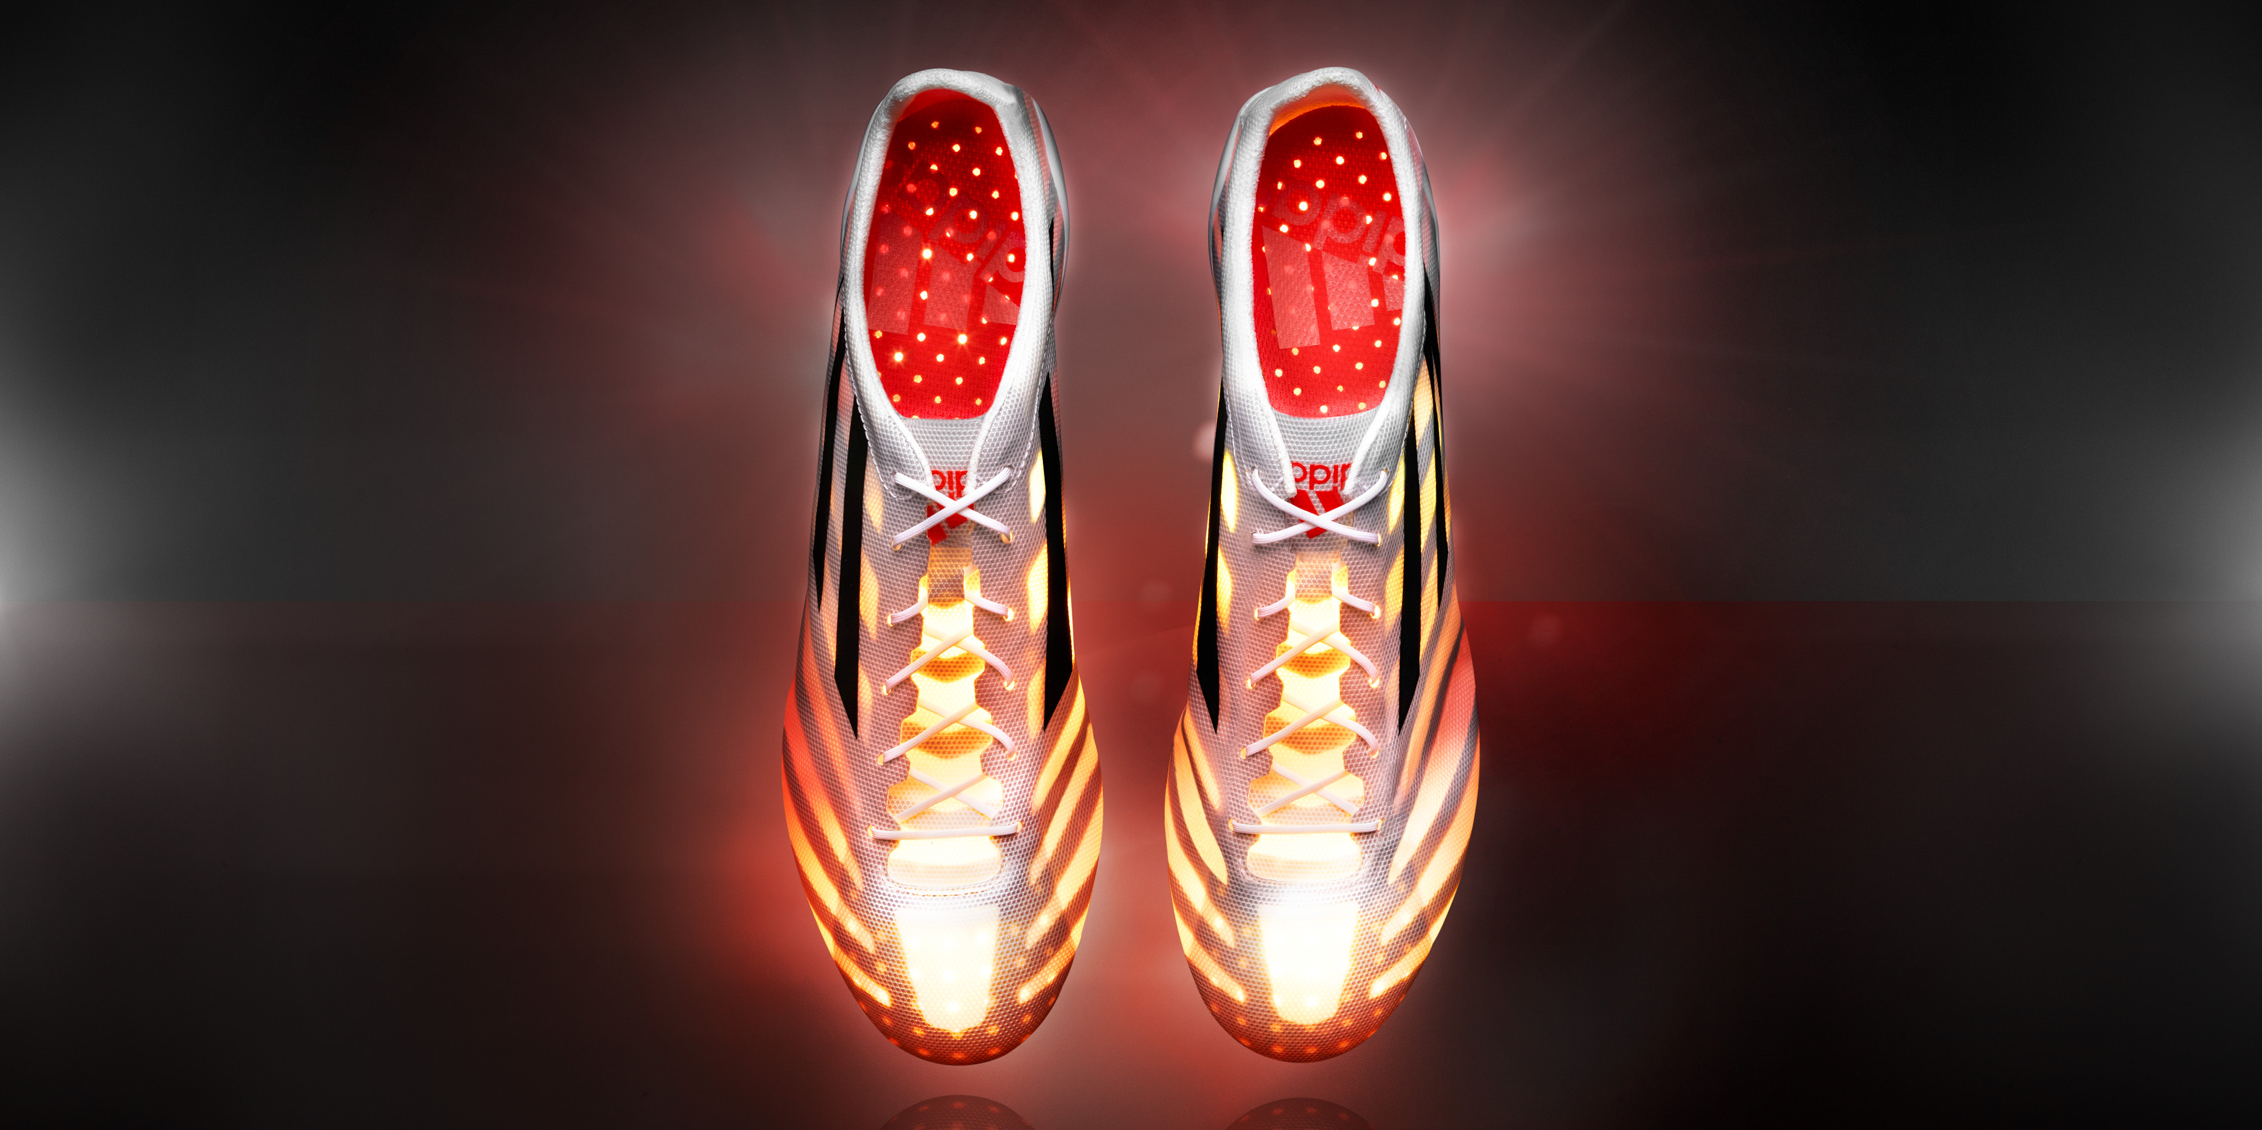
The adidas adizero 99g

Previously presented as a “concept car” model at the adidas Innovation Lab in 2013, the adizero 99g is the first product drop under the umbrella of the new adidas Football “Limited Collection”. Footwear items to be included in the “Limited Collection” range will be those released in super-limited quantities, which also showcase the best in adidas Football innovation and / or collaboration.

The game-changing adizero 99g marks a revolutionary step in technology and product innovation in football, with the boot designed to make players both lighter and faster, giving them both a physical and psychological advantage on the field.

The eye-catching boot, rigorously tested for tear strength and abrasions, has been created in adidas’ adizero speed range and is aimed at enhancing player performance through added raw speed and agility, whilst still ensuring players are suitably protected in an increasingly fast and competitive game.

With just 299 pairs to be put on sale globally, the boots themselves have undergone extensive global player-testing - including amateur players, semi-professionals and some of the world’s best players with the likes of Karim Benzema and David Alaba.

The adidas adizero 99g

Talking about the design as part of the forthcoming adidas Gamedayplus episode due to launch on the adidas Football YouTube channel at 2045hrs CET this evening, adidas Product Manager Hazim Kulak said: “Player feedback is at the heart of everything we do in football, and the reduction of weight is important to players as weight is a powerful driver for speed. This reduction in weight assists players in performing to the highest level and continues adidas’ commitment to being on the cutting edge of technology in football. We are incredibly proud of this design and believe it will only help players develop and improve their game.”

Ground-breaking features of the 99g boot include:

- 1mm polyamide outsole which reduces weight but has the rigidity to perform at the highest level
- Extremely lightweight upper layer made from a single layer of woven polyester mesh
- Unique stud layout to ensure fastest possible movements in all directions

The new adizero 99g is around half the weight of a regular boot. Regardless of the weather conditions, the material is always 99g, unlike synthetic or leather boots which simply get heavier when wet.

The limited edition adidas adizero 99g boot is available to purchase in size 8.5 UK only from Wednesday 15th April in adidas own-retail outlets as well as specialist retailers worldwide. There will be only 299 pairs available and each pair will be individually numbered.

For further information please visit adidas.com/football or go to facebook.com/adidasfootball or follow @adidasfootball #LimitedCollection on twitter to join the conversation.

- END -

For further media information please visit http://news.adidas.com/GLOBAL/PERFORMANCE/FOOTBALL or contact:

Robert Hughes  adidas Global Football PR Director  Email: robert.hughes@adidas.com  Tel: +49/9132/84-6856 | Alan McGarrie  adidas Senior Global Football PR Manager  Email: alan.mcgarrie@adidas.com  Tel: +49/9132/84-4686

Notes to editors:
About adidas Football
adidas is the global leader in football. It is the official sponsor / official supplier partner of the most important football tournaments in the world, such as the FIFA World Cup™, the FIFA Confederations Cup, the UEFA Champions League, the UEFA Europa League and the UEFA European Championships. adidas also sponsors some of the world’s top clubs including Real Madrid, FC Bayern Munich, AC Milan, Flamengo and Chelsea. Some of the world’s best players also on the adidas roster are Leo Messi, Gareth Bale, Thomas Müller, Arjen Robben, James Rodriguez, Karim Benzema and Bastian Schweinsteiger.

