EMBARGOED UNTIL SATURDAY 21st MARCH, 1000HRS CET

WEAR IT IF YOU DARE:
MIADIDAS F50 HATERS

Gareth Bale will answer the “haters” tomorrow in the new miadidas f50

Herzogenaurach, Saturday 21st March – The best players in the world stimulate the most envy. Great performances on the pitch lead to jealousy and hatred off it – and Gareth Bale is ready to take on his “haters” this weekend in his exclusive new miadidas f50 Haters boots.

The new miadidas f50 Haters boots will be worn exclusively in El Clásico tomorrow by Gareth Bale

The new miadidas f50 Haters are available from today on www.miadidas.com and will be worn exclusively on the field of play by the world’s most expensive footballer Gareth Bale. In the world’s biggest rivalry, emotions run high, and Bale will debut the boot in the ‘El Clásico’ match with Barcelona tomorrow (Sunday 22nd March). Now, Gareth Bale has the weapons to dominate on the biggest stage.

Only the elite players light up the pitch, and the white / silver colour of the miadidas f50 Haters are reserved for the very best players who dare to wear it. The next generation of adizero f50 have been developed to maximise speed and manoeuvrability, and the miadidas f50 Haters have all the latest technology. A revolutionary new design including a “ghost” graphic, bold white colour and new 3-Stripes branding ensures you will own the bragging rights on the pitch. A 3D dribbletex layer on the upper allows for better speed dribbling in wet or dry conditions. The outsole has also had a complete re-design, with a new grip texture and stud configuration with a second level of traction on the forefoot base, inspired by sprint spikes.

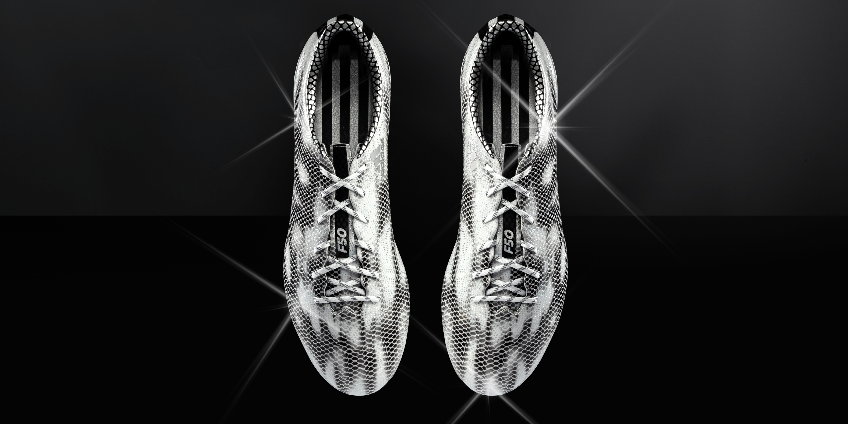
The new miadidas f50 Haters boots will be worn exclusively in El Clásico tomorrow by Gareth Bale

miadidas.com is a service allowing footballers to "Create Your Own" design and incorporate colour schemes and personal touches to their boots. The website contains a huge range of personalisation options, meaning that it is easier than ever for 'designers' to purchase their creations or share them on social media.

The all-new miadidas f50 Haters come in three possible colourways (black, white or pink) and are exclusively available to buy now at www.miadidas.com. To join the conversation visit facebook.com/adidasfootball or follow @adidasfootball on twitter #ThereWillBeHaters.

- END -

For further media information please visit http://news.adidas.com/GLOBAL/PERFORMANCE/FOOTBALL or contact:

Robert Hughes  adidas Global Football PR Director  Email: robert.hughes@adidas.com  Tel: +49/9132/84-6856 | Alan McGarrie  adidas Senior Global Football PR Manager  Email: alan.mcgarrie@adidas.com  Tel: +49/9132/84-4686
Notes to editors:
About adidas Football
adidas is the global leader in football. It is the official sponsor / official supplier partner of the most important football tournaments in the world, such as the FIFA World Cup™, the FIFA Confederations Cup, the UEFA Champions League, the UEFA Europa League and the UEFA European Championships. adidas also sponsors some of the world’s top clubs including Real Madrid, FC Bayern Munich, AC Milan, Flamengo and Chelsea. Some of the world’s best players also on the adidas roster are Leo Messi, Gareth Bale, Thomas Müller, Arjen Robben, James Rodriguez, Karim Benzema and Bastian Schweinsteiger.

