PIBE DE BARR10: BOOTS MADE FOR THE BEST

adidas reveals new signature boots for Leo Messi that pay homage to star’s hometown

Herzogenaurach, 16th March – 2015 so far has belonged to Leo Messi. No player in any major league has scored more goals than the Argentinian. No player in any major league has scored more than the Argentinian. Leo has been directly involved in 24 La Liga goals this year; no other TEAM has scored more. For club and country in 2015, Messi has played 17 times, scored 20 goals and grabbed 11 assists. His most recent hat-trick made him the all-time leader in La Liga hat-tricks, at just 27. Now, adidas has unveiled the new boots that will be worn by the world’s best player. The new Pibe de Barr10, inspired by the Barrio of Las Heras, Rosario, where Messi learned to play the game.

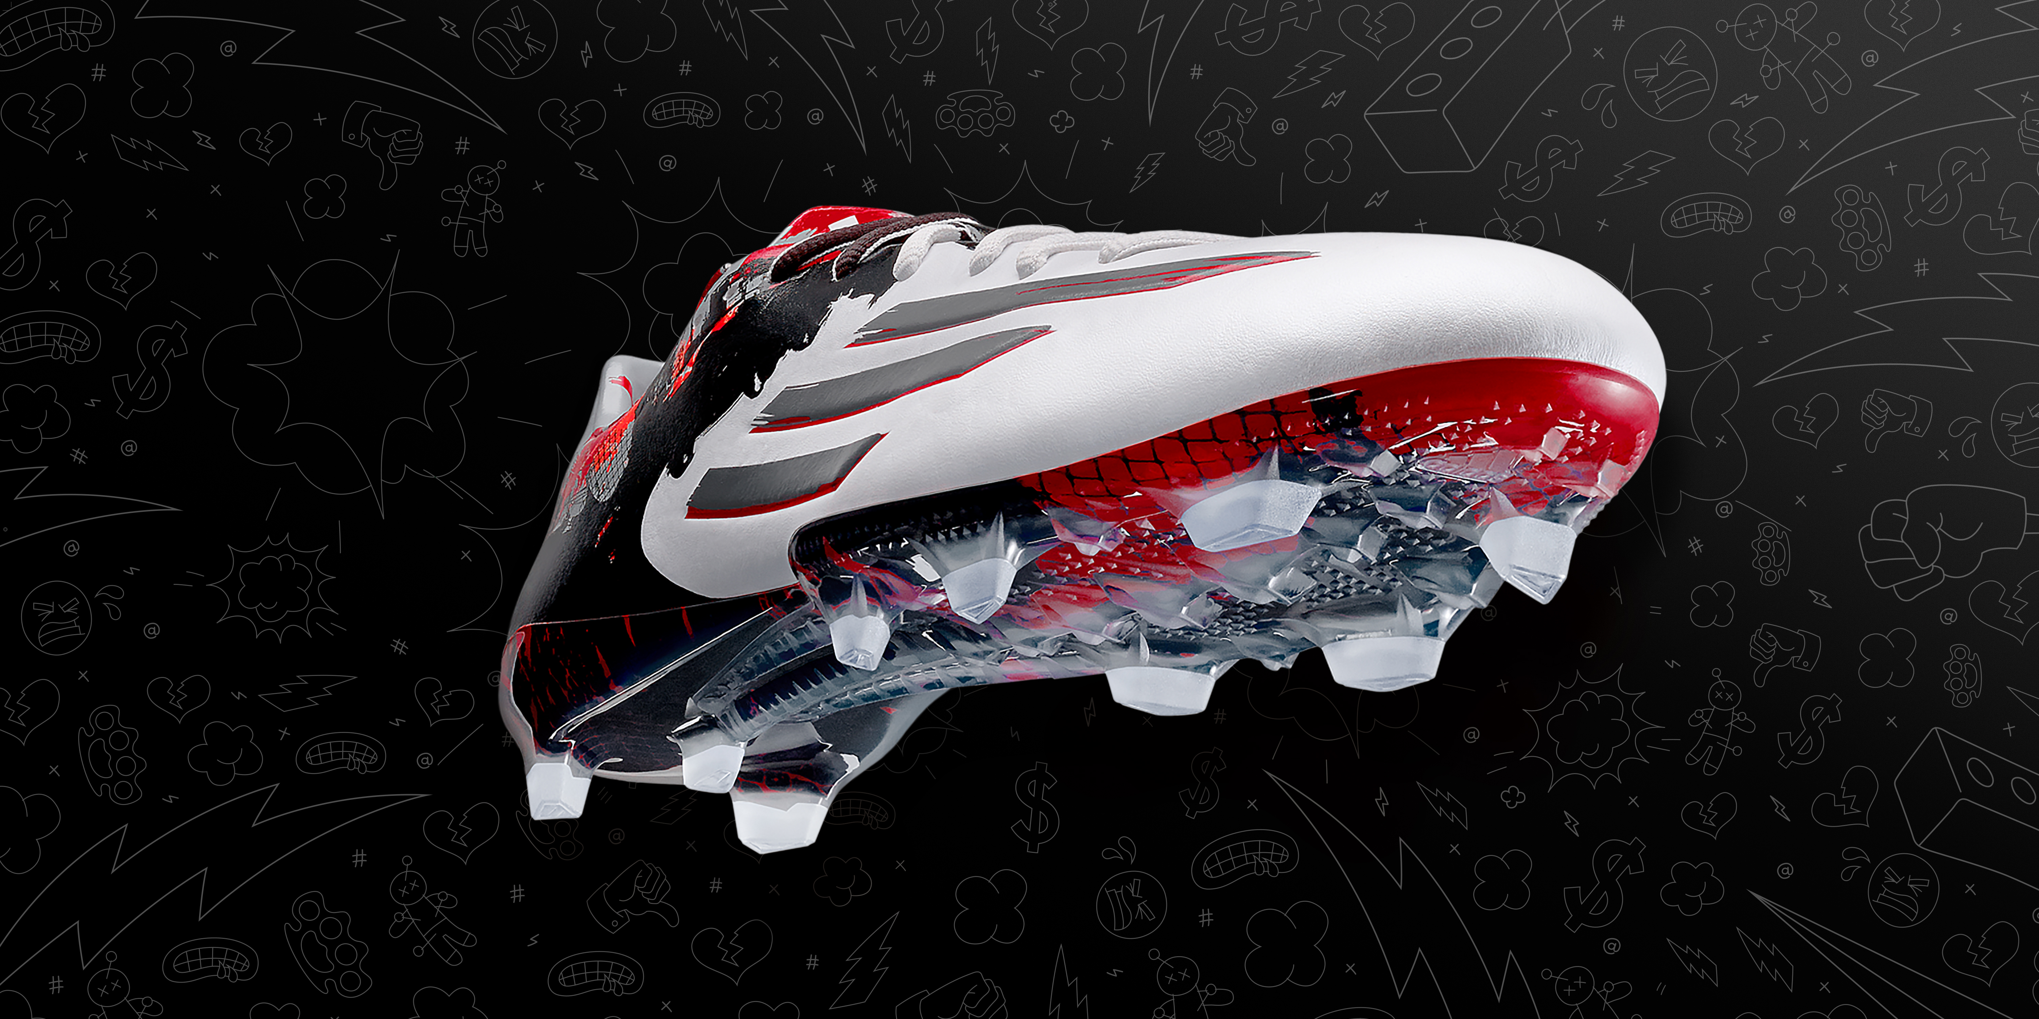
The new adidas Messi Pibe de Barr10

Las Heras was where Leo Messi first began his journey to becoming the greatest player on earth. The streets and pitches of the Barrio are where he first shaped his game. The new Pibe de Barr10 were designed in collaboration with Rosario-born graphic artist Ignacio Valenti in a style that pays tribute to Messi’s childhood. Fusing urban-inspired raw brush strokes with polished sleekness on the synthetic hybrid touch upper, the Pibe de Barr10 embodies Leo Messi’s footballing style; beautiful, yet dangerous.

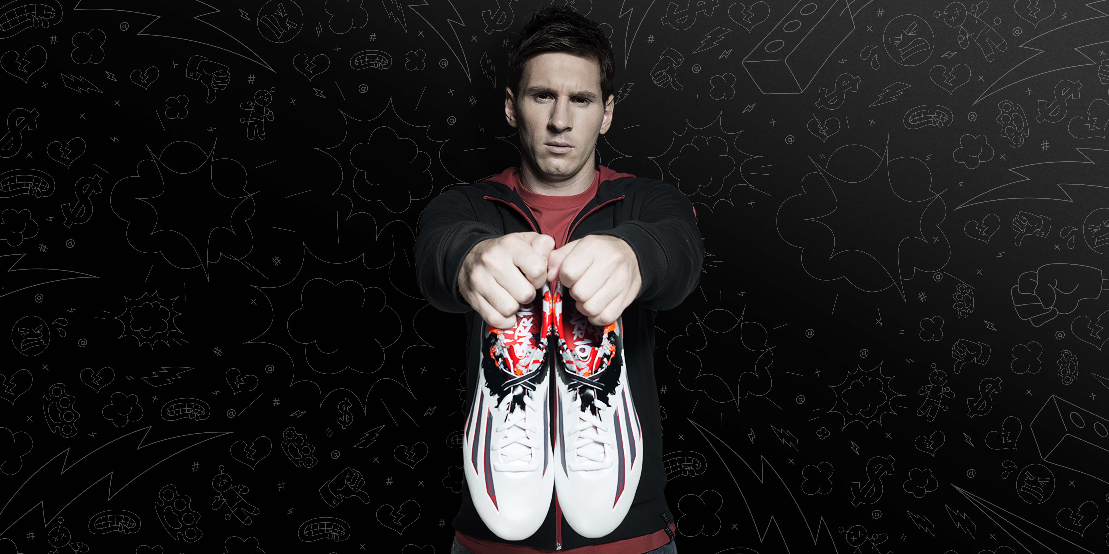
The new adidas Messi Pibe de Barr10

Speaking about his new signature boots, Leo Messi said: “I did leave Rosario when I was young, but I still have my people, my neighborhood, and my favorite spots. Pibe de Barr10 have a lot to do with my life, my childhood and a lot to do with me.”

The boot has been created as part of the #therewillbehaters series that celebrates the “hate” at the heart of football. There were some that never believed Leo Messi would leave Rosario, but he has gone on to break records and win trophies. You don’t get to be the best in the world by listening to the doubters. Messi wears the Pibe de Barr10 and there’s nothing the haters can do to stop him.

The Pibe de Barr10 contain the latest product innovations demanded by the best in the world. The speed traxion stud alignment and outsole are modeled on sprinters’ spikes, to provide the speed and agility to dominate on the pitch. 360˚ DRIBBLETEX coating provides for unprecedented control. In wet or dry conditions, the ball will stick like glue.

Max Gassner, Product Manager at adidas said: “The lines on the shoe are based on an idea from a local artist from Rosario, where Leo Messi is from. This shoe is for the biggest player in the world, for the ultimate stage. If you want to get the best boot, for the biggest stage, for the best player, this is the one.”

The world’s best player Leo Messi will wear the new Pibe de Barr10 from Wednesday 18th March, with the boots available to purchase the following day. For further information please visit adidas.com/messi or go to facebook.com/TeamMessi or follow @TeamMessi #ThereWillBeHaters on twitter to join the conversation.

- END -

Note to Editors: Statistics contained within this release are correct at time of writing – please update the goal count following this weekend’s La Liga matches. Alternatively, an updated version of the press release will also be available from http://news.adidas.com/GLOBAL/Latest-News/FOOTBALL when the embargo lifts on Monday 16th March at 1000hrs CET.

For further media information please visit http://news.adidas.com/GLOBAL/PERFORMANCE/FOOTBALL or contact:

Gugu Ntuli  adidas South Africa  Public Relations Manager: Performance  Email: gugu.ntuli@adidas.com  Tel: +27 (21) 442 6200 | Siyavuya Madikane  Magna Carta Reputation Management Consultants  Account Manager  Email: Siyavuya@magna-carta.co.za  Tel: +27 (87) 099 1024
About adidas Football
adidas is the global leader in football. It is the official sponsor / official supplier partner of the most important football tournaments in the world, such as the FIFA World Cup™, the FIFA Confederations Cup, the UEFA Champions League, the UEFA Europa League and the UEFA European Championships. adidas also sponsors some of the world’s top clubs including Real Madrid, FC Bayern Munich, AC Milan, Flamengo and Chelsea. Some of the world’s best players also on the adidas roster are Leo Messi, Gareth Bale, Thomas Müller, Arjen Robben, James Rodriguez, Karim Benzema and Bastian Schweinsteiger.

