EMBARGOED UNTIL 1000HRS CET, FRIDAY 21ST NOVEMBER

adidas DEFINES ELEGANCE WITH THE NEW 11PRO

New boot is the ultimate in class and sophistication

Herzogenaurach, 21st November 2014 – Today adidas revealed a new version of its 11Pro boot, which is set to offer the most comfortable and premium fit to date. The all-new design and colour blocking ensures that the 11Pro is the classiest boot on the football field and the “perfect suit” in terms of elegance and style.

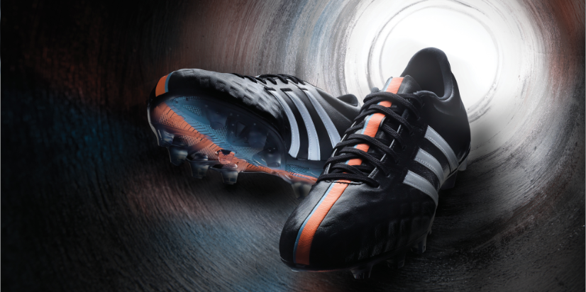
The all-new adidas 11Pro
The Predator Instinct Hunt
The Predator Instinct Hunt
The 11Pro has been re-engineered from heel to toe allowing for increased stability and protection. A new skeleton in the heel and forefoot allows for the perfect fit, as well as increased stability. The all new comfort outsole also features a comfort frame which distributes pressure across the shoe, while new smaller studs provide perfect ground penetration. The leather upper provides an ultra-comfortable fit as well as optimum control.

As well as providing unparalleled comfort and support, the boot comes with a new premium and modern look. The classic black and white design gives the boots a timeless appeal and puts them at the forefront of style in the beautiful game.

To accompany the launch of the new 11Pro, adidas has also launched an updated Nitrocharge - the chosen weapon for box to box players, with the latest version adding even more protection for the players at the heart of the action. A new energy-sling positioning has been used alongside an increased area of protection pads and protection mesh to provide unrivalled stability.

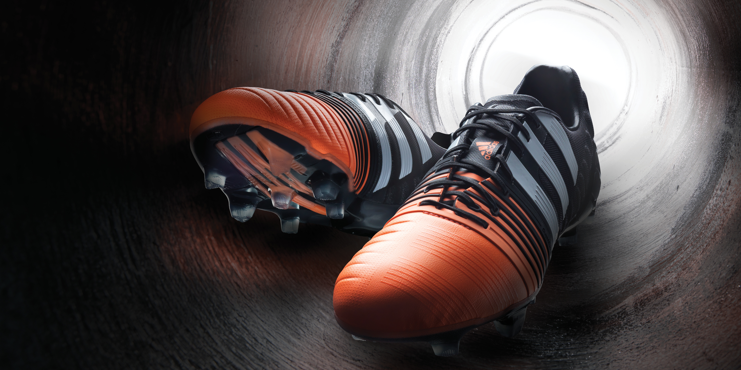
adidas Nitrocharge 1.0

Both boots are stamped with the UEFA Champions League logo inside, a mark that these boots are designed to deliver on the biggest of all stages.

The all-new adidas 11Pro & adidas Nitrocharge 1.0 is available to buy at www.adidas.com/football from Monday 1st December. For further information please visit adidas.com/football or go to facebook.com/adidasfootball or @adidasfootball on twitter to join the conversation.
- END -

For further media information please visit http://news.adidas.com/GLOBAL/PERFORMANCE/FOOTBALL or contact:

For further information please contact:

Robert Hughes  adidas Global Football PR Director  Email: robert.hughes@adidas.com  Tel: +49/9132/84-6856 | Alan McGarrie  adidas Senior Global Football PR Manager  Email: alan.mcgarrie@adidas.com  Tel: +49/9132/84-4686

Notes to editors:
About adidas Football
adidas is the global leader in football. It is the official sponsor / official supplier partner of the most important football tournaments in the world, such as the FIFA World Cup™, the FIFA Confederations Cup, the UEFA Champions League, the UEFA Europa League and the UEFA European Championships. adidas also sponsors some of the world’s top clubs including Real Madrid, FC Bayern Munich, AC Milan, Flamengo and Chelsea. Some of the world’s best players also on the adidas roster are Leo Messi, Gareth Bale, Thomas Müller, Arjen Robben, James Rodriguez, Karim Benzema and Bastian Schweinsteiger.

