EMBARGOED UNTIL TUESDAY 26th AUGUST 1400HRS CET
adidas launch new Real Madrid C.F. 3rd kit
Kit designed by Yohji Yamamoto to be worn by defending European Champions
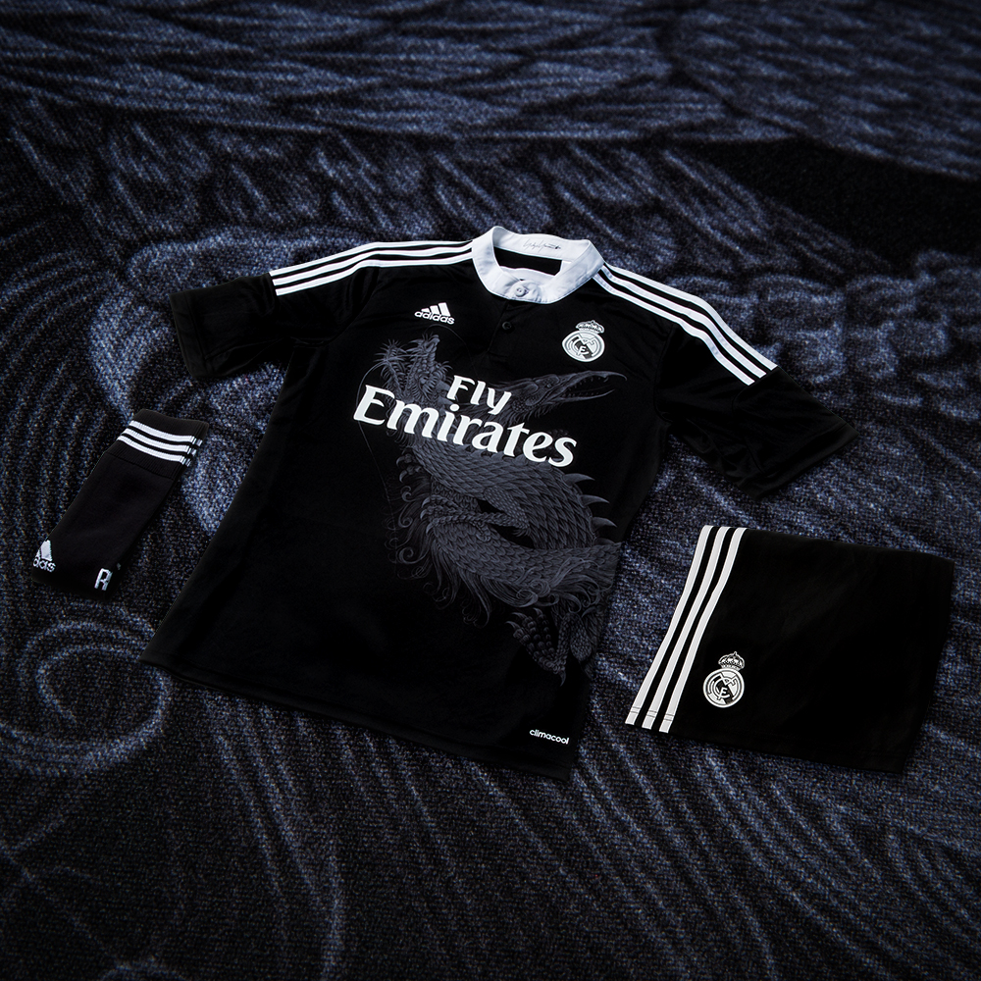
26th August 2014 – Herzogenaurach / Madrid – Real Madrid and adidas today launched the new kit the club will wear in this season’s UEFA Champions League. Stars including Gareth Bale, Marcelo, Benzema and new signings James Rodriguez and Toni Kroos will wear the all-black kit as Madrid attempt to become the first team ever to retain the UEFA Champions League.

The striking new kit has been designed by Japanese design revolutionary and long term adidas collaborator Yohji Yamamoto, bringing together a global design legend with one of the biggest football clubs in the world. The design collaboration aims to unify the values ​​of Madridismo focused on its two main elements, greatness and determination. Both elements are represented by two mythical beasts which originate from the Eastern culture and are interlaced on the front of the shirt.

- Dragon king symbolizes the greatness, glory and power of the club
- Dragon bird, an animal that is able to relive in the most hostile situations, represents the clubs resistance, determination and agility on its way to the victory

The kit is produced in black, Yamamoto’s favourite colour, with white details which contributes to a timeless and elegant look. Following the design of the home and away kit, the shirt is crowned by a mao type collar, a two-colour crest and the signature of the Japanese designer. Furthermore, the kit is equipped with the innovative adizero™ technology that ensures maximum performance for the players. The ultra-light fabric enhances breathability while allowing unparalleled freedom of movement and comfort without compromising elasticity and durability.

In addition to the adizero version of the kit worn by the players on pitch, a special edition collaboration will be available in very limited quantities. 1500 jerseys will be available on selected retailers worldwide and will come in an exclusive packaging (1200 PCS in handmade commemorative box and 300 PCS with an exclusive dragon egg packaging). The exclusive jerseys themselves bear the Yohji Yamamoto’s personal signature and the number 3 representing the iconic three stripes of adidas.

Also released today is the latest limited edition Yohji Yamamoto adizero f50 boot. Following the success of last year’s launch of the Yamamoto adizero f50 boot which drew inspiration from Japanese imperial lion-dogs, the new boots come in a striking blue and green colourway. The traditional design has been placed in the context of Japan's modern sci-fi culture creating a spiritual connection between the past and the future.

The Yohji Yamamoto designed Real Madrid third kit will be worn by the team on pitch in the new Uefa Champions League season and is available in stores from today, Tuesday August 26th.

Join the adidas football conversation at www.facebook.com/adidasfootball or on Twitter: @adidasfootball
***
- END -

For further media information please visit http://news.adidas.com/GLOBAL/PERFORMANCE/FOOTBALL or contact:

Robert Hughes  adidas Senior Global Football PR Manager  Email: robert.hughes@adidas.com  Tel: +49/9132/84-6856 | Alan McGarrie  adidas Global Football PR Manager  Email: alan.mcgarrie@adidas.com  Tel: +49/9132/84-4686
About adidas Football
adidas is the global leader in football. It is the official sponsor / official supplier partner of the most important football tournaments in the world, such as the FIFA World Cup™, the FIFA Confederations Cup, the UEFA Champions League, the UEFA Europa League and the UEFA European Championships. adidas also sponsors some of the world’s top clubs including Real Madrid, FC Bayern Munich, AC Milan, Flamengo and Chelsea. Some of the world’s best players also on the adidas roster are Leo Messi, Gareth Bale, Thomas Müller, Arjen Robben, James Rodriguez, Dani Alves, Karim Benzema and Bastian Schweinsteiger.

About Yohji Yamamoto
Since establishment of Y’s Company Ltd. in 1972, Yohji Yamamoto continues to spread his revolutionary, ever-widening sphere of influence in mode, driven by his rebellious spirit.
Ever since the first Paris collection of his brand YOHJI YAMAMOTO in 1981, each collection is greeted by the world with great uproar and applause.
***

