EMBARGOED UNTIL 1000HRS CET, FRIDAY 8th AUGUST

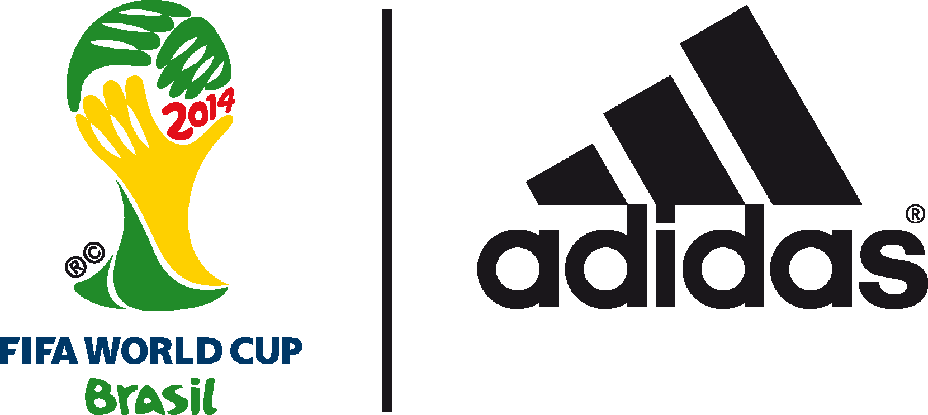

James Rodríguez PRESENTED
WITH adidas GOLDEN BOOT AWARD

Colombian star rewarded for top-scoring performance at
2014 FIFA World Cup Brazil™

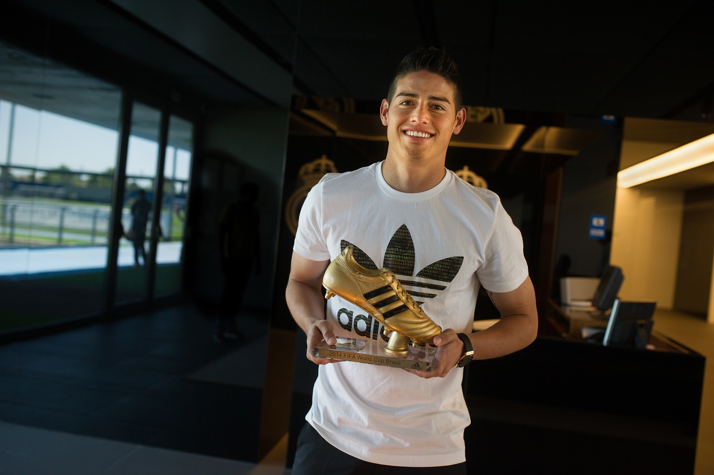

Herzogenaurach / Bogotá / Madrid, 8th August 2014 – adidas and FIFA officially handed over the adidas Golden Boot Trophy to Colombia’s James Rodríguez today during a short presentation in Madrid.

The prestigious adidas Golden Boot Trophy recognises the top goal scorer of the 2014 FIFA World Cup Brazil™. 23-year-old Rodríguez ended the tournament with six goals, scoring in all of his five games, including a penalty kick in Colombia's 2-1 quarter-final defeat by Brazil and a stunning volley against Uruguay in the round of 16.

Recognised as a huge talent leading into the competition, the gifted Rodríguez proved his ability to perform under pressure, and his record number of goals was a contributing factor to why Los Cafeteros broke new ground in reaching the last eight for the first time.

With his six goals, James finished the tournament as the clear top goal scorer, putting Germany’s Thomas Müller (five), and Brazil’s Neymar (four) in to second and third spots respectively. Leo Messi and Robin van Persie also finished the tournament on four goals (the same number as Neymar) but the Brazilian’s fewer minutes played on pitch combined with his greater number of assists confirmed Neymar’s third place finish in the scoring charts.

For the 2014 FIFA World Cup Brazil™, the adidas Golden Boot Trophy took the form of the best-selling boot in football history - the iconic adidas Copa Mundial - worn by some of the all-time greats including Franz Beckenbauer, Zico & Karl-Heinz Rummenigge. Since the Copa Mundial was created it has been sold over 10 million times and was in fact the last revolutionary product innovation created by sporting goods legend and founder of the adidas brand Adi Dassler. He had been personally involved in the early development of the original Copa Mundial before he passed away in 1978.

Speaking upon receiving the adidas Golden Boot Trophy, James Rodríguez said: “I am delighted to accept this award on behalf of my family and my international team mates who have been there for me every step of the way. The tournament in Brazil was an unbelievable experience for me personally, but also for Colombia as a nation as the team reached heights we have never reached before. To finish the tournament as top goal scorer is a great achievement and I look forward to many more successes with Colombia and with my new club, Real Madrid.”

Rodríguez’s Golden Boot Trophy completes a clean sweep of adidas trophies at the 2014 FIFA World Cup Brazil™; with winners Germany emerging victorious against fellow adidas federation Argentina, and Leo Messi and Manuel Neuer winning the adidas Golden Ball and adidas Golden Glove for best overall performance and best goalkeeping performance respectively.

In addition to the handover of the adidas Golden Boot Trophy, and to further commemorate this award, adidas has also produced a very limited edition piece of footwear in the form of a specially designed pair of golden miadidas adizero f50s for James Rodríguez. miadidas.com is the customisation section of the adidas website where consumers can create their own customised style of footwear based on their individual tastes. There are only six pairs of the miadidas golden boots in existence, one for each goal scored by Rodríguez during the tournament, and the boots include a special customisation on the side reading “top goalscorer of the FIFA World Cup™”. The adidas adizero f50, as worn by players such as James Rodríguez, Leo Messi & Arjen Robben was the highest goal scoring boot of the 2014 FIFA World Cup Brazil™. The first pair of limited edition miadidas boots will be given away today via a special activation on James Rodríguez’s personal Twitter account (@jamesdrodriguez) and via @adidasfootball.

Fans of James Rodríguez can win his special golden miadidas adizero f50 boots by following @adidasfootball on Twitter #allin. Fans can also create, buy & share their own golden adidas adizero f50 designs by visiting www.miadidas.com.

- END -

For further media information please visit http://news.adidas.com/GLOBAL/PERFORMANCE/FOOTBALL or contact:

Robert Hughes  adidas Senior Global Football PR Manager  Email: robert.hughes@adidas.com  Tel: +49/9132/84-6856 | Alan McGarrie  adidas Global Football PR Manager  Email: alan.mcgarrie@adidas.com  Tel: +49/9132/84-4686
Notes to editors:
About adidas Football
adidas is the global leader in football. It is the official sponsor / official supplier partner of the most important football tournaments in the world, such as the FIFA World Cup™, the FIFA Confederations Cup, the UEFA Champions League, the UEFA Europa League and the UEFA European Championships. adidas also sponsors some of the world’s top clubs including Real Madrid, FC Bayern Munich, AC Milan, Flamengo and Chelsea. Some of the world’s best players also on the adidas roster are Leo Messi, Gareth Bale, Thomas Müller, Arjen Robben, James Rodriguez, Dani Alves, Karim Benzema and Bastian Schweinsteiger.

About adidas Football / The FIFA World Cup™
The FIFA World Cup™ is the world’s largest football event and the ultimate platform for the adidas state-of-the-art apparel, hardware and footwear. adidas has made every FIFA World Cup™ ball since 1970, and recently extended the partnership with FIFA until 2030, including the supply of the official match ball.

