Built for Champions

adidas unveils new Bayern Munich 2014/2015 third kit

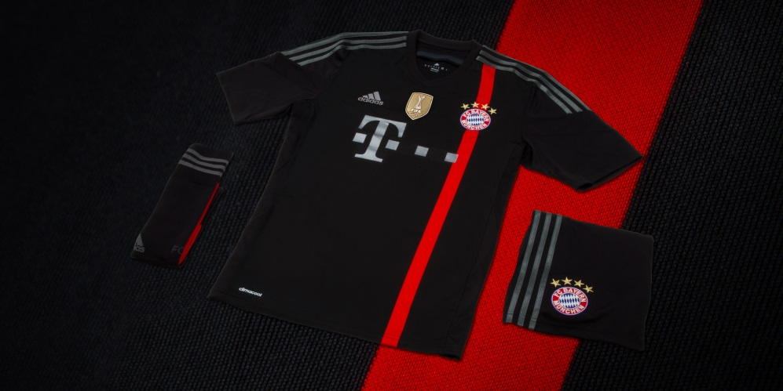

Munich, August 8th, 2014 – adidas and Bayern Munich are excited to announce the launch of the new official third jersey for the 2014/2015 season, a kit that seeks both to celebrate the club´s extraordinary legacy in the UEFA Champions League and also its unique team spirit.

Bayern Munich´s record in the world´s most important club competition speaks for itself and the club´s unique team spirit has always been a decisive factor when taking on the challenge of playing top European football.

This year they will aim to add more golden moments to their already celebrated history and they will be doing so sporting the latest adidas designed third kit, an impactful combination of black and red that will have Bayern Munich shining throughout European pitches on and off the pitch.

The mostly black jersey boasts a printed front panel fabric featuring a single vertical red stripe that goes through the club´s crest. The red band is further present on the socks and shorts of the kit, which are black and feature an additional three iron grey vertical stripes.
The adidas iconic three stripes that shape the sleeves of the shirt are in a striking iron grey. For the first time, a matching goalkeeper outfit will also be available. The red goalie jersey with the single vertical black stripe is the exact colour counterpart.

Availability
Bayern Munich’s third kit will be launched tomorrow during the club´s official presentation at the Allianz Arena. It´s available for purchase starting today in select adidas retail outlets, associated stockists, the Bayern Munich Online-Shop (www.fcbayern.de/shop) and via www.adidas.com/football. Join the adidas football conversation at www.facebook.com/adidasfootball or on Twitter: @adidasfootball.

For further information please contact:
Robert Hughes  adidas Senior Global Football PR Manager  Email: robert.hughes@adidas.com  Tel: +49/9132/84-6856 | Alan McGarrie  adidas Global Football PR Manager  Email: alan.mcgarrie@adidas.com  Tel: +49/9132/84-4686

Notes to editors:
About adidas Football
adidas is the global leader in football. It is the official sponsor / official supplier partner of the most important football tournaments in the world, such as the FIFA World Cup™, the FIFA Confederations Cup, the UEFA Champions League, the UEFA Europa League and the UEFA European Championships. adidas also sponsors some of the world’s top clubs including Real Madrid, FC Bayern Munich, AC Milan, Flamengo and Chelsea. Some of the world’s best players also on the adidas roster are Leo Messi, Gareth Bale, Mesut Özil, James Rodriguez, Dani Alves, Oscar, Xavi, Karim Benzema and Bastian Schweinsteiger.

