D Rose 5 Boost
THE FACTS
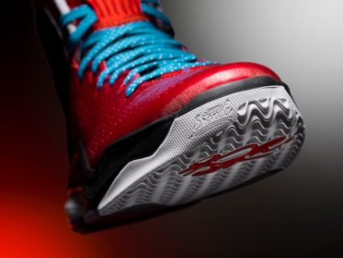
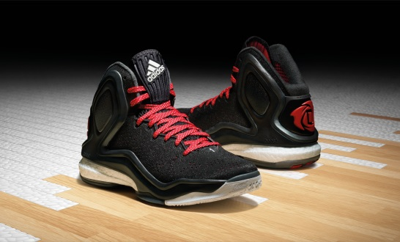
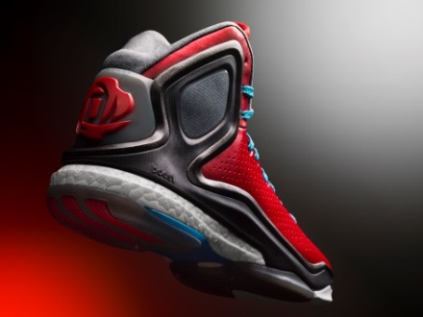

FULL LENGTH BOOST TECHNOLOGY | The D Rose 5 Boost is an all-new basketball shoe in the D Rose signature collection that brings game-changing energy return innovation to the court.  For the first time ever, full length Boost cushioning is featured in a basketball shoe to ensure maximum performance.  Boost cushioning helps players through the fourth quarter with an ideal combination of energy return, responsiveness and comfort.
REVOLUTIONARY CUSHIONING | Boost features an industry-first cushioning technology unlike any other foam in basketball.  Thousands of capsules make up Boost, providing soft, lightweight cushioning that helps store and release energy efficiently.  First introduced in running shoes in 2013, Boost has since been recognized as the best cushioning in the industry. The Boost innovation outperformed more than 800 shoes tested by Runner’s World before making its way to the court.
SIGNATURE DETAILS | Signature details are woven throughout the design reveal details about Derrick, his family and his path to success.  The ankle support features unique personal inscriptions including:  - “R.A.D.” – stands for his brothers, Reggie, Allen and Dwayne, who helped raise Derrick, giving him the opportunity to play basketball undeterred  - “Not supposed to be here” – quote Derrick gave at a press conference for the launch of the D Rose 3 where he spoke on how he defied the odds to be a successful NBA player  - “No Freshman” – represents the rule at his high school where freshman weren’t allowed to play on the varsity basketball team  - “Everybody Eats” – his desire to uplift those in his circle and from his neighborhood of Englewood  - “1.7%” – the odds that the Chicago Bulls had to land the first overall pick in the 2008 NBA Draft, which they used to select Derrick  Personal details of the D Rose 5 Boost continue with the toe of each shoe featuring the name of his mother, Brenda, and his son, PJ.  A bigger and bolder D Rose logo on the heel represents his family and style of play.  Derrick’s signature is woven into the traction pattern of the forefoot of the outsole.  Future colorways will feature additional details and unique SPRINTWEB upper finishes for updated style.
SUPERIOR PERFORMANCE ELEMENTS | An all-new EVA fit-cage provides strength and support for an ideal fit.  SPRINTWEB upper delivers enhanced light-weight support and breathability.  Interior mesh ankle pockets offer air flow and increased comfort.  Traction zones on the outsole include a wave pattern on the forefoot and a square pattern on the heel and midfoot to ensure ideal court feel.  Separated forefoot and heel outsole to maximize Boost feel.  Enlarged TPU plate aids arch support.
AVAILABILITY | The D Rose 5 Boost drops Oct. 16 on adidas.com and other leading retailers.
MORE INFO | For more information, visit news.adidas.com, adidas Basketball Facebook page, www.adidasbasketball.com or follow us on Twitter and Instagram @adidasHoops with #DRose5 #Boost.  Paul Jackiewicz, adidas PR  (o) 971-234-2357  (m) 503-593-5316  Paul.Jackiewicz@adidas.com
MEDIA USAGE GUIDES | adidas lowercase adidas in all references  adidas Basketball capitalize Basketball when in reference to adidas Basketball  D Rose 5 capitalize the D and R in all references  Boost capitalize the “B” in all references  SPRINTWEB capitalize in all references

###

