Crazylight Boost
THE FACTS
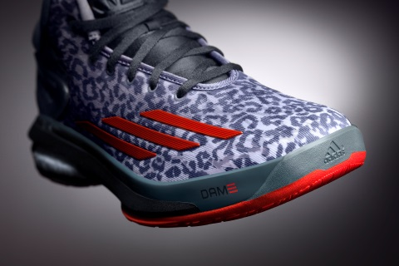
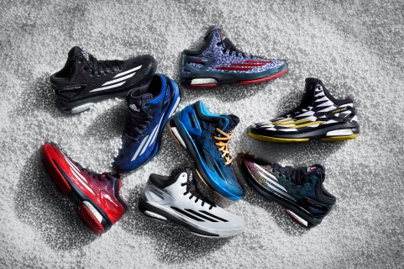
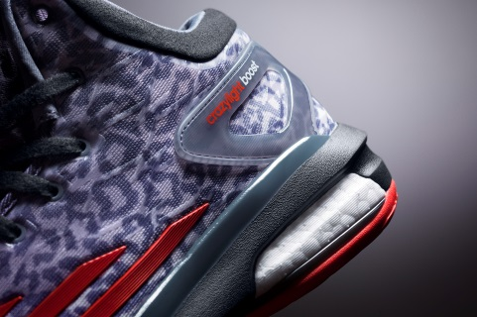

BOOST TECHNOLOGY | Crazylight Boost is an all-new basketball shoe that brings a game-changing energy return innovation to the court for the first time.  Boost cushioning helps players through the fourth quarter with an ideal combination of energy return, responsiveness and comfort.  Damian Lillard of the Portland Trail Blazers, Joakim Noah of the Chicago Bulls, Jrue Holiday of the New Orleans Pelicans, Mike Conley of the Memphis Grizzlies and Jeff Teague of the Atlanta Hawks will debut the Crazylight Boost this season.
REVOLUTIONARY CUSHIONING | Boost features an industry-first cushioning technology unlike any other foam in basketball.  Thousands of capsules make up Boost, providing soft, lightweight cushioning that helps store and release energy efficiently.  First introduced in running shoes in 2013, Boost has since been recognized as the best cushioning in the industry and outperformed more than 800 shoes tested by Runner’s World before making its way to the court.
EXCEPTIONALLY LIGHT | Staying true to the Crazylight franchise, the Boost model remains exceptionally light at 11.6 ounces, helping make athletes faster and more comfortable than opponents.
NBA-ATHLETE  TESTED | Built and engineered specifically for basketball, the Crazylight Boost underwent extensive research and collaboration between adidas design and innovation teams.  For over a year, the best athletes in the world including top NCAA and NBA players, such as Patrick Beverley, Arron Afflalo and Ben McLemore, tested this footwear in a series of high performance drills and tests.  All athletes gave universally positive feedback, consistently preferring Boost over EVA cushioning during testing.
UPPER, MIDSOLE, AND OUTSOLE CONSTRUCTION | Every element of the Crazylight Boost is constructed to maximize the energy benefit of Boost.  - ShockWeb overlay adds strength and support while increasing depth and premium style  - Soft mesh upper for increased comfort and breathability  - All-new collar design features a unique cut offering the mobility of a low-top and stability of a mid  - Tongue combines GEOFIT padding and TECHFIT four-way stretch mesh for added comfort and improved fit  - StableFrame midsole offers support and smooth transition throughout the midfoot for comfort  - ShockWeb outsole provides optimal traction, prime for quick cuts and lateral movement  - Torsion System delivers balance to the outsole and provides Boost cushioning a strong platform for reaction and response
DESIGN AND STYLE | Crazylight Boost features three stripes horizontally placed across the toe, creating a sleek, fast aesthetic.  The Crazylight Boost will be available in a variety of team and special colorways, including player editions for Lillard and Timberwolves point guard Ricky Rubio.
AVAILABILITY | The Crazylight Boost ($140) will be available September 1 at adidas.com.
MORE INFO | For more information, visit news.adidas.com, adidas Basketball Facebook page, www.adidasbasketball.com or follow us on Twitter and Instagram @adidasHoops with #Boost.  Madeline Breskin, adidas PR  (o) 971-234-2220  (m) 971-295-6936  Madeline.Breskin@adidas.com

###

