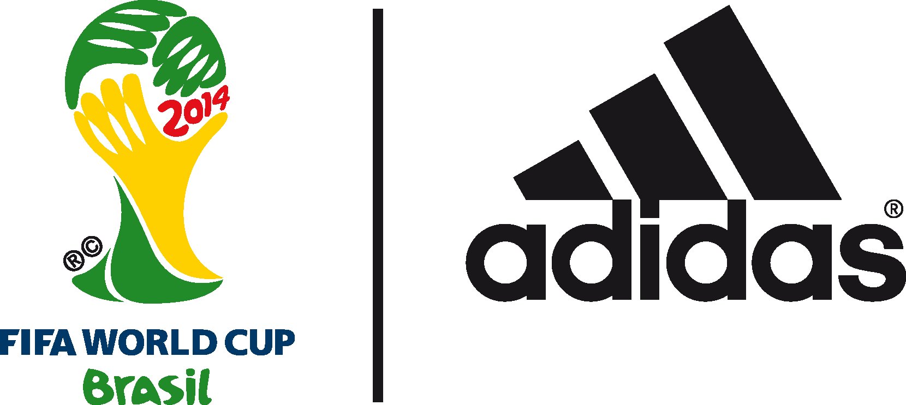

adidas finale film sets scene for 2014 FIFA World Cup BrazilTM Final

‘Forever or Never’ epic film features Leo Messi and Thomas Müller ahead of showdown at Maracana

11th July 2014 –Rio de Janeiro –adidas has today unveiled its landmark ‘Forever or Never’ film featuring Germany and Argentina ahead of the 2014 FIFA World Cup Brazil Final in Rio. The highly stylized and momentous film marks the climax to the adidas ‘allin or nothing’ brand campaign for the 2014 FIFA World Cup.
To watch the film go to http://youtu.be/nnL_8H22NuA

Filmed in black and white to articulate the allin or nothing choice players have to make, the film has been created using a long uncut tracking shot with the camera moving forward into the images. The finale film story includes key moments from the tournament and the finalists, and focuses on two adidas stars of the tournament, Leo Messi and Thomas Müller.

With an epic mantra, the scene will be set for the most important match of them all.

One billion eyes watching.
the mother of all cups.
Two teams. one trophy.
give everything. regret nothing.
find something to die for.
and live for it. hunt. or be hunted.

grab your fourth star
or be the greatest of all time

Go down in history. or go home.
They will scream your name. one way or another.
Rule . Or be ruled
This is your day!
the nation is with you.
behead kings. or bow.
Forever or never.
who wants it more?

all in or nothing.

Tom Ramsden, adidas Global football, said “This World Cup has been a real success story for adidas and it is fantastic to have two teams, Argentina and Germany, in the World Cup Final. This film is the trailer to the ultimate stage in football; reinforcing that at the World Cup Final it truly is all in or nothing"

The end slate of the film also gives fans the opportunity to win a Brazuca Finale that was used as an official match ball in the final, giving fans a chance to own a piece of history.

The film marks the end of an incredibly successful tournament for adidas, the world’s leading football brand. As well as two adidas teams reaching the FIFA World Cup Final for the first time since 1990, adidas is the most talked about brand at the World Cup 2014 across all major social media channels with increase of 4,865,502* followers across all platforms, more than any other sports brand. adidas also boasts the highest scoring boot of the tournament (the adidas adizero f50) with 46 goals to date. It also has three of the top scorers in the tournament wearing the adidas adizero f50 boot (Rodriguez 6, Müller 5 and Messi 4).

Join the adidas football conversation at www.facebook.com/adidasfootball or on Twitter: @adidasfootball #allin or nothing or @brazuca.

***
- END -

For further media information please visit http://news.adidas.com/GLOBAL/PERFORMANCE/FOOTBALL or contact:

Robert Hughes  adidas Senior Global Football PR Manager  Email: robert.hughes@adidas.com  Tel: +49/9132/84-6856 | Alan McGarrie  adidas Global Football PR Manager  Email: alan.mcgarrie@adidas.com  Tel: +49/9132/84-4686
Notes to editors:
*stats taken from simply measured (20:30 09.07.2014)

About adidas Football
adidas is the global leader in football. It is the official sponsor / official supplier partner of the most important football tournaments in the world, such as the FIFA World Cup™, the FIFA Confederations Cup, the UEFA Champions League, the UEFA Europa League and the UEFA European Championships. adidas also sponsors some of the world’s top clubs including Real Madrid, FC Bayern Munich, AC Milan, Flamengo and Chelsea. Some of the world’s best players also on the adidas roster are Leo Messi, Gareth Bale, Thomas Müller, Arjen Robben, James Rodriguez, Dani Alves, Karim Benzema and Bastian Schweinsteiger.
.

***

