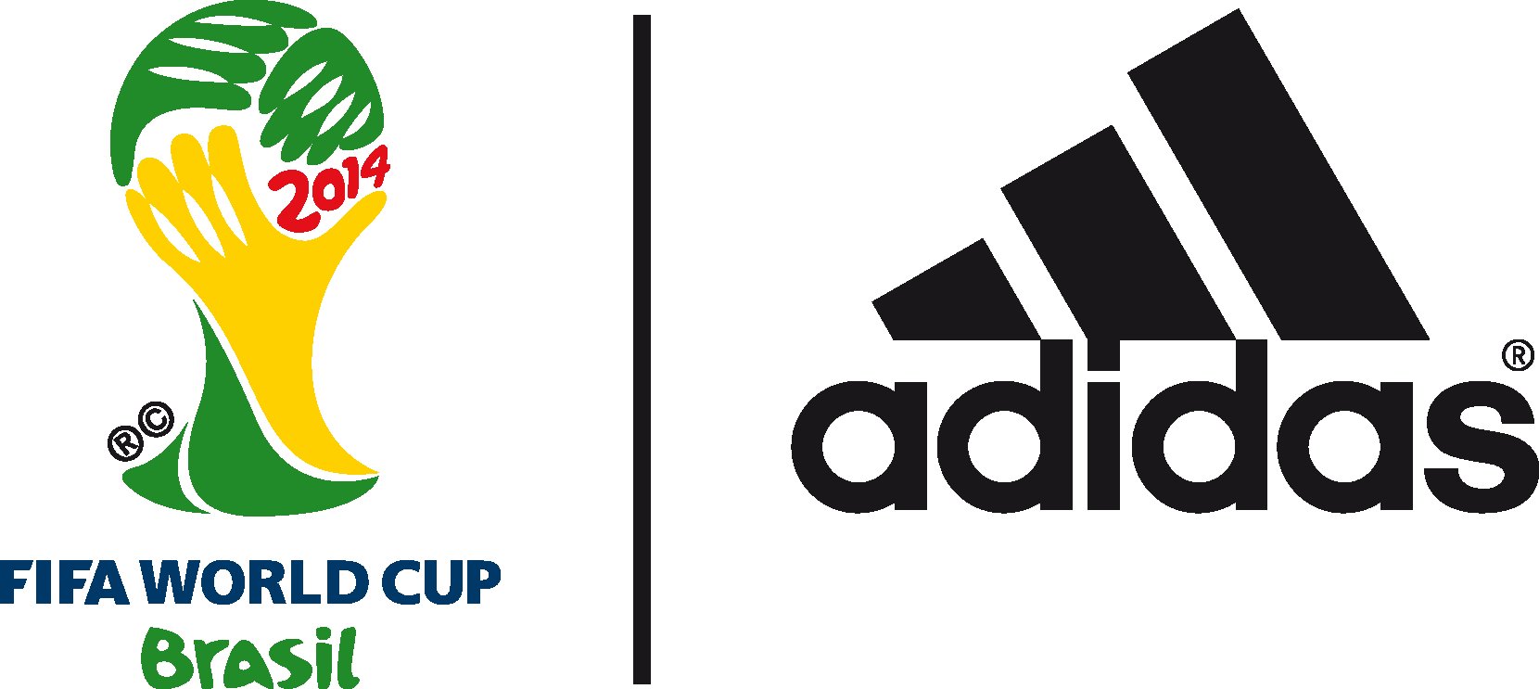

Standing tall in the adidas adizero f50

Leo Messi and Arjen Robben go head to head in the second semi-final of the 2014 FIFA World Cup Brazil™

9th July 2014 – Herzogenaurach / Rio de Janeiro – With the second spot for Sunday’s Final still to be decided, it’s a case of now or never for two of the top performing players of the 2014 FIFA World Cup Brazil™.

Today, both Leo Messi of Argentina and Arjen Robben of Holland will take to the pitch having both had tournaments to remember, powered by the adidas adizero f50. Between them they have collected an incredible six man of the match awards. They have also scored a combined total of seven goals from a total of 25 shots on target, while both players have had one assist each. While Robben has the edge when it comes to solo runs into the area - 17 to Messi’s seven, Messi is on top when it comes to deliveries into the area, with 22 compared to Robben’s 17.

The adizero f50 is the boot of choice for an incredible six of the tournament’s top nine goalscorers. This includes 2014 FIFA World Cup Brazil™ sensation and current adidas Golden Boot leader, James Rodriguez of Colombia with six goals, while both Leo Messi (four) and Arjen Robben (three) are also competing to be top goalscorer. Also in contention are Thomas Müller, Germany (four) and Robin van Persie, Netherlands (three).

Join the adidas football conversation at www.facebook.com/adidasfootball or on Twitter: @adidasfootball.

***
- END -

For further media information please visit http://news.adidas.com/GLOBAL/PERFORMANCE/FOOTBALL or contact:

Robert Hughes  adidas Senior Global Football PR Manager  Email: robert.hughes@adidas.com  Tel: +49/9132/84-6856 | Alan McGarrie  adidas Global Football PR Manager  Email: alan.mcgarrie@adidas.com  Tel: +49/9132/84-4686
Notes to editors:
About adidas Football
adidas is the global leader in football. It is the official sponsor / official supplier partner of the most important football tournaments in the world, such as the FIFA World Cup™, the FIFA Confederations Cup, the UEFA Champions League, the UEFA Europa League and the UEFA European Championships. adidas also sponsors some of the world’s top clubs including Real Madrid, FC Bayern Munich, AC Milan, Flamengo and Chelsea. Some of the world’s best players also on the adidas roster are Leo Messi, Gareth Bale, Mesut Özil, Dani Alves, Oscar, Xavi, Karim Benzema and Bastian Schweinsteiger.

***

