adidas Outdoor apparel news spring/summer ‘15

In spring/summer ’15, adidas Outdoor will relaunch terrex. Besides established key products, the terrex range will be completed with several new versatile and lightweight styles. They are made without compromise, with the finest materials and always with the purpose of supporting athletes. The new terrex range is made for athletes with unlimited imagination, who want to constantly redefine their limits and set new targets – no matter how they explore the outdoors: biking, climbing, running or flying.
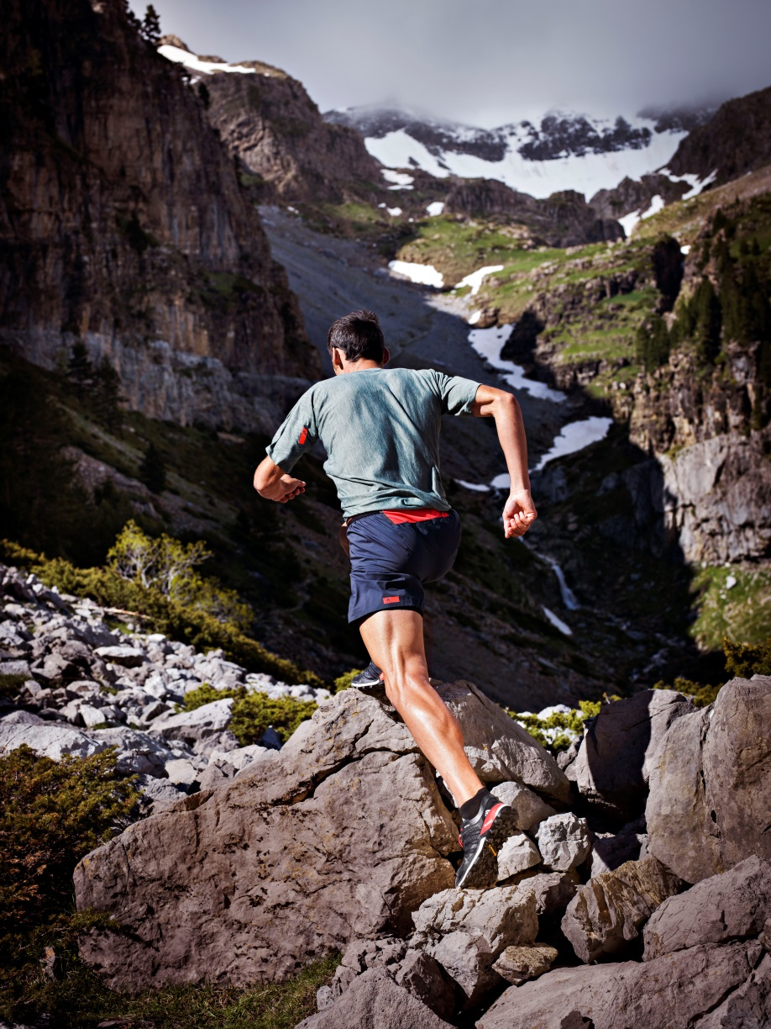

terrex Agravic Wind Jacket

A handful of jacket. It is super small and it is super light (100g). You don't even need a backpack to carry this jacket, it fits into every pocket. The terrex Agravic Wind Jacket is the ideal companion, whenever the weather turns bad or you just need some more protection. It is minimalistic, but still offers everything you need to be well protected from wind and light rain. And for those who also want to look good and hang around in this jacket, it offers a silky soft material feel and has a modern, athletic look.

Features & Benefits:

- Climastorm® provides protection in windy and light rain conditions
- Durable Water Repellency (DWR): sheds rain and snow, quick-drying
- Adjustable hood
- Zipped side pocket
- Elastic parts at the hem for optimum comfort

Colors men: solar red // light onix
Weight: 105g (size 50)

Colors women: solar red // light onix
Weight: 90 g (size 36)

Price: € 149.95 (RRP)

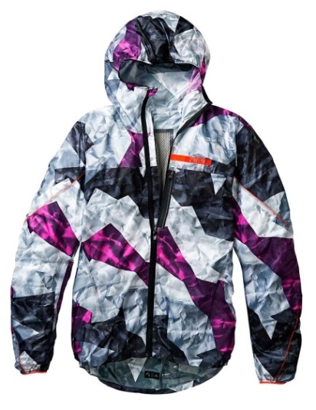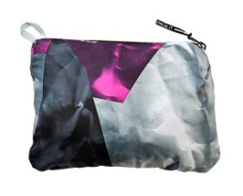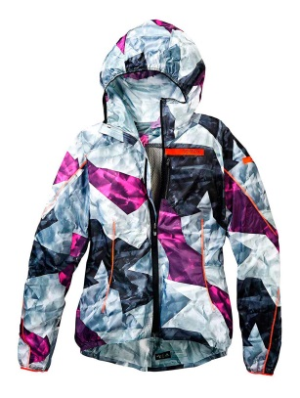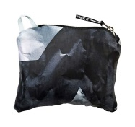

terrex Agravic Tee

Stronger together. Everybody who is active in the mountains is probably looking for a base layer with a nice skin feel that transports sweat away from the body and does not smell. The terrex Agravic Tee with a mix of 50% merino wool and 50% ThermoCool polyester offers exactly that. Furthermore, this lightweight Tee (120g) is made out of only one piece of fabric and has only two seams, which makes it very comfortable when wearing under a backpack.

Features & Benefits:

- Pontetorto® Merino Tecnowool: 50% merino wool / 50% ThermoCool hollow fiber polyester. Finest, softest base layer fabric that absorbs moisture without a clammy feeling and insulates the body even when wet
- Light, seam-reduced base layer shirt with excellent skin feel
- Only one piece of fabric and two seams
- No seams on the back piece and only 2 seams on the front

Colors men: base green // night flash // dark grey
Weight: 120g (size 50)

Colors women: solar red // light onix
Weight: 90 g (size 36)

Price: € 79.95 (RRP)

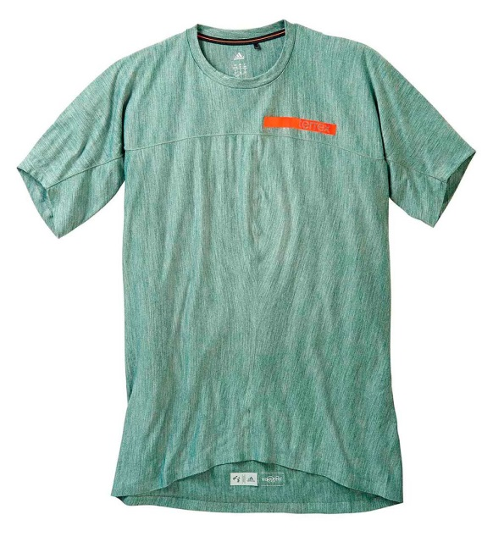
W terrex Agravic Top

The terrex Agravic Top is a light, reduced top for women. Thanks to the very light and soft 50% merino wool / 50% ThermoCool® polyester hollow fiber combination from Pontetorto® and its breathable mesh fabric at the back it is the perfect top for hot weather conditions in a neat female silhouette.

Features & Benefits:

- Pontetorto® Merino Tecnowool: 50% merino wool / 50% ThermoCool hollow fiber polyester. Finest, softest base layer fabric that absorbs moisture without a clammy feeling and insulates the body even when wet
- Bonded seams
- Back mesh lining for optimum comfort and breathability

Colors women: solar red // night flash
Weight: 45g (size 36)

Price: € 69.95 (RRP)

Available only in women’s style

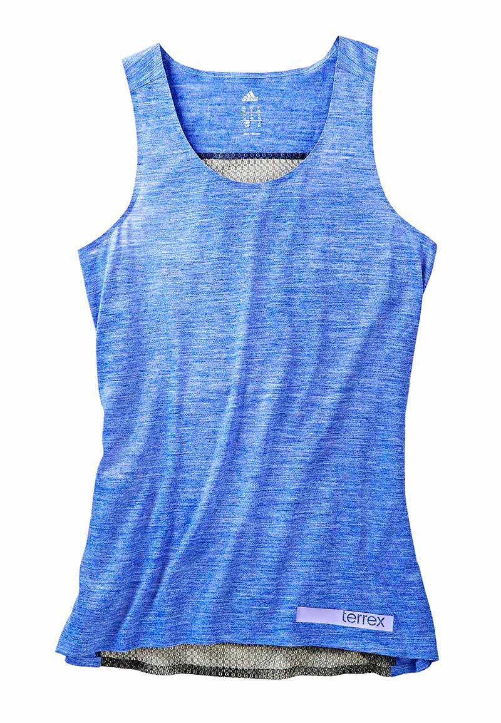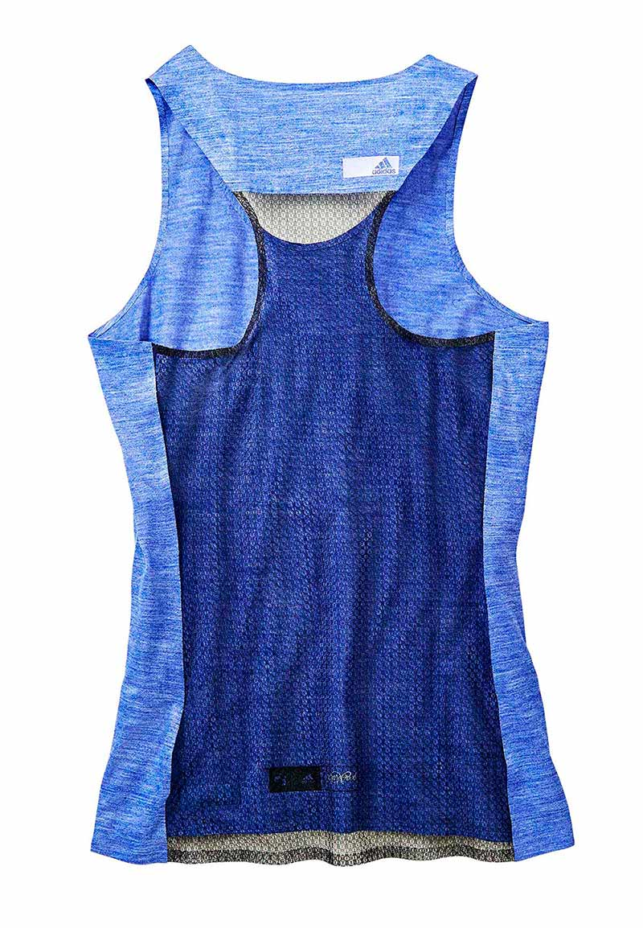
terrex Agravic Windlatz

Full front protection for the really fast ones. The innovative terrex Agravic Windlatz offers the possibility to put it on and off whilst wearing a backpack without having to stop. It can be packed into an integrated hip pocket and easily pulled out when wind and light rain protection through a Pertex® Microlight fabric is needed – a great companion for mountain runners and mountain bikers at only 49 grams.

Features & Benefits:

- Pertex® Microlight: lightweight material with good strength and abrasion resistance
- Open back piece in order to put it on and off easily whilst wearing a backpack
- Breathable mesh around the collar as well as lower back for optimum breathability and increased sweat reduction
- ½ zip for ventilation possibility

Color men and women: night flash
Weight: 49g (size 50)

Price: € 79.95 (RRP)

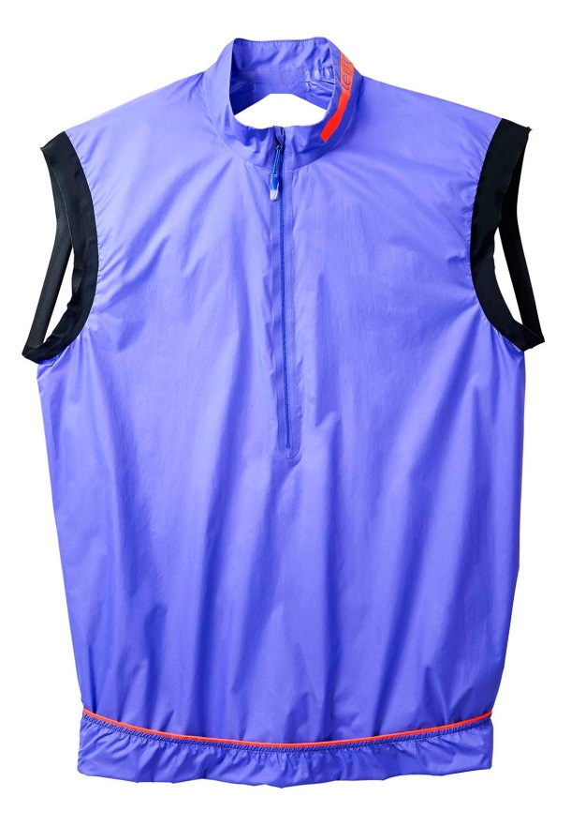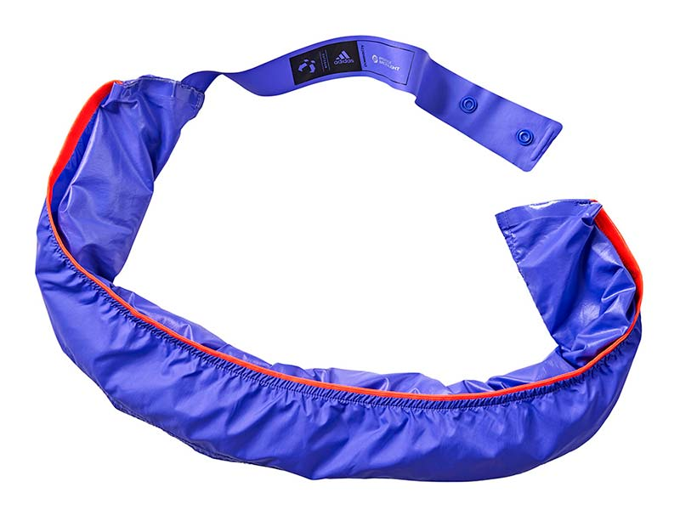
terrex Agravic Shield

Protective lightness for summer. You need some more protection than a shirt offers but at the same time you’re looking for very good ventilation? The terrex Agravic Shield combines the advantages of two materials: a very light and soft 50% merino wool / 50% ThermoCool polyester hollow fiber combination from Pontetorto® forms the base of this sleeveless ½ zip. At the front part, a Pertex® Equilibrium® overlay guarantees additional wind protection and excellent moisture management.

Features & Benefits:

- Pertex® Equilibrium®: overlayer for additional wind protection. Moisture is transported away from the skin to the outside of the fabric where it evaporates
- Pontetorto® Merino Tecnowool: 50% merino wool / 50% ThermoCool hollow fiber polyester. Finest, softest base layer fabric that absorbs moisture without a clammy feeling and insulates the body even when wet
- ½ zip for ventilation
- FORMOTION® cut: guarantees unrestricted freedom of movement and athletic fit at the same time
- Hybrid construction combining the advantages of different performance fabrics.

Colors men: black // dark grey // night flash
Weight: 122g (size 50)

Price: € 99.95 (RRP)

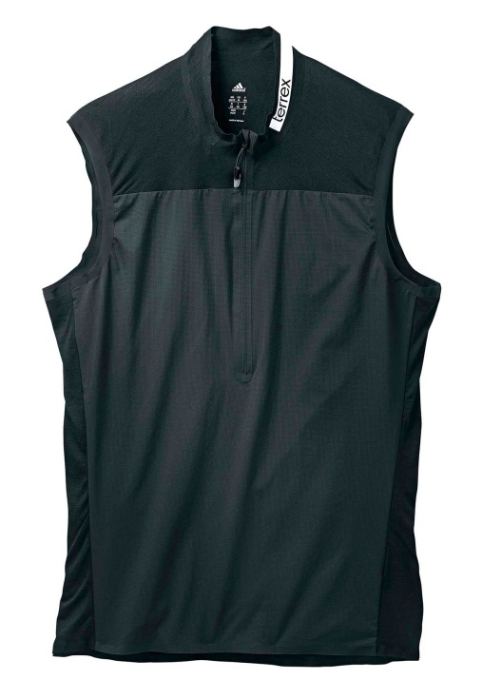
terrex Agravic Shorts

The terrex Agravic shorts are definitely a piece that you do not feel during effort because of their incredible lightness. The 4-way stretch material with Pertex® Equilibrium® is extremely durable and bonded seams limit rubbing on the skin. The back pocket offers enough space for gels and an integrated security pocket for your keys or smartphone. These shorts are a masterpiece of lightness and robustness in 65 grams and one of the favorite products of our athletes.

Features & Benefits:

- Pertex® Equilibrium®: overlayer for additional wind protection. Moisture is transported away from the skin to the outside of the fabric where it evaporates
- Elastic waistband
- Bonded seams
- Back pocket for gel
- Zip pocket for keys integrated into the back pocket
- FORMOTION® cut: guarantees unrestricted freedom of movement and athletic fit at the same time
- Durable Water Repellency (DWR): sheds rain and snow, quick-drying

Colors men: black // dark grey
Weight: 65 g (size 50)

Color women: black
Weight: 49 g (size 36)

Price: €79.95 (RRP)

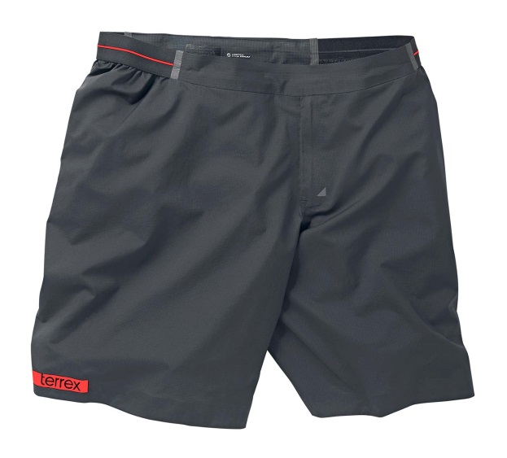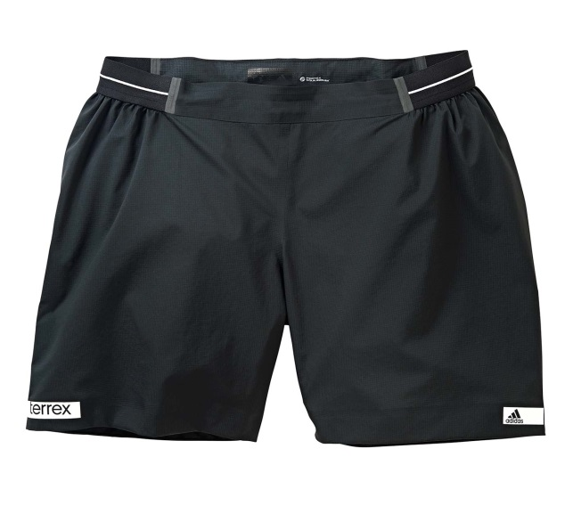
terrex Agravic 3-Layer Jacket

This is the perfect jacket for everyone who is looking for minimal pack size and maximal weather protection at the same time. With its extremely low weight (186g / size 50) and its practical pack-it pocket it is the perfect partner for every mountain sports activity. In action it offers everything you need to be fully protected: waterproof and durable 3-layer material, a fully adjustable hood and a security chest pocket. One of the favorite pieces of our athletes.

Features & Benefits:

- Climaproof®: water- and windproof material for use in extreme weather conditions; water column: 20,000mm
- Fully adjustable hood
- Elastic waist with drawcords for adjustability
- Pack-it pocket

Colors men: black // solar red
Weight: 186g (size 50)

Color women: flash pink
Weight: 159g (size 36)

Price: € 249.99 (RRP)

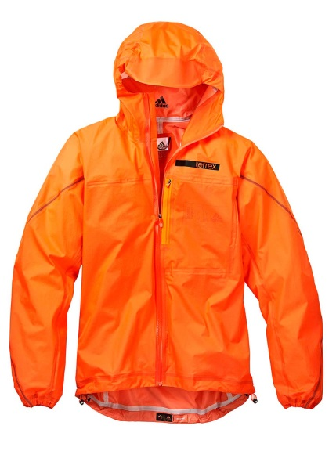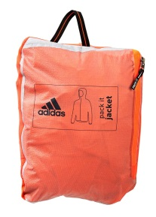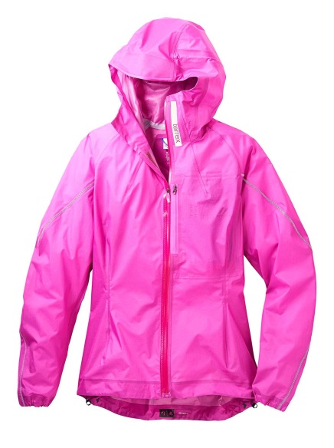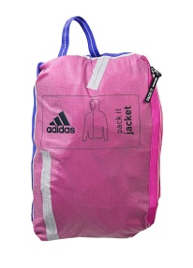

terrex Agravic 3-Layer Pants

The terrex Agravic 3 Layer Pants are extremely lightweight and waterproof mountain pants with great freedom of movement. Small and packable in the built-in pack-it pocket, they fit easily into every backpack. When the weather turns bad, they provide full rain and wind protection. Among their thought-through details are full-length zippers to ensure ease of entry and exit.

Features & Benefits:

- Climaproof®: water- and windproof material for use in extreme weather conditions; water column: 20,000mm
- Full-length zippers to ensure ease of entry and exit
- Pack-it pocket
- Hook-and-loop closure adjustable waist

Color men: black
Weight: 229g (size 50)

Color women: black
Weight: 198g (size 369

Price: € 179.95 (RRP)

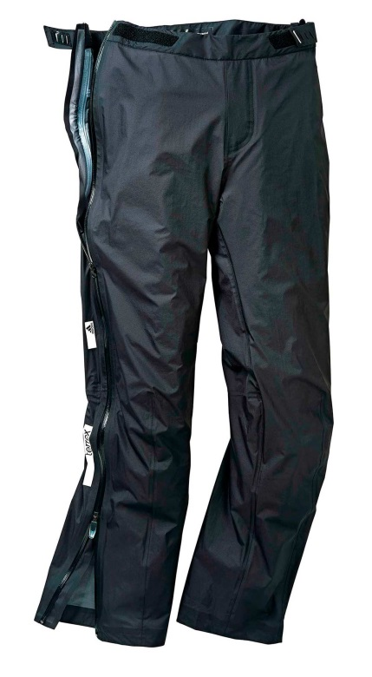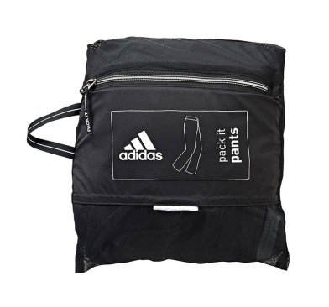

terrex SkyClimb Top

Do more with less. The terrex SkyClimb Top was created to do the job of three garments in just one piece. It is an ideal base-layer, using Polartec’s® best-performing Power Dry® High Efficiency fabric. It also functions as a mid-layer, using Polartec® Alpha® insulation, and it features an overlay of the lightest Pertex® Equilibrium® adding the function of a windproof vest. All these fabrics have extraordinary mechanical wicking properties to ensure the highest level of comfort in a wide range of activity and weather scenarios. The placements of these fabrics make the top a perfect lightweight versatile piece for fast forward mountain sports activities.

Features & Benefits:

- Polartec® Power Dry® High Efficiency: keeps your skin dry when sweating, dries quickly and feels comfortable next to the skin
- Polartec® Alpha®: combination of lightweight warmth and true breathability that provides warmth even when wet and dries quickly
- Pertex® Equilibrium®: overlayer for additional wind protection. Moisture is transported away from the skin to the outside of the fabric where it evaporates
- Hybrid construction combining the advantages of different performance-fabrics. It allows highest breathability and moisture management while offering warmth during low-activity times
- FORMOTION® cut: guarantees unrestricted freedom of movement and athletic fit at the same time
- ½ zip at front part of the mid-layer

Colors men: dark grey // solar red // black/white
Weight: 205g (size 50)

Colors women: solar red // black/white
Weight: 205g (size 36)

Price: € 149.95 (RRP)

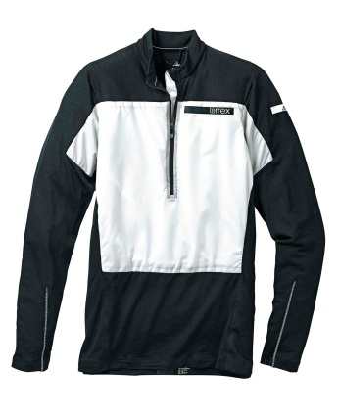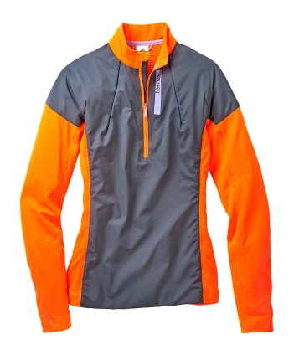
terrex DownBlaze Jacket

More warmth, less weight. The terrex DownBlaze Jacket uses PrimaLoft® Down Blend Gold combining the benefits of hydrophobic down with ultrafine synthetic fibers. The outer material is made up of very abrasion-resistant and lightweight Pertex® Microlight. And in order to provide extra warmth for extremely cold conditions, the adidas designers worked out an innovative heat-retaining construction. Differential baffling, where every other baffle on the inside is wider, overlapping the stitching lines, reduces heat loss significantly without adding weight.

Features & Benefits:

    - Pertex® Microlight: lightweight material with good strength and abrasion resistance.
    - PrimaLoft® Down Blend Gold: made from functional, durable, resistant goose down together with high-performance PrimaLoft® ultra-fine denier fibers. Combines the best qualities of both materials and offers warmth, protection and comfort, no matter what conditions
    - Differential baffling: reduces thermal bridges generated by stitch lines without adding weight through an H-baffle construction as every other baffle on the inside is wider, overlapping the stitching lines, increasing the heat retention value significantly
    - Heat guards: excellent heat retention on neck, sleeves and waist
    - Two-zip hand pockets

Colors men: black // base green // night flash
Weight: 369g (size 50)

Colors women: white/black // base green
Weight: 323g (size 36)

Price: € 249.95 € (RRP)

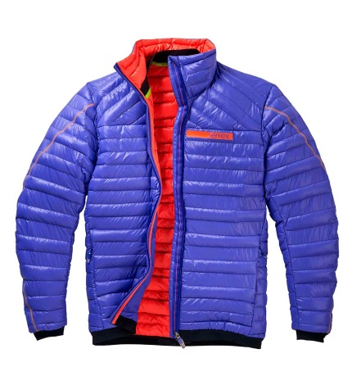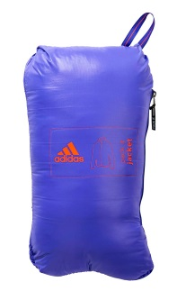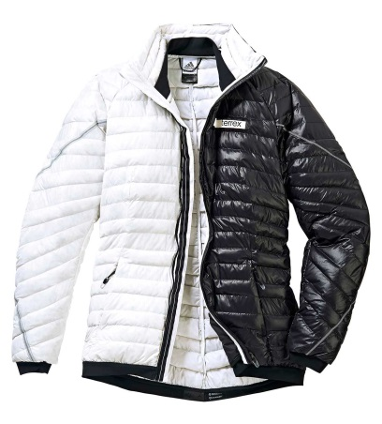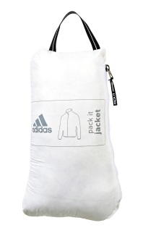
terrex GTX® Active Shell Jacket

The wind- and waterproof terrex GTX® Active Shell Jacket is designed for high-pulse activities. It offers a combination of weather protection, great packability and clean design.

Features & Benefits:

- GORE-TEX® Active Shell: the lightest and most breathable GORE-TEX® 3-layer fabric
- Athletic fit with full freedom of movement
- Fully adjustable and helmet-compatible hood
- One chest pocket and two big hand pockets
- Reflective elements for enhanced visibility and safety

Colors men: white/black // base green // night flash
Weight: 385g (size 50)

Colors women: white/black // night flash
Weight: 340g (size 36)

Price: € 299.95 (RRP)

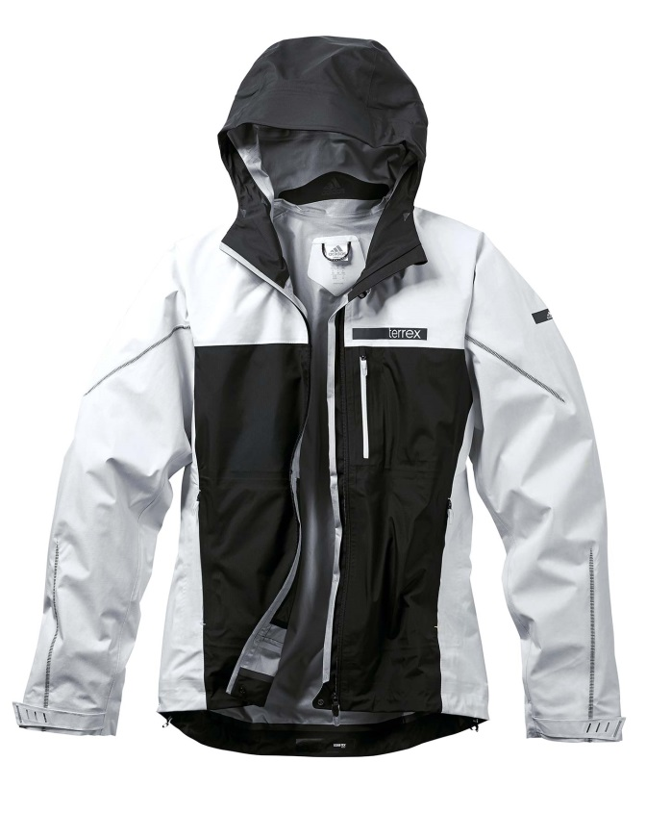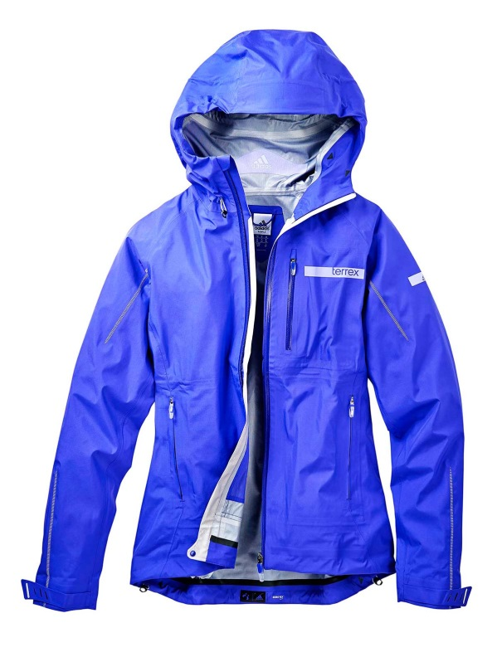

terrex Fast Jacket 2

Looking for a breathable, abrasion-resistant soft shell jacket with great next-to-skin comfort and excellent fit? Then this is your jacket. The second generation of the terrex Fast Jacket keeps all the proven features from last season and gets a new adjustable hood for best protection and improved comfort.

Features & Benefits:

- 100% WINDSTOPPER® provides full wind protection and is twice as breathable as comparable windproof fabrics
- Security chest pocket and two zip hand pockets
- Elastic waist with drawcords for adjustability
- Adjustable hood

Colors men: night flash // base green // black
Weight: 445g (size 50)

Colors women: base green // flash pink
Weight: 300g (size 36)

Price: € 219.95 (RRP)

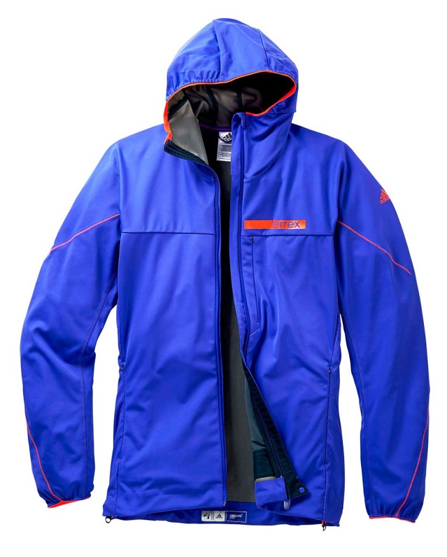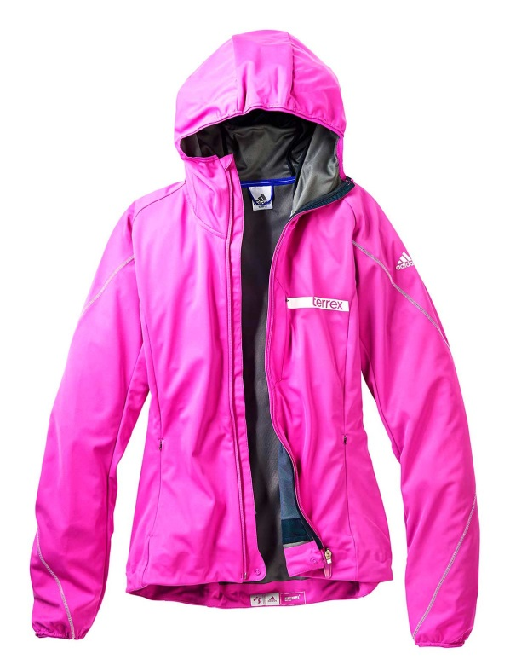

terrex Frost Guard Pants

Slip in and feel comfortable. The terrex Frost Guard Pants are lightweight, packable PrimaLoft® pants with a full-length side zip to ensure ease of entry and exit. They are the ideal companion for high-alpine adventures, bivouacking or staying warm before and after a ski tour.

Features & Benefits:

- PrimaLoft® Gold Insulation: highest performing synthetic insulation on the market
- Pertex® Microlight: lightweight material with good strength and abrasion resistance
- Full-length side zip
- Pack-it pocket
- Hook-and-loop closure adjustable waist

Color men: black/white
Weight: 360g (size 50)

Color women: black/white
Weight: 360g (size 36)

Price: € 159.95 (RRP)

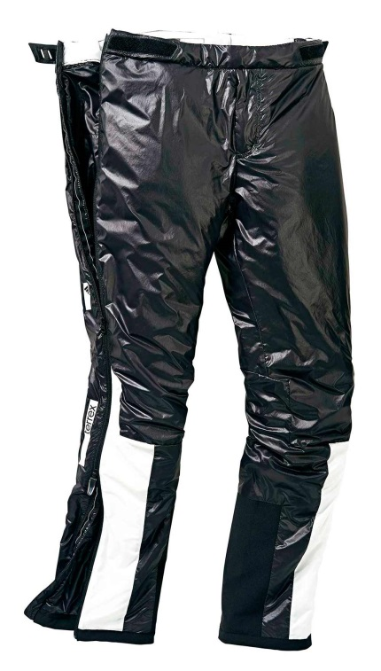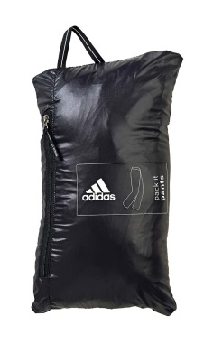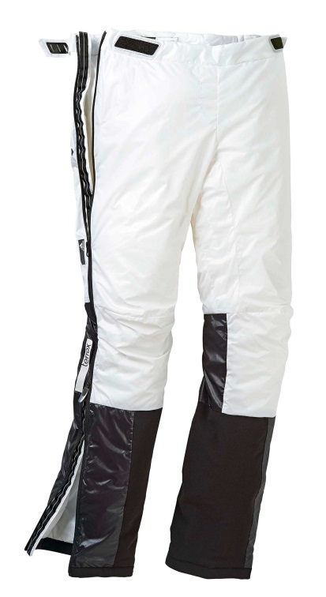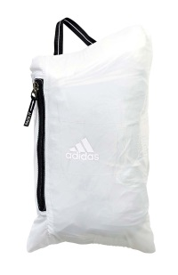

terrex Mountain Flash Pants

These versatile summery mountain pants can be used for multiple outdoor activities such as climbing, biking, hiking and mountain running. When you slip in, they immediately feel like your second skin, extremely comfortable, super light and with great freedom of movement.

Features & Benefits:

- Climacool®: provides excellent breathability and comfort
- Durable Water Repellency (DWR): sheds rain and snow, quick-drying
- 4-way stretch soft shell fabric
- Reinforced leg opening
- Gel and security pocket
- Elastic waist
- One panel per leg construction
- Reduced seam solution
- FORMOTION® cut: guarantees unrestricted freedom of movement and athletic fit at the same time

Colors men: solid grey/black // solar red/bold orange // base green
Weight: 223g (size 50)

Colors women: base green // solar red/bold orange

Material: 90% recycled polyester / 10% EL Print, DWR, CLIMACOOL

Price: € 99.95 (RRP)
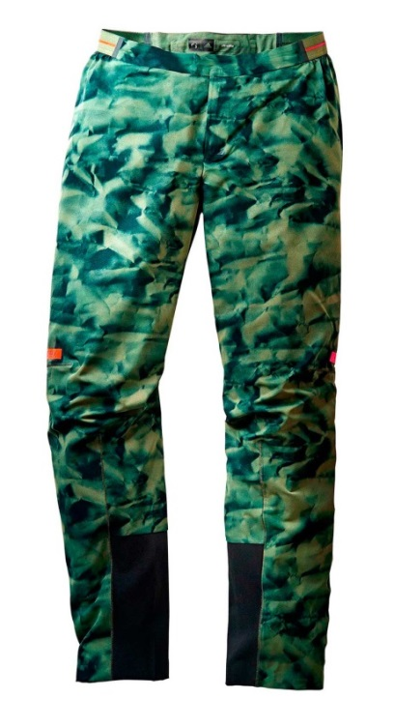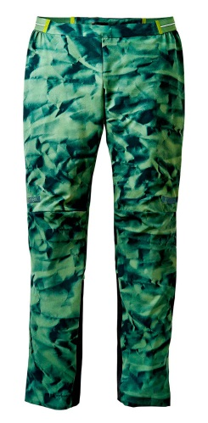

terrex Endless Mountain Bermudas

The terrex Endless Mountain Bermudas are lightweight and flexible soft shell shorts for various mountain and outdoor activities.

Features & Benefits:

- Climacool®: provides excellent breathability and comfort
- Durable Water Repellency (DWR): sheds rain and snow, quick-drying
- Elastic waist
- Breathable back waist pocket
- Recycled polyester
- Double weave 4-way stretch
- Bonded seams
- Stab stitch

Colors men: solid grey/black // night flash/amazon purple // solar red/bold orange
Weight: 130g (size 50)

Colors women: flash pink // base green
Weight: 117g (size 36)

Price: € 119.95 (RRP)

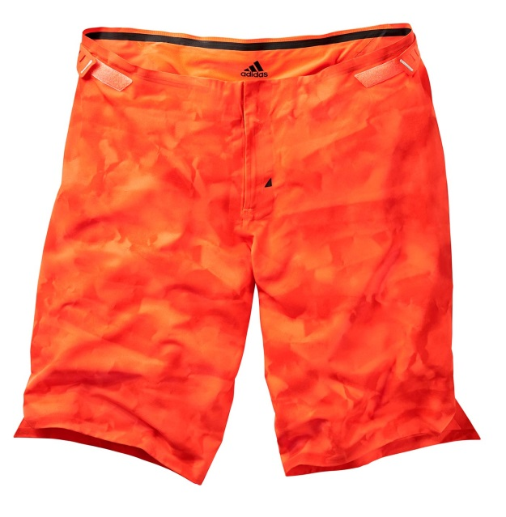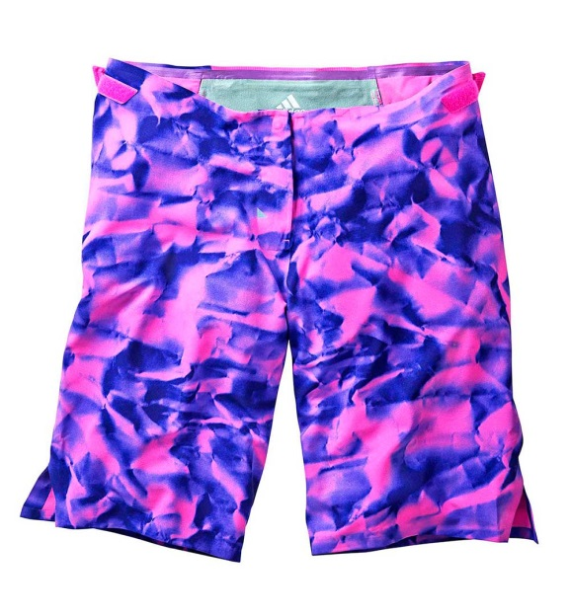

***

More information at
www.adidas.com/outdoor/
www.facebook.com/adidasoutdoor
www.instagram.com/adidasoutdoor
www.youtube.com/adidasoutdoortv

Lena Hackforth
Global PR & Social Media Manager adidas Outdoor
+49 9132 84 4380
+49 160 884 4380 (mobile)
lena.hackforth@adidas.com

