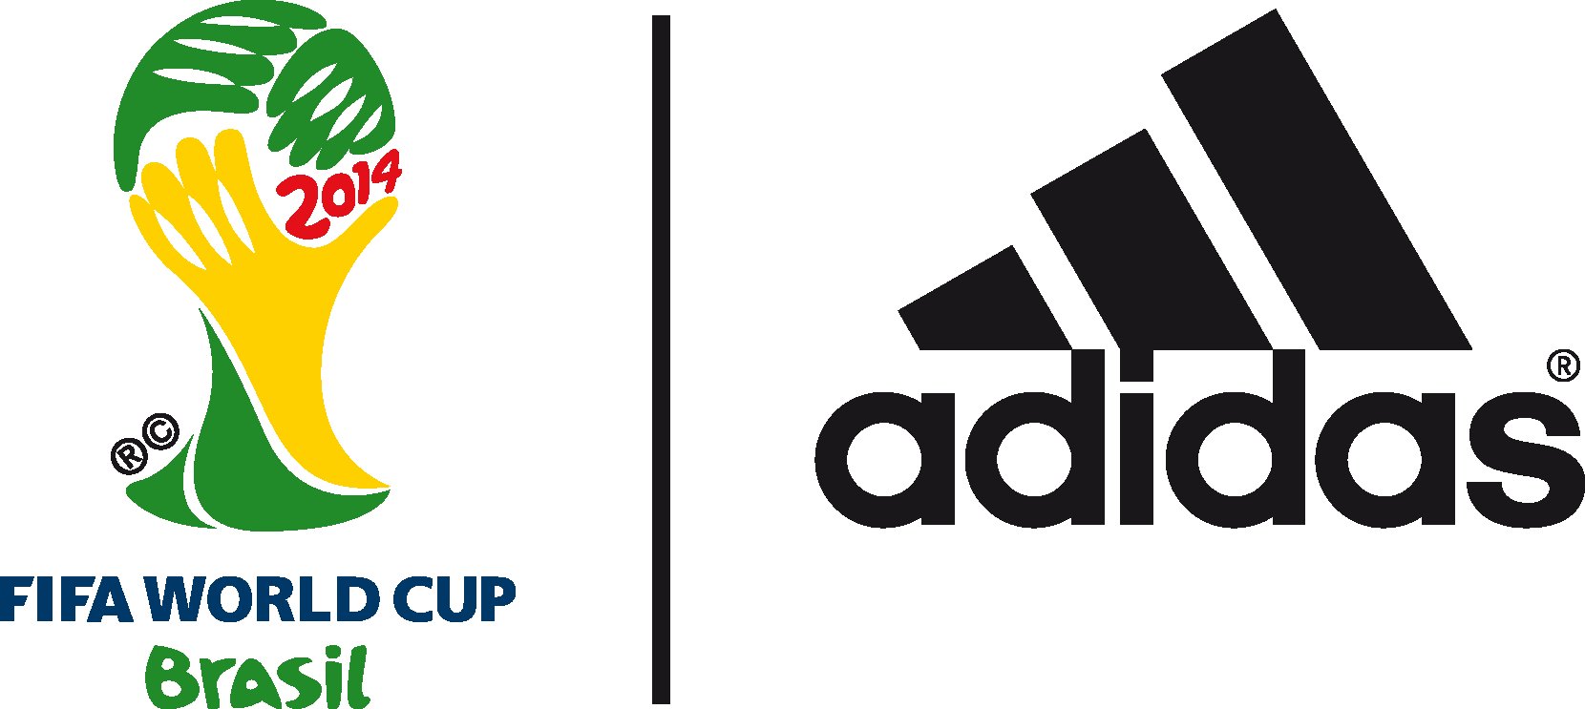

adidas and Christopher Mintz-Plasse team up to discover the real World Cup party in Brazil

Superbad and Kick-Ass actor stars alongside Cafu and Patrick Vieira for Funny or Die sketch

Wednesday 2nd July 2014 – Herzogenaurach / Rio de Janeiro – adidas today released a new video with comedy production team Funny or Die, in which Hollywood actor Christopher Mintz-Plasse finds himself on a quest to discover the best World Cup party. Filmed on location in Rio de Janeiro, and featuring cameos from adidas stars and legends including Fernando Hierro, Juan Mata, Cafu and Patrick Vieira, the sketch sees Mintz-Plasse on a journey through Rio as a roving reporter searching for a party with hilarious results.

To watch the video go to http://youtu.be/6oq4hdDn0TY

Along the way Mintz-Plasse joins Fernando Hierro for the adidas miCoach Smart Ball Power Challenge, receives football tips from Juan Mata and trains with the Flamengo youth team, before talking Brazil and Argentina with Cafu. Feeling disappointed with not being able to find any parties, it is left to French legend Patrick Vieira to explain that the World Cup and going to a match is the biggest party of them all.

Join the adidas football conversation at www.facebook.com/adidasfootball or on Twitter: @adidasfootball.

***
- END -

For further media information please visit http://news.adidas.com/GLOBAL/PERFORMANCE/FOOTBALL or contact:

Robert Hughes  adidas Senior Global Football PR Manager  Email: robert.hughes@adidas.com  Tel: +49/9132/84-6856 | Alan McGarrie  adidas Global Football PR Manager  Email: alan.mcgarrie@adidas.com  Tel: +49/9132/84-4686
Notes to editors:
About adidas Football
adidas is the global leader in football. It is the official sponsor / official supplier partner of the most important football tournaments in the world, such as the FIFA World Cup™, the FIFA Confederations Cup, the UEFA Champions League, the UEFA Europa League and the UEFA European Championships. adidas also sponsors some of the world’s top clubs including Real Madrid, FC Bayern Munich, AC Milan, Flamengo and Chelsea. Some of the world’s best players also on the adidas roster are Leo Messi, Gareth Bale, Mesut Özil, Dani Alves, Oscar, Xavi, Karim Benzema and Bastian Schweinsteiger.

***

