Cold as ice

Bosnia and Herzegovina striker Edin Dzeko shows his commitment to his country in a picture created by adidas

15th June, Herzogenaurach / Sarajevo: Bosnia and Herzegovina will make its first World Cup appearance as an independent nation in Brazil. Prolific striker Edin Dzeko is ready to put his body on the line to bring glory to his nation.

The World Cup is no place for half measures. Now Bosnia has made it to the World’s biggest stage, Dzeko and his teammates will do whatever it takes in pursuit of glory. The commitment of the Bosnian to his country’s cause has been captured in this photo from adidas.

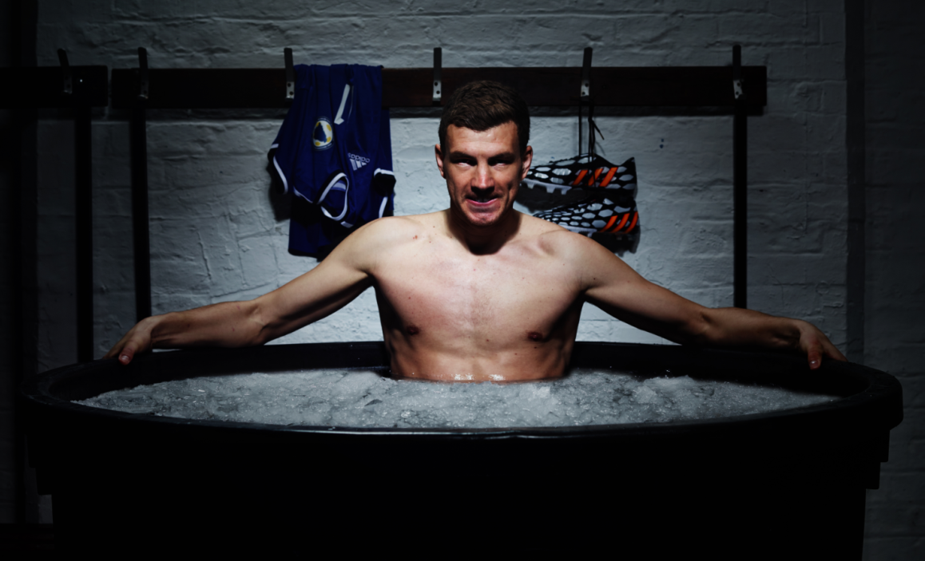
The photograph depicts Dzeko sitting in an ice bath, preparing his body for the challenge in Brazil. The ice bath is a traditional Eastern European method of cleansing the body. The image, part of the adidas all in or nothing FIFA World Cup™ campaign, represents the strain that players will have to place on their bodies to succeed in Brazil.

The all in or nothing campaign from adidas is about challenging the world’s best footballers to seize their moment at the World Cup™. It is a provocative and bold campaign that celebrates the players able to defy the pressure and step-up on the world’s biggest stage.

Commenting on the image, Dzeko said, “Playing in the World Cup is a huge moment for my country. Brazil is going to be a tough test, but I will put myself through any situation, no matter how tough, to make sure their first World Cup is one which makes the Bosnian people proud”.

Caption- ‘Dzeko puts his body on the line for Bosnia. Bosnia and Herzegovina striker Edin Dzeko pushes himself to the limits for World Cup glory in a picture created by adidas.’

------ENDS-------

CTA- For further media information please visit http://news.adidas.com/GLOBAL/home/FIFA-WORLD-CUP-2014 or contact:

Robert Hughes  adidas Senior Global Football PR Manager  Email: robert.hughes@adidas.com  Tel: +49/9132/84-6856 | Alan McGarrie  adidas Global Football PR Manager  Email: alan.mcgarrie@adidas.com  Tel: +49/9132/84-4686

