Exhibition Template ☒ready for publication
Topic : | World cup shoes
Title of Exhibition : | Iconic World Cup Shoes
Date of Publication: | 31.03.2014 | Due date | Click here to enter a date.
IR-40
https://www.adidas-archive.org//#/exhibitions/1270/objects?start=0&num=30&language=en

Introduction Text (limited to 440 characters including space)
There is a unique story behind every World Cup tournament and adidas has played a big role in all World Cups since 1954. This exhibition tells some legendary football stories through a selection of special boots – one from each event, starting with the famous “Miracle of Bern” to the last tournament in South Africa. Which one is your favourite?

Exhibition objects:
Order | Object Number | Displayed View | Object text (limited to 220 characters including space) | comments
1 | F-105b | 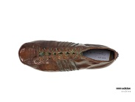 | It was with this shoe that German striker Helmut Rahn scored West Germany's third goal in the 1954 World Cup Final against Hungary. Making it 3:2 with six minutes left, he led his team to victory.
2 | F-181a | 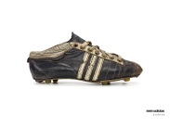 | This shoe was worn by French international Just Fontaine in the 1958 World Cup. He scored 13 goals in the tournament, making him the top scorer.
3 | F-198a | 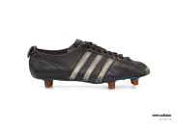 | Karl Heinz Schnellinger wore this shoe in the 1962 World Cup in Chile. In the same year, he was awarded German Footballer of the Year.
4 | F-308 | 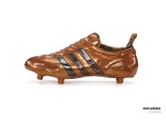 | It was wearing this shoe that Geoff Hurst scored his famous hat-trick in the 1966 World Cup Final in England against West Germany, which ended 4:3. The match is remembered for England's only World Cup trophy so far.
5 | F-312 | 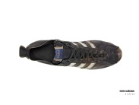 | The captain of the Brazilian national team, Carlos Alberto Torres, wore this shoe when he led his team to World Cup victory in 1970 in Mexico.
6 | F-380 | 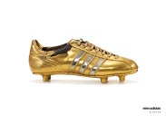 | It was with this shoe that Gerd Müller scored what turned out to be the winning goal for West Germany in the 1974 World Cup Final against the Netherlands.
7 | F-381 | 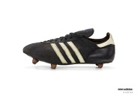 | This shoe is a prototype for the 1978 World Cup in Argentina. It represents the last football boot development personally led by Adi Dassler.
8 | F-1003 | 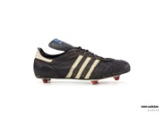 | Karl Heinz Rummenigge wore this shoe in the1982 World Cup in Spain. Together with the West German team, he became second in the tournament.
9 | F-1005a | 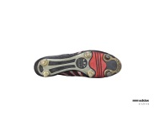 | It was wearing this shoe that England’s Gary Lineker scored 6 goals and became the tournament’s best scorer in the 1986 World Cup in Mexico.
10 | F-1104 | 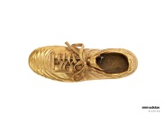 | Andreas Brehme scored the winning penalty wearing this custom-made shoe in the 1990 World Cup Final in Italy against Argentina. West Germany claimed their third World Cup title.
11 | F-1108 | 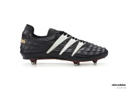 | This shoe was launched for the 1994 World Cup in the United States. It meant absolute innovation for the players – in terms of power, control and accuracy.
12 | F-932 | 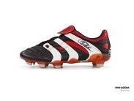 | The Predator Accelerator Cut was released to coincide with the 1998 World Cup in France. The shoe was signed by Zinedine Zidane, who scored 2 goals in the final against Brazil leading France to their first title.
13 | F-965 | 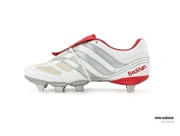 | The Predator Mania was launched for the 2002 World Cup in South Korea and Japan. This shoe was custom-made for the English national player David Beckham.
14 | F-946a | 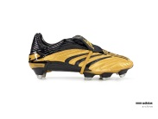 | This shoe was custom-made for the Swedish national player Niclas Alexandersson. It was launched before the 2006 World Cup in Germany.
15 | F-1121a | 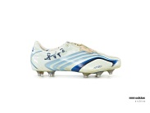 | German national player Bastian Schweinsteiger wore this shoe in the 2006 World Cup in Germany. His performance helped the host win the third place match against Portugal.
16 | F-934a | 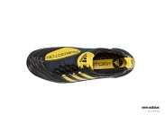 | This Predator X was custom-made for the Spanish national player Xavier “Xavi” Hernandez i Creus for the 2010 World Cup. Spain won their first world title in South Africa.
17
18
19
20
Minimum of 5 items per collection
Maximum of 20 items per collection
Please name your file: YYYYMMDD_exhibition_topic01.doc
(e.g. 20130423_exhibition_history of running 01.doc)
and save it here:
W:\International\History Management\Brand_Archive\Projekte\adidasArchive\Exhibitions

