adidas France launches its campaign "all in or nothing "

Two weeks before the kick-off of the 2014 FIFA World Cup Brazil™, adidas launches its biggest communication campaign ever: “all in or nothing “. As claimed in this powerful mantra, adidas – global football leader and France’s favourite brand – makes the choice to adopt an attitude with zero compromise, at the dawn of the most popular sport event in the world. To express this position, adidas France surprised the audience during an audacious launch night 100% #allin or nothing.

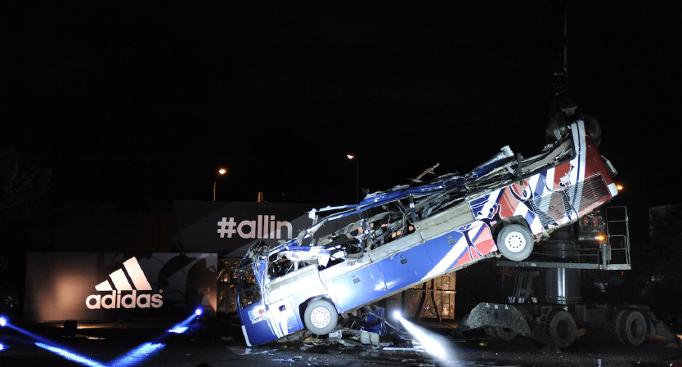

As said in its new communication campaign, adidas France wanted to express its brand attitude with something spectacular and symbolic, during the launch event in France, on 26th May. This launch celebrated all the « all in or nothing » dimensions, from the most inspiring to the most impressive. During this event, adidas literally destroyed the « Knysna’s bus of shame», to make it reborn few days later as a piece of art. adidas, which has been the French football partner in its biggest success as in the defeats, is the most legitimate brand to close one of the most unfortunate episodes in football history.

For the FIFA World CupTM, adidas is « all in or nothing »
The 2014 FIFA World Cup Brazil™, international party that unites the best football players, is the occasion to give to people a unique show, a subtle mix between class and talent. However, as in every competition in the world, the cruelty of the result is as strong as the joy of a shining victory. Because sport has no mercy: if there is a winner, there is for sure a loser…
Everyone has to make a choice. adidas’ one is clearly defined through its new campaign « all in or nothing », revealed during the UEFA Champions LeagueTM Final’ half-time, on 24th May. While viewers and internet users were discovering the new commercial spot of the brand leader on football, all the adidas players were wearing the shoe collection called « Battle Pack », pure visual translation of the adidas campaign « all in or nothing » for the 2014 FIFA World Cup Brazil™. And, it’s a fact, every shoe is 50% white and 50% black: « it’s black or white, all in or nothing ».
If « all in » is the adidas brand philosophy, « all in or nothing » is the expression of the ability to break its own limits and the essential attitude to give the best of ourselves in the key moments. Beyond the final result on which we cannot have a total control, we have to be here when we are expected to be, during the crucial moments.
To give our best, we have to make the right choices: fear or be feared, evolve or die, hunt or be hunted. To support this message, adidas can count on their prestigious ambassadors who will battle during the Brazilian event, from Leo Messi to Dani Alves, and Luis Suarez to Karim Benzema. Modern warriors, ready to do all the sacrifices to win. « all in or nothing » soldiers.

Destruction of the « bus of shame » in France, pure illustration of « all in or nothing »
As the big tragedies are written on symbols, the one linked to the sad day of 20th June 2010 took the incredible form of a bus. The Knysna’s bus story has been brought back in the media, few weeks before the World Cup. The « bus of shame », as it was called by the people, represented the end of the dream for all the French supporters. 4 years later and some days before the opening match of the FIFA World Cup BrazilTM, adidas decided to close this bad chapter by a spectacular and unexpected way!
For this event « all in or nothing » on 26th May 2014, at La Courneuve, hundreds of medias and opinion leaders attended to the destruction of the controversial bus. With this daring initiative, adidas wanted to remove this dark souvenir from its memory, in order for everyone to look forward, to take on the past and to give their best to make history.
To take a new start, happier, more creative and more positive, the bus will also take a final trip full of surprises. After its destruction by a recycling specialist company, the « rests » of Knysna will literally reborn from the chaos thanks to the art magic. The sculptor-designer Louis-Guillaume Piéchaud, famous for his work into the Lutetia hotel, will transform this destroyed bus in true piece of art, but also let the bus recognizable by adding some elements like the license number, the covering, etc. The result will be showcased at the adidas store Champs Elysées, and then will be put on auction at the benefit of the Diambars association, for their socio-educational program Stade Sup, which aim is to make that “sport passion leads to the education”.
This gesture « all in or nothing » from the football leader brand is an incentive to move forward. The public destruction of this bus is the true illustration of « all in or nothing ». It allows to understand a fundamental element: the border between victory and defeat is very tight. But the consequence of a fail can be tragic. The « bus of shame » shows all this together: how a spark can change the destiny of a hero team to a hated team. adidas has definitely turned the page of Knysna’s bus, by transforming this failure symbol into a piece of art. But the great champions can’t make the same errors twice. This time, they will have to give their best, to put everything to not regret anything. To be forgiven. And to remind us that, for adidas, football is « all in or nothing ».

Photos of the events are available here : https://www.hightail.com/download/ZUcxTXRRNDRvQnZtcXNUQw
For more information :
adidas.com/worldcup
facebook.com/adidasfootball
twitter @adidasfootball #allin or nothing

Contact adidas
FOOTBALL PR MANAGER / ADIDAS FR
Julien Lanfrey
julien.lanfrey@adidas.com
T : + 33 3 88 87 83 10
M : + 33 6 31 60 56 48

Notes to editors:
About adidas Football
adidas is the global leader in football. It is the official sponsor / official supplier partner of the most important football tournaments in the world, such as the FIFA World Cup™, the FIFA Confederations Cup, the UEFA Champions League, the UEFA Europa League and the UEFA European Championships. adidas also sponsors some of the world’s top clubs including Real Madrid, FC Bayern Munich, AC Milan, Flamengo and Chelsea. Some of the world’s best players also on the adidas roster are Leo Messi, Gareth Bale, Mesut Özil, Dani Alves, Oscar, Xavi, Karim Benzema and Bastian Schweinsteiger.

