EMBARGOED UNTIL 1400hrs CET THURSDAY 29th MAY

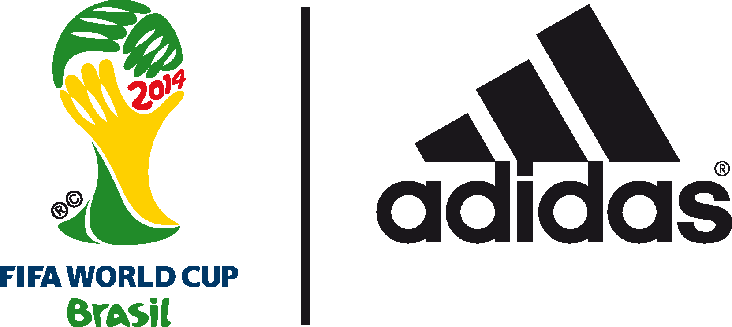

adidas unveils BRAZUCa FINAL rio: THE OFFICIAL MATCH BALL FOR THE FINAL OF THE 2014 FIFA World Cup Brazil™

Match ball specially created for showpiece Final on Sunday 13th July with colours reflecting the green and gold of the FIFA World Cup trophy

Herzogenaurach / Rio de Janeiro, 29th May 2014 – adidas today unveiled the brazuca Final Rio Official Match Ball, the official match ball for the Final of the 2014 FIFA World Cup Brazil™. The ball will be an integral part of the Final on 13th July when the top two federations battle it out for a place in history. The design of brazuca Final Rio has been inspired by the green and gold on the FIFA World Cup™ trophy and is a variation of the previously released adidas brazuca Official Match Ball which was launched back in December last year.
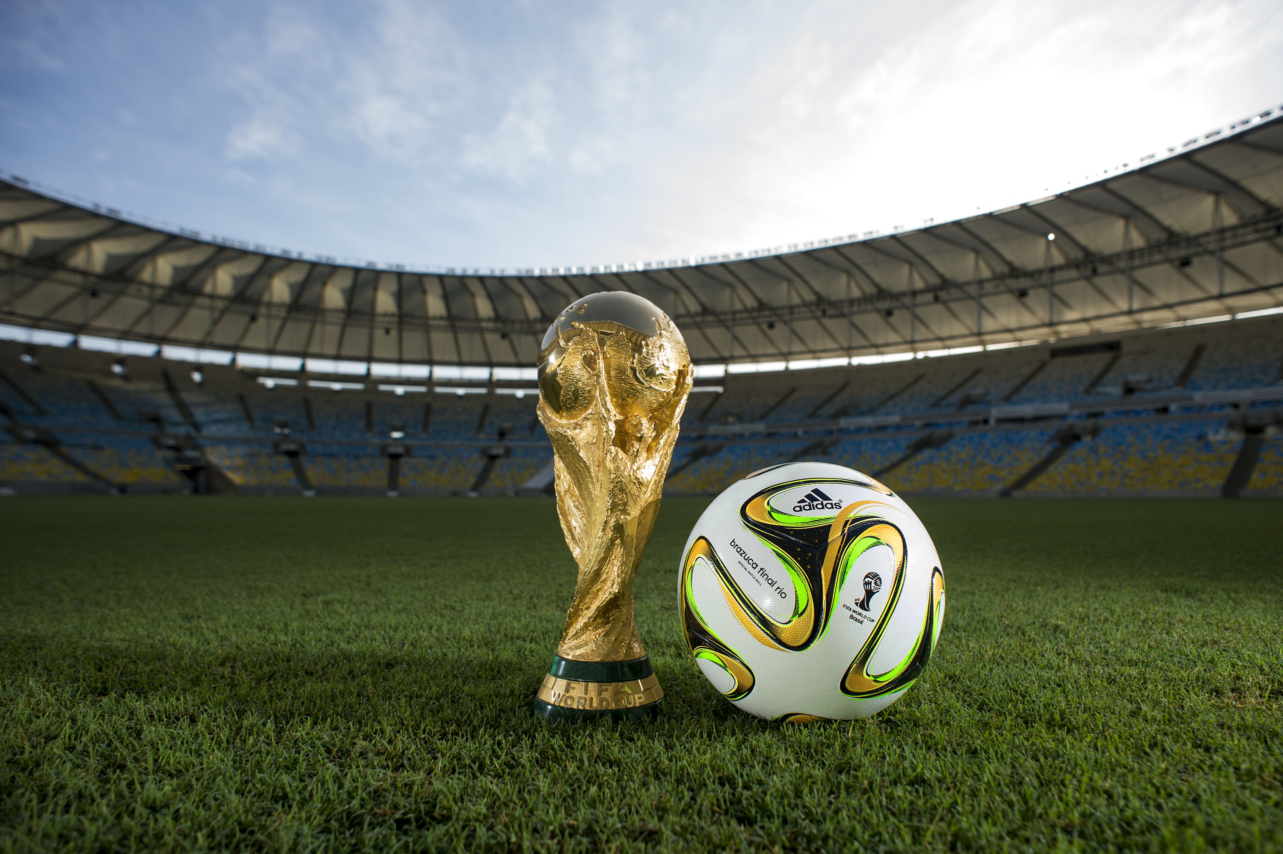
In the build-up to the FIFA World Cup™, adidas has used brazuca as part of its "all in or nothing" FIFA World Cup™ campaign and launched @brazuca on Twitter. After the launch in December 2013, @brazuca already has over 131,000 followers and has introduced fans to some of the world’s greatest footballers and celebrities including Zinedine Zidane, Cafu, Samuel L Jackson and Hugh Jackman. It has even travelled to the Vatican City to meet Pope Francis. Fans on twitter have also been able to track the build-up to the FIFA World Cup™ in Brazil through the eyes of the ball as it travels the world and offers an alternative take on the game.

Back in December 2013, adidas delivered brazucas to all federations competing in the 2014 FIFA World Cup Brazil™ in order for all teams to have sufficient time to train with the new balls both in training and competitive matches. Since then, the ball has also played a starring role in competitions such as the FIFA Club World Cup, Copa del Rey, MLS, DFB Pokal as well as numerous international friendlies.

Prior to the official launch, brazuca and brazuca Final Rio went through a thorough testing process over a two-and-a-half-year period involving more than 600 of the world’s top players and 30 teams in 10 countries across three continents, making it the most tested ball ever by adidas and ensuring that it is suited to all conditions. Clubs involved in testing included AC Milan, Bayern Munich, Palmeiras and Fluminense. Players involved in the process included global football stars Leo Messi, Iker Casillas, Bastian Schweinsteiger and Zinedine Zidane.

The technology incorporated into the bladder and carcass of brazuca and brazuca Final Rio is identical to the Tango 12 (UEFA EURO 2012™), Cafusa (FIFA Confederations Cup 2013) and the ever-popular UEFA Champions League™ Official Match Ball. However, a new structural innovation with a unique symmetry of six identical panels alongside a different surface structure will provide improved grip, touch, stability and aerodynamics on the pitch. brazuca has been thoroughly tested to meet and exceed all FIFA metrics for an official match ball, ensuring top performance for every condition.

The FIFA World Cup™ is the world’s largest football event and the ultimate platform for the adidas state-of-the-art apparel, hardware and footwear. adidas has made every FIFA World Cup™ ball since 1970, and recently extended the partnership with FIFA until 2030, including the supply of the official match ball.

Brazuca Final Rio is available to purchase globally from Sunday 1st June in selected adidas retail outlets, associated stockists and via www.adidas.com/worldcup. Join the adidas football conversation at www.facebook.com/adidasfootball or on Twitter: @adidasfootball #allin or nothing.

- END -

For further media information please visit http://news.adidas.com/GLOBAL/PERFORMANCE/FOOTBALL or contact:

Robert Hughes  adidas Senior Global Football PR Manager  Email: robert.hughes@adidas.com  Tel: +49/9132/84-6856 | Alan McGarrie  adidas Global Football PR Manager  Email: alan.mcgarrie@adidas.com  Tel: +49/9132/84-4686

Notes to editors:
About adidas Football
adidas is the global leader in football. It is the official sponsor / official supplier partner of the most important football tournaments in the world, such as the FIFA World Cup™, the FIFA Confederations Cup, the UEFA Champions League™, the UEFA Europa League™ and the UEFA European Championships. adidas sponsors some of the top football federations in world football including Spain, Argentina, Germany, Japan, Russia, Colombia, Nigeria, Mexico and Bosnia and Herzegovina. adidas also sponsors some of the world’s top clubs including Real Madrid, FC Bayern Munich, AC Milan, Flamengo and Chelsea. Some of the world’s best players also on the adidas roster are Leo Messi, Gareth Bale, Mesut Özil, Dani Alves, Oscar, Xavi, Karim Benzema and Bastian Schweinsteiger.

