Crazyquick 2
THE FACTS
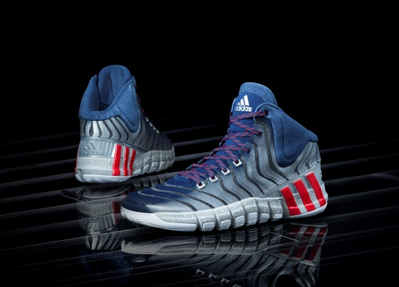
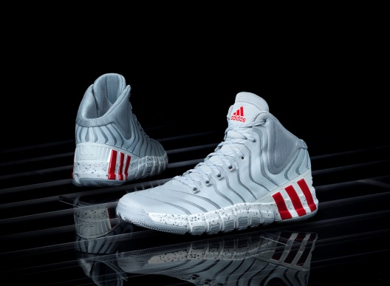

QUICKER  ALL-NEW  UPPER | Worn by John Wall and Damian Lillard in the 2014 NBA All-Star Game, the Crazyquick 2 is the newest model of the game-changing basketball shoe designed specifically to help make players quick on the court. adidas improved the innovation that helped redefine what it means to be quick by combining an all-new upper with the Crazyquick outsole technology.  The Crazyquick 2 features an all-new QUICKWEB upper that increases flexibility and control. The QUICKWEB upper incorporates perforated grooves that contour with the movement of your foot while aligning with the Crazyquick outsole technology.
4 QUICK  ZONES  GREATER  TRACTION  ADDITIONAL  FEATURES | Crazyquick 2 features four unique quick zones in the outsole that work with the upper to provide maximum traction and flexibility for quick movements on court. The flexibility and direction of herringbone traction and 17 unique diverging pods play a specific role in allowing players to be quick:  - Toe zone delivers quick push-off through an enlarged herringbone pad  - Forefoot zone ensures quick cuts and aggressive lateral movements through independent suspension allowed by increased flexibility of outsole and lateral traction  - Midfoot zone provides enhanced support through an increased surface area and lateral traction to provide stability while allowing the foot to flex  - Heel zone allows for quick multi-directional stopping through an ultra-fine herringbone profile  Crazyquick technology allows greater controlled flexibility, better traction and optimal foot lock-down for quick cuts. Crazyquick 2 increases traction between the shoe and the floor, allowing for quick cuts in the paint and on the perimeter.  The Crazyquick 2 provides additional features including:  - All-new molded GEOFIT collar extends through the outside of the shoe for contoured fit and increased comfort with an aesthetic that matches the QUICKWEB upper design  - Heel stripes give the upper design a sleek, quick look  - Signature details include personalized names across the lace loops for two of the quickest guards in the game, John Wall of the Washington Wizards and Damian Lillard of the Portland Trail Blazers  - Enlarged, re-engineered SPRINTFRAME moderates movement and provides optimum support
ROLL OUT AND AVAILABILITY | Crazyquick 2 ($125) will be available April 1 at adidas.com and other leading retailers.
MORE INFO | For more information, visit news.adidas.com, adidas Basketball Facebook page, www.adidasbasketball.com and adidas Basketball Twitter and Instagram with #Crazyquick2.  Paul Jackiewicz, adidas PR  (o) 971-234-2357  (m) 503-593-5316  Paul.Jackiewicz@adidas.com

###

