One step ahead: adidas reveal world’s first all-in-one knitted football boot and sock hybrid
adidas lift the curtain on the future of football by unveiling the Primeknit FS

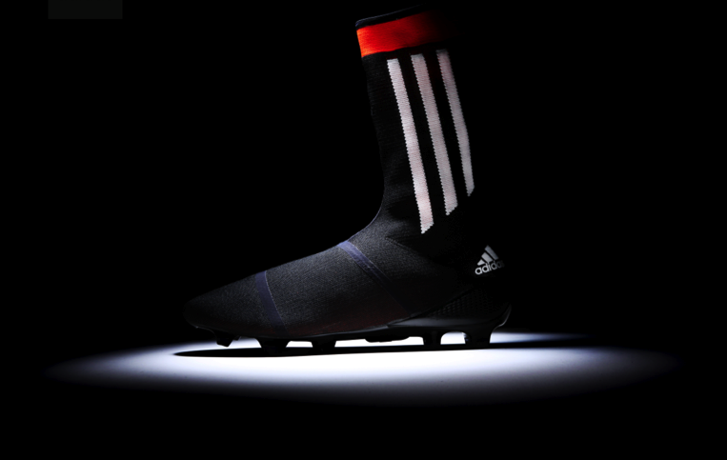
Herzogenaurach, Thursday 6th March 2014: Following the recent launch of the world’s first knitted football boot, the adidas Samba Primeknit, adidas gives fans a glimpse of the football boots of the future by unveiling the new adidas Primeknit FS.

The limited edition Primeknit FS will be produced in a black, white and red design and is the world’s first all-in-one knitted football boot and sock hybrid. This unique ‘sock silhouette’ design will provide a bespoke second-skin feel that will offer the perfect fit from toe to calf. The sock improves ball to foot touch compared to boots with traditional overlays, edges or laces.

While the adidas Primeknit FS remains in design phase and is currently being treated as a “concept model”, adidas is currently working with its top players to finalise development of the product and release it on pitch later this year. The one piece design and strong light yarns of the Primeknit FS is expected to provide new levels of flexibility and comfort with stability and strength equal to that of conventional boots. Each yarn receives a high precision coating that guarantees water resistance even in the most challenging conditions.

Similar to the recently released adidas Samba Primeknit, the world’s first knitted football boot, the technology behind the world’s first fully integrated knitted football boot and sock hybrid allows for optimised and engineered zones for the different performance needs of each player in one single layer.

Commenting on the unveiling of the adidas Primeknit FS, Markus Baumann, Senior VP for Global Football at adidas said, “Following the launch last week of the adidas Samba Primeknit, the world’s first knitted football boot, we’re excited to be able to give the World a glimpse into the future of our products. The introduction of the adidas Primeknit FS is only the latest chapter of adidas football products and further cements our place as the pioneer of footballing innovation.”

To find out more about the adidas Primeknit FS and other adidas innovations, go to www.facebook.com/adidasfootball or join the conversation on Twitter: @adidasfootball #allin or nothing.”
- END -

For further media information please visit http://news.adidas.com/GLOBAL/PERFORMANCE/FOOTBALL or contact:

Robert Hughes  adidas Senior Global Football PR Manager  Email: robert.hughes@adidas.com  Tel: +49/9132/84-6856 | Alan McGarrie  adidas Global Football PR Manager  Email: alan.mcgarrie@adidas.com  Tel: +49/9132/84-4686
Notes to editors:
About adidas Football
adidas is the global leader in football. It is the official sponsor / official supplier partner of the most important football tournaments in the world, such as the FIFA World Cup™, the FIFA Confederations Cup, the UEFA Champions League, the UEFA Europa League and the UEFA European Championships. adidas also sponsors some of the world’s top clubs including Real Madrid, FC Bayern Munich, AC Milan, Flamengo and Chelsea. Some of the world’s best players also on the adidas roster are Leo Messi, Gareth Bale, Mesut Özil, Dani Alves, Oscar, Xavi, Karim Benzema and Bastian Schweinsteiger.

