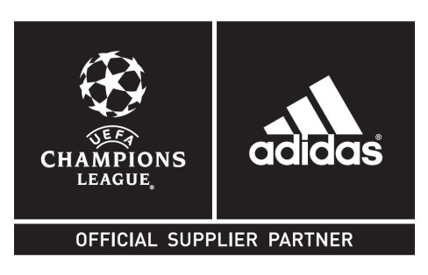
adidas launch new adizeroTM f50 Messi boots &
UEFA Champions League Finale Lisbon Official Match Ball
Both products to debut during UEFA Champions League round of 16

Herzogenaurach / Lisbon, 17th February 2014 – Today adidas unveils the new adizeroTM f50 Messi signature boots, to be worn by the Argentinian star for the first time tomorrow during the UEFA Champions League round of 16.

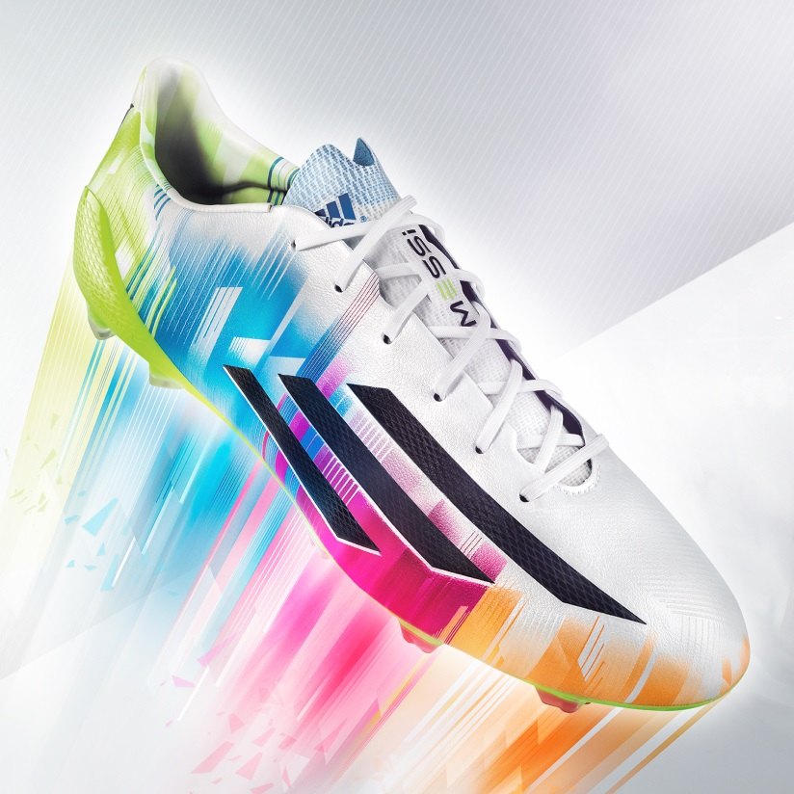
The new adizeroTM f50 Messi

The new adizeroTM f50 Messi boots feature a sleek colour scheme of green, blue, pink, orange and white, along with the iconic adidas three stripes, and combines revolutionary technologies with the precision engineering befitting of a four-time Ballon d’Or winner. At only 165g, the adizero™ f50 Messi is one of the lightest shoes on the market.

Messi, along with every player taking part in the UEFA Champions League round of 16, will also play for the first time with the adidas Finale Lisbon, the official match ball for the knock-out stages of the most prestigious club competition in world football.
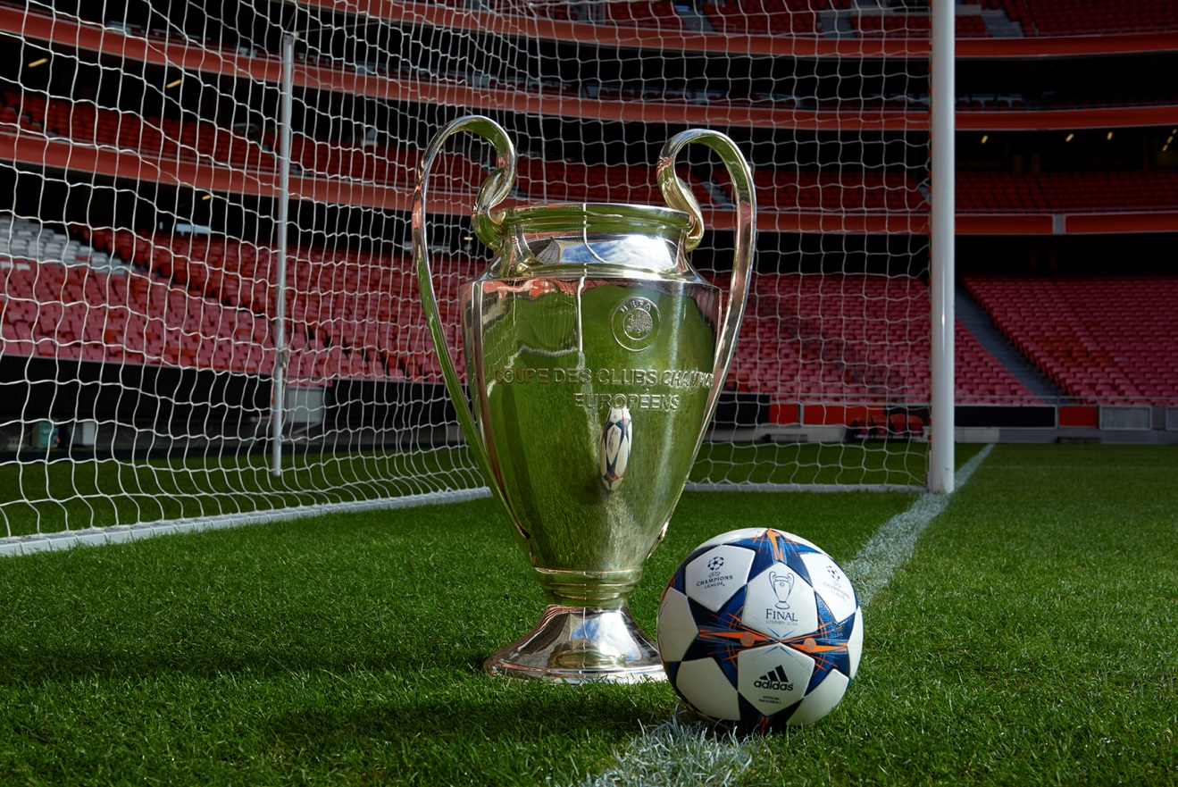
The adidas Finale Lisbon Official Match Ball along with the UEFA Champions League Trophy

The design inspiration of the ball this year is a celebration of Portugal´s legacy as a proud sea going nation. The different shades of blue reflect the importance that both sky and sea have played in Lisbon’s nautical history. The orange is a testament to the capital city’s orange-roofed houses, which can be seen from the numerous viewpoints scattered throughout Lisbon´s several hills.

The ball features an outer coating texture designed to provide optimal grip at the point of impact. The thermally bonded star panel design on the match ball, based on the design of the UEFA Champions League logo, provides a seamless surface and enhanced performance.

Commenting on the new adidas Finale Lisbon Official Match Ball and his adizeroTM f50 Messi boots, Leo Messi said: "It's great to play in the knock out stages of the UEFA Champions League and hopefully this season we can make it to the Final in Lisbon. The ball is very beautiful! I would say that the UEFA Champions League ball is the most popular ball with the players, it really is the benchmark, and adidas continue to improve on this product year after year. I'm also very excited to show my fans my new adizero f50 Messi boots which I will debut for the first time in the UEFA Champions League on Tuesday night."

Jochen Raff, adidas Football Senior Product Manager said: "Throughout the years, the innovation put in to each of our balls reflects the evolution of football and how it´s played. Sometimes it´s not so much a question of ground-breaking revolutions but rather making subtle but decisive tweaks that make the ball even better and enhance the experience both for professional and amateur, everyday players."

The adidas Finale Lisbon ball will be used on field during UEFA Champions League matches from February 18th onwards up until and including the final. It is available now for purchase in selected adidas retail outlets, associated stockists and via www.adidas.com/football. Join the UEFA Champions League conversation on www.adidas.com/gamedayplus or on Twitter: @adidasfootball #ucl.

The adizeroTM f50 Messi boots are available for purchase in adidas retail outlets, associated stockists from March 1st. For further information follow www.facebook.com/teammessi or join the conversation on twitter @teammessi.

- END -

For further media information please visit http://news.adidas.com/GLOBAL/PERFORMANCE/FOOTBALL or contact:

For further information please contact:

Robert Hughes
Senior Global PR Manager Football

Email: Robert.Hughes@adidas.com
Tel: +49-160 884 6856

Alan McGarrie
adidas Global Football PR Manager
Email: alan.mcgarrie@adidas.com
Tel: +49/9132/84-4686

Notes to Editors:
adidas Production of Official Match Balls since 1970
adidas’ experience in football production is unparalleled. adidas has been making footballs since 1963 and is now the world’s leading manufacturer, always at the cutting edge of technology. adidas has supplied the Official Match Balls to all major UEFA and FIFA tournaments since 1970, and since 2006 is also the Official Supplier of the match ball for all UEFA Champions League games. The adidas Finale ball has been used for the UEFA Champions League Final since the 2000/2001 season. Since 2008, adidas is also the Official Supplier of the match ball for the Africa Cup of Nations organized by the Confédération Africaine de Football (CAF).

