adidas and the Mexican Football Federation introduce the new national team away kit

Heritage and innovation are the key features of the new Mexican away kit that has been designed especially for the 2014 FIFA World Cup Brazil™

México City, February 14th, 2014 – adidas presents the official away kit of the Mexican national football team for the 2014 FIFA World Cup Brazil™

The new away kit of the Mexican team stands out through an innovative combination of red and black, reinterpreting classic jerseys of the national team worn in previous World Cups. This colour combination was first used in Uruguay 1930 through to Sweden 1958.

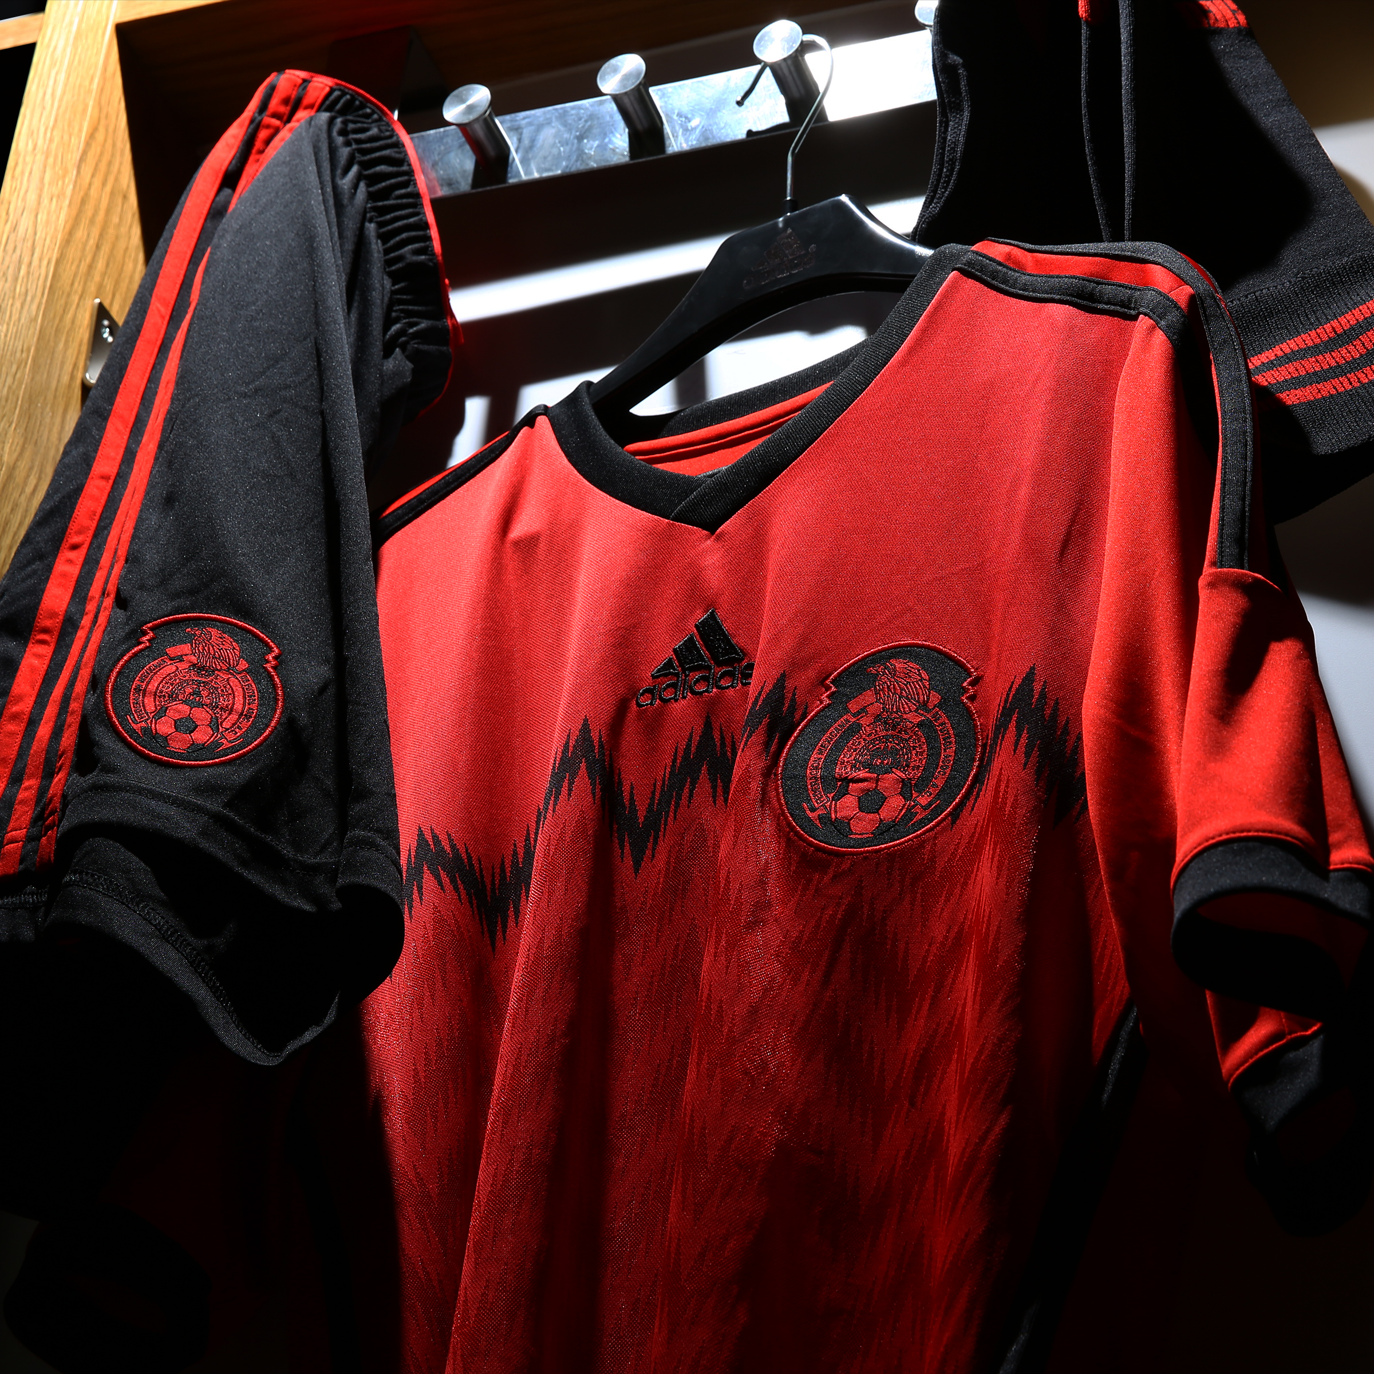

The color in the jersey pays homage to the passion, union and the combative spirit reflected in the red color of the Mexican flag. The shirt´s design is completed with black elements, around the v-neck, the borders of the sleeves and the traditional adidas three stripes, which provide elegance to the jersey’s design.

The crest is placed at the height of the heart featuring a dichromatic application. Below it, a black fretwork graphic is repeated subtlety in red tones down the front of the shirt.

The colors of the Mexican flag are present at the back of the jersey through the stripe located under the shoulders where the word “México” is framed in green, white and red. The rest of the kit is complemented by black shorts and red socks.

Like the home kit, the away kit also has the adidas adizero engineering, which makes these kits the lightest in history, offering a competitive advantage on pitch.

The new México kit will be available for sale from February 14th at adidas stores, authorized distributors and at adidas.com. Join the conversation on Twitter @adidasFMF and Instagram @adidaslatam.

***

Press contacts:
Rodrigo Chávez
adidas México
+52 55 54818100
Rodrigo.Chavez@adidas.com

Ernesto Campos
Edelman México
+52 55 53501500
Ernesto.Campos@edelman.com

Notes to editors:
About adidas Football
adidas is the global leader in football. It is the official sponsor / official supplier partner of the most important football tournaments in the world, such as the FIFA World Cup™, the FIFA Confederations Cup, the UEFA Champions League™, the UEFA Europa League™ and the UEFA European Championships. adidas sponsors some of the top football federations in world football including Spain, Argentina, Germany, Japan, Russia, Colombia, Nigeria and Mexico. adidas also sponsors some of the world’s top clubs including Real Madrid, FC Bayern Munich, AC Milan, Flamengo and Chelsea. Some of the world’s best players also on the adidas roster are Leo Messi, Gareth Bale, Mesut Özil, Dani Alves, Oscar, Xavi, Karim Benzema and Bastian Schweinsteiger.

