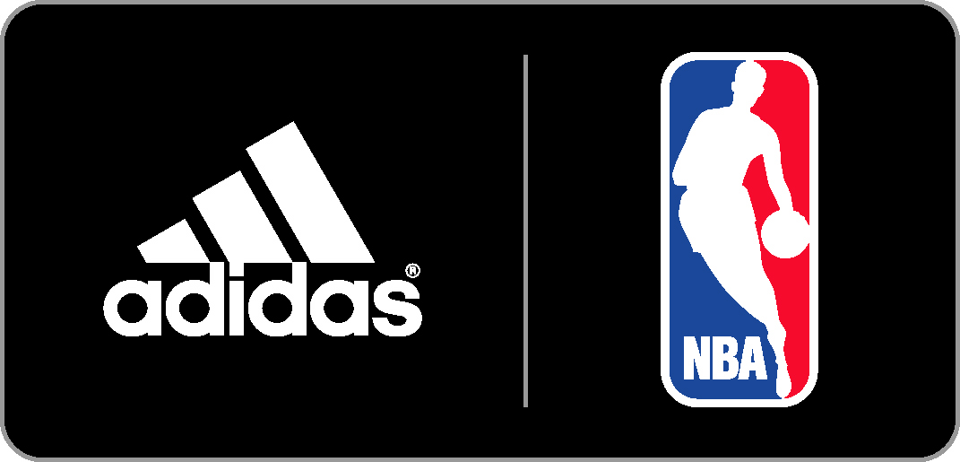

Adidas BASKETBALL DEBUTS
2014 NBA All-Star GAME FOOTWEAR collection

New Styles Celebrate New Orleans and the Fun Atmosphere of NBA All-Star Weekend

OVERVIEW  CRAZY 8  CRAZY 1 |  | Dwight Howard, John Wall, Damian Lillard Joakim Noah and others will debut special NBA All-Star versions of the Howard 4, Crazy 8, Crazy 1 and the all-new Crazyquick 2 at the 63rd NBA All-Star Game in New Orleans.  Inspired by New Orleans’ rich culture and the atmosphere of NBA All-Star weekend, the footwear collection features bright Mardi Gras colors and exciting prints which will be rolled out Feb. 14 and 15.  - The classic model, originally launched in 1997, features an aggressive design that follows the form and function of the foot  - The NBA All-Star Crazy 8 will be worn by players during the Rookie game and NBA All-Star Saturday Night contests  - Bright orange and blue colors and splatter paint print are inspired by the architectural and art of New Orleans and celebratory spirit of Mardi Gras and NBA All-Star weekend  - The Crazy 8 ($110) will be available Feb. 14  - The classic model, originally launched in 2000 features a curved, aerodynamic upper inspired by luxury automobiles  - The NBA All-Star Crazy 1 will be worn by players during the Rookie game and NBA All-Star Saturday Night contests  - Double foam collar provides added ankle support while the torsion system improves stability and traction  - Bright orange and blue colors and splatter paint print are inspired by the architectural and art of New Orleans and celebratory spirit of Mardi Gras and NBA All-Star weekend  - The Crazy 1 ($125) will be available Feb. 14
DWIGHT HOWARD 4  CRAZYQUICK 2 |  | - The NBA All-Star version of the Howard 4 features a metallic “Blast Purple” colorway for one of the most elite centers in the league  - A unique take on the traditional purple of Mardi Gras, the metallic “Blast Purple” stands out on the court and gives the superstar center a unique look for the big stage of the NBA All-Star Game  - The SPRINTWEB and TECHFIT upper provides lightweight support and lockdown with maximum breathability  - Crazyquick technology elements include an articulated forefoot with two-way flex zones for increased traction and court feel  - The Howard 4 ($125) will be available Feb. 15  - The NBA All-Star version of the all-new Crazyquick 2 features a “Vivid Berry” and black upper with “Solar Slime” splatter paint print that pays homage to the celebratory spirit of Mardi Gras and NBA All-Star weekend  - The NBA All-Star Crazyquick 2 will be worn on-court by Damian Lillard of the Portland Trail Blazers (West), John Wall of the Washington Wizards (East) and Joakim Noah of the Chicago Bulls (East)  - QUICKWEB upper provides increased flexibility and superior fit in the all-new style  - Signature Crazyquick outsole technology is once again featured in the Crazyquick 2 for increased traction and court feel  - The Crazyquick 2 ($125) will be available in limited quantities at NBA All-Star Jam Session in New Orleans on Feb. 13 and at retailers worldwide April 1
 | FOR MORE INFORMATION  CONTACT | For more information, visit news.adidas.com, adidas Basketball Facebook page, www.adidasbasketball.com or follow us on Twitter and Instagram @adidasHoops  Paul Jackiewicz, Global Basketball PR  971-234-2357 (o)  Paul.Jackiewicz@adidas.com

###

