The iconic Copa Mundial dances to the rhythm of Samba

Colourful limited edition boot collection inspired by Brazil
Herzogenaurach, Saturday 25th January 2014 – adidas is proud to unveil the Samba Copa Mundial collection: a series of uniquely styled boots that build on the colourful Samba line previously launched at the end of last year and mixes it up with the iconic Copa Mundial – the best-selling boot in football history.

In November 2013 adidas successfully kicked off its “All in or Nothing” 2014 FIFA World Cup Brazil™ campaign by launching the Samba collection, an array of new and exciting colourways for each of its four boot ranges, adizero™ f50, predator®, nitrocharge™ and 11pro. Following the positive response by fans worldwide, adidas decided to ramp up the collection by merging it with the classic Copa Mundial.
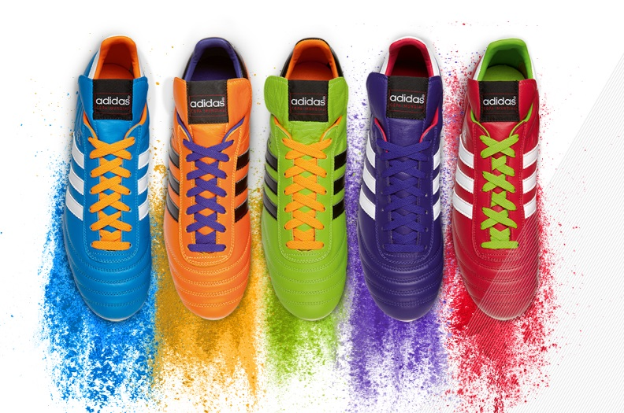

adidas Samba Copa Mundial

First released in 1982, the Copa Mundial is the best-selling boot in football history and has been worn by some of the all-time greats including Franz Beckenbauer, Michel Platini, Zico & Karl-Heinz Rummenigge. Since then it has been sold over 10 million pairs and was actually the last revolutionary product innovation created by sporting goods legend and founder of the adidas brand Adi Dassler.

adidas will release limited numbers for each colour and boot of the special Samba Copa Mundial. These new boots maintain the same qualities and feel of the traditional version but boast the high intensity colourways of the Samba collection.

Michael Meinhold, Product Manager, adidas Football said: “For the Samba Copa Mundial we wanted to honour the legendary status of the Copa Mundial but also give footballers worldwide the chance to add some extra colour and celebrate the World Cup in Brazil. The pack is colourful, energetic but fully respects the Copa´s iconic design and feel.“

The Samba Copa Mundial is available from today (25th January) for purchase in selected adidas retail outlets, associated stockists and via www.adidas.com/football. Join the adidas football conversation at www.facebook.com/adidasfootball or on Twitter: @adidasfootball #allin or nothing.

- END -

For further media information please visit http://news.adidas.com/GLOBAL/PERFORMANCE/FOOTBALL or contact:

Robert Hughes  adidas Senior Global Football PR Manager  Email: robert.hughes@adidas.com  Tel: +49/9132/84-6856 | Alan McGarrie  adidas Global Football PR Manager  Email: alan.mcgarrie@adidas.com  Tel: +49/9132/84-4686

Notes to editors:
About adidas Football
adidas is the global leader in football. It is the official sponsor / official supplier partner of the most important football tournaments in the world, such as the FIFA World Cup™, the FIFA Confederations Cup, the UEFA Champions League, the UEFA Europa League and the UEFA European Championships. adidas also sponsors some of the world’s top clubs including Real Madrid, FC Bayern Munich, AC Milan, Flamengo and Chelsea. Some of the world’s best players also on the adidas roster are Leo Messi, Gareth Bale, Mesut Özil, Dani Alves, Oscar, Xavi, Karim Benzema and Bastian Schweinsteiger.

