adidas presents the Japanese federation kit for
2014 FIFA World Cup Brazil™
Tokyo / Herzogenaurach, November 11th, 2013: adidas and the Japan Football Association (JFA) are proud to release the new official home uniform for the Japan National Football Team, as the squad prepares to compete in the upcoming 2014 FIFA World Cup Brazil™.

The concept of this brand new official home uniform for the Japan National Football Team is “ENJIN (i.e., the act of ‘going into a huddle’)”: the uniform is an expression of the strong determination as the players and the supporters realise that now is the time to unite as one and go into a huddle (“ENJIN”) to get ready for the battle ahead, to go all in for the 2014 FIFA World Cup Brazil™ and capture victory.

On the left side of the chest, there are 11 lines spreading out from the emblem, expressing the way those players depart from the “ENJIN” to their respective positions on the pitch for the battle.

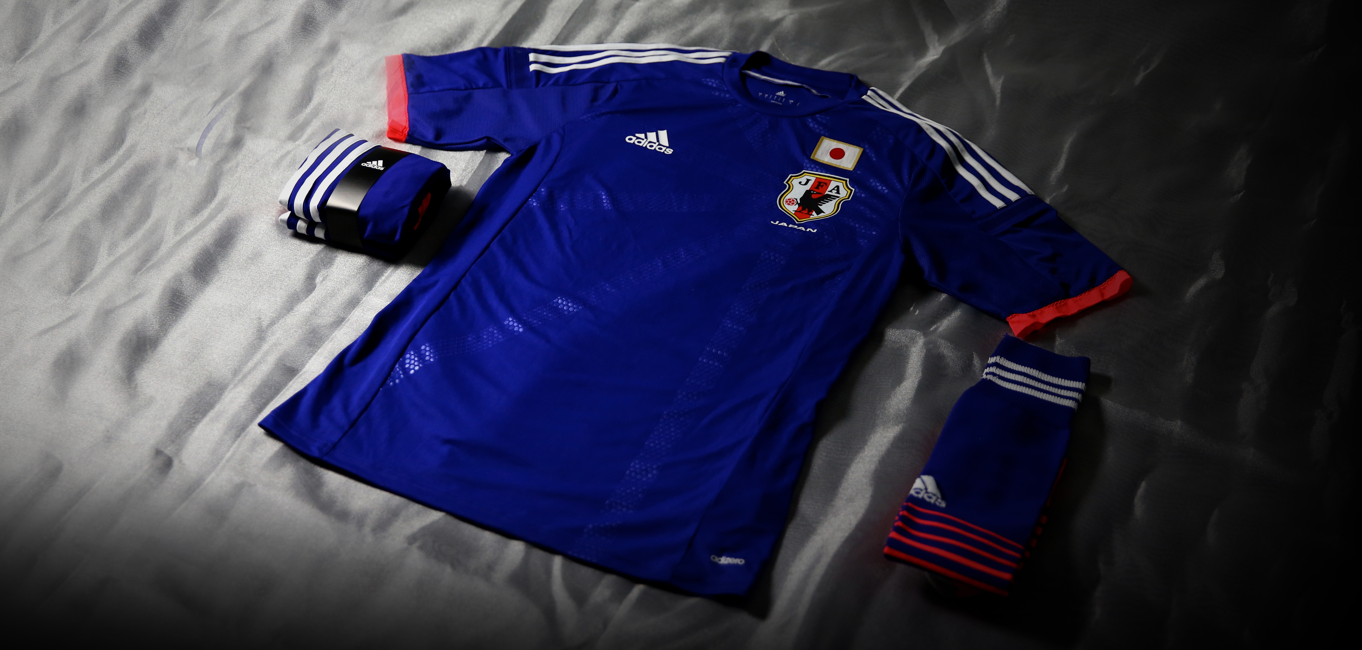

From a technology point of view, the uniform features the new ultra-light polyester material called adizero, which helps to make it up to 40% lighter in comparison to previous versions of the kit, while retaining enhanced mobility and wider performance benefits.

- DESIGN -
Single Line on the Back (Symbol of “ENJIN”)
The “single line signifying ‘KESSOKU (bond, unity),’” which became a familiar symbol of the previous version of the kit, has been carried over to the back side of the upgraded uniform with its “ENJIN” concept. The single line (drawn with a calligraphy brush) is an expression of the strong bond and desire for victory shared between players and supporters. The line is designed in such a way that one huge circle will be formed whenever the national team gets into a huddle (“ENJIN”) out on the pitch.

11 Lines
On the left side of the chest, 11 lines spread out from the emblem as the central point. This expresses the way the players depart from the “ENJIN” to their respective positions on the pitch before the match begins. The 11 lines symbolising the “ENJIN” are also found on the socks.

Band Design
The band featured on the back of the uniform uses the Brazilian good-luck charm (including wish for victory) “bonfim (or miçanga)” as a motif. The band also serves the dual function to enhance ventilation.

Bright Neon Colour (Fluorescent Colour)
The so-called neon colour (fluorescent colour) is featured for the line on the back of the uniform, as well as the sleeves. The fluorescent red pop is now brighter than the previous red colour, contributing to the players’ greater presence on the pitch.

Japan’s National Flag to Inherit the Pride and DNA of the National Team
As in the previous version, Japan’s national flag is proudly shown on the left chest of the new uniform; the flag effectively inherits the “DNA” of the Japan National Football Team’s old uniforms, as it has been sewn with the thread newly spun from previous historic uniforms worn by players in the past. This guarantees that the pride and history of past squads are being carried over for the 2014 FIFA World Cup Brazil™.

- TECHNOLOGY -
adizero
The Japan National Football Team’s authentic home uniform features adizero technology, developed in the pursuit of ultimate lightness, to achieve the status as the lightest football uniform in the entire history of adidas .

ClimaCool
The uniform is equipped with adidas’ unique “ClimaCool” technology, which helps to control the internal environment and sustain comfort. Using the mesh material on both sides and back area has contributed to the superior sweat-absorbent / quick-drying characteristic. In addition, the “ENJIN” concept-based band on the back serves the ventilation function to enhance the breathability more effectively.

The new Japan kit will be available globally from November 14th in selected adidas retail outlets, associated stockists and via www.adidas.com/worldcup. Join the adidas football conversation at www.facebook.com/adidasfootball or on Twitter: @adidasfootball #allin or nothing.

- END -

For further media information please visit http://news.adidas.com/GLOBAL/PERFORMANCE/FOOTBALL or contact:

Robert Hughes  adidas Senior Global Football PR Manager  Email: robert.hughes@adidas.com  Tel: +49/9132/84-6856 | Alan McGarrie  adidas Global Football PR Manager  Email: alan.mcgarrie@adidas.com  Tel: +49/9132/84-4686

Notes to editors:
About adidas Football
adidas is the global leader in football. It is the official sponsor / official supplier partner of the most important football tournaments in the world, such as the FIFA World Cup™, the FIFA Confederations Cup, the UEFA Champions League, the UEFA Europa League and the UEFA European Championships. adidas sponsors some of the top football federations in world football including Spain, Argentina, Germany, Japan, Russia, Colombia & Mexico. adidas also sponsors some of the world’s top clubs including Real Madrid, FC Bayern Munich, AC Milan, Flamengo and Chelsea. Some of the world’s best players also on the adidas roster are Leo Messi, Gareth Bale, Mesut Özil, Dani Alves, Oscar, Xavi, Karim Benzema and Bastian Schweinsteiger.

