adidas launches innovative new online football platform FOR UEFA CHAMPIONS LEAGUE

Gamedayplus to enhance tournament action for fans around the world

Herzogenaurach, October 1st 2013 – with this season's UEFA Champions League in full swing, adidas has launched an innovative social media campaign for fans to enhance their match-day and tournament experience. adidas Gamedayplus is a mobile led, second screen social platform which aggregates the best UEFA Champions League content from adidas football, adidas players and clubs, journalists and super fans and adds this to a user's existing twitter feed. The season-long interactive platform will enable fans across the world to engage in "real-time" to enhance their tournament experience in a new and exciting way.

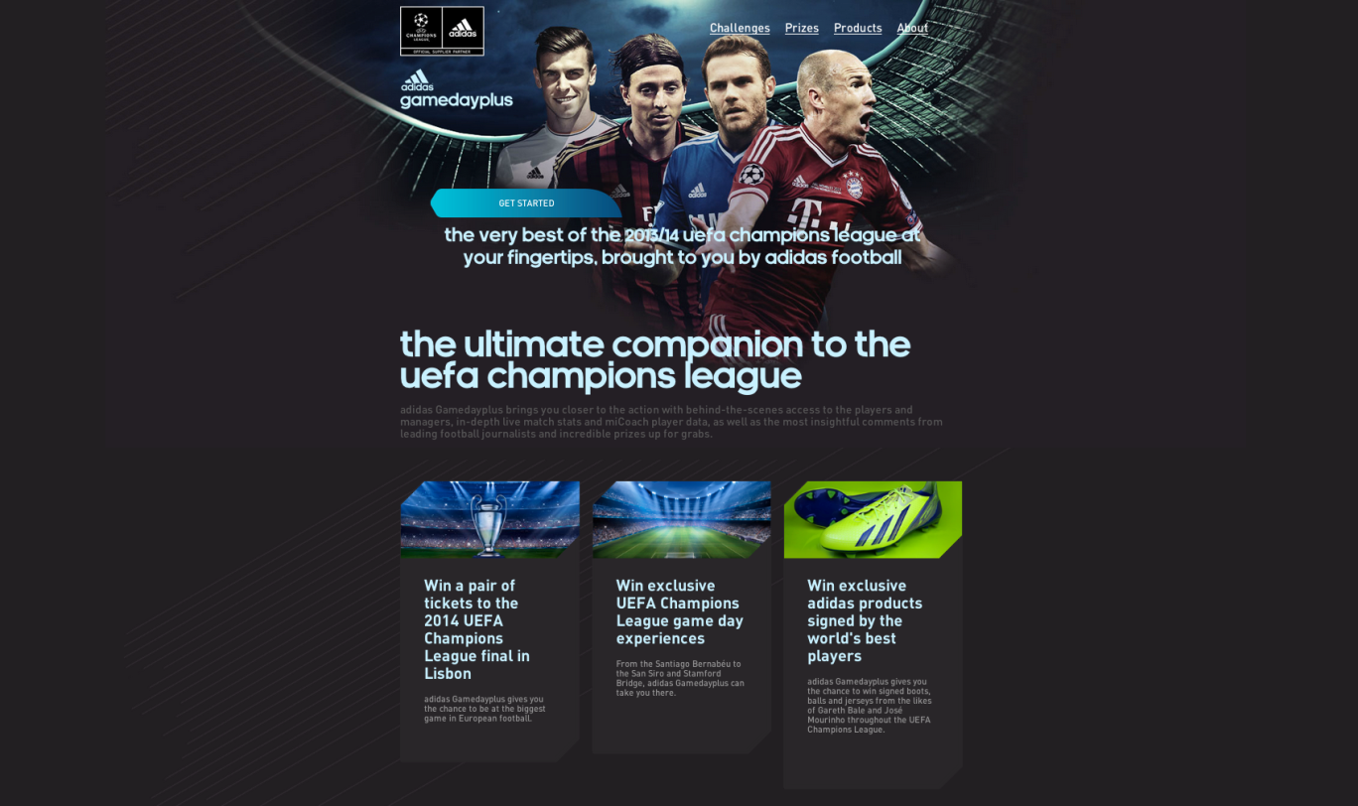

Gamedayplus will be predominantly driven through twitter (@adidasfootball) but will live on adidas.com. The platform ‘gamifies’ the viewing experience of the UEFA Champions League in real time, reacting to the events on the pitch and rewarding users with experiences and multiple chances to win once in a lifetime prizes and exclusive UEFA Champions League content. For the first time ever, by simply watching the matches on TV or online, fans will be rewarded for their natural online social behaviour. The season-long activation is endorsed by some of the world's top coaches such as Pep Guardiola (FC Bayern München).

This launch follows the success adidas experienced in social media during last season’s UEFA Champions League Final where they saw over half a million engagements on the day and were the most talked about brand around the match. adidas has produced Gamedayplus to capitalise on the brand’s position at the centre of the UEFA Champions League conversation online. This was achieved in no small part by the strength of the content adidas has produced for its football fans. Creative and reactive imagery, real-time tweets and a focused hashtag strategy have helped to channel the conversation and attract new followers. A 68% increase in followers on Twitter from May 2012 to May 2013 displays an upturn in focus and success across social media and the next step for adidas is Gamedayplus.

All users will have to do is sign in with their current twitter account (or via adidas.com) and they will be presented with a world of new and ground-breaking content. Bespoke adidas content, fan challenges, tweets and updates from adidas players and clubs, as well as live in game data are just a number of elements that will make adidas Gamedayplus a revolutionary tool for fans around the world.

From 1st October, fans can access the experience online on http://www.adidas.com/gamedayplus and via @adidasfootball on Twitter. To coincide with the launch adidas will be releasing exclusive interview footage with Pep Guardiola, offering the opportunity for fans to win match tickets and carry the match ball on to the pitch, representing a whole host of other prizes and opportunities that will be made available on Gamedayplus.

For further information please visit adidas.com/football or go to facebook.com/adidasfootball or @adidasfootball on twitter to join the conversation.

- END -

For further media information please visit http://news.adidas.com/GLOBAL/PERFORMANCE/FOOTBALL or contact:

Robert Hughes  adidas Global Football PR Manager  Email: robert.hughes@adidas.com  Tel: +49/9132/84-6856 | Alan McGarrie  adidas Global Football PR Manager  Email: alan.mcgarrie@adidas.com  Tel: +49/9132/84-4686
Notes to editors:
About adidas Football
adidas is the global leader in football. It is the official sponsor / official supplier partner of the most important football tournaments in the world, such as the FIFA World Cup™, the FIFA Confederations Cup, the UEFA Champions League, the UEFA Europa League and the UEFA European Championships. adidas also sponsors some of the world’s top clubs including Real Madrid, FC Bayern Munich, AC Milan, Flamengo and Chelsea. Some of the world’s best players also on the adidas roster are Leo Messi, Gareth Bale, Mesut Özil, Dani Alves, Oscar, Xavi, Karim Benzema and Bastian Schweinsteiger.

