Media Pitch
2nd October 2013

VIDEO RELEASE: Novak and Nole – paired to win

adidas Tennis gives an intimate insight into the training regime and mental preparation of Novak Djokovic ahead of his defence of the Shanghai Masters.

The video ‘Novak Djokovic – performance meets personality’ examines the two sides of Novak’s personality, the off-court joker and the very-focused on-court tennis superstar. The video shoes how these two sides allow him to deal with the intense pressure of playing one of the most mentally demanding individual sports in the world.

The video follows Novak on a regular training day and gives an insight into his intimate relationship with his team and driven attitude to training.

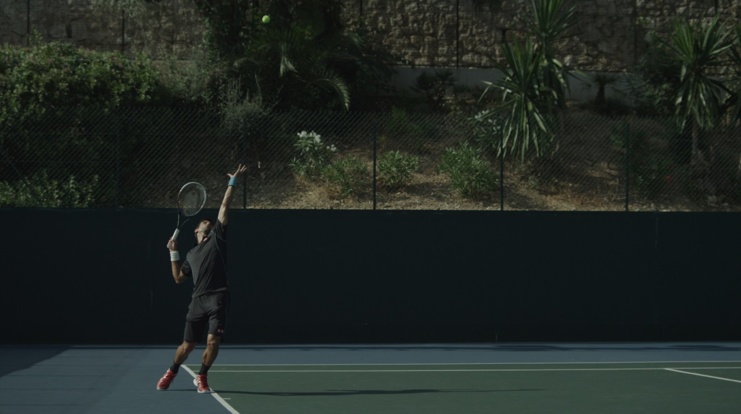

Known for his laid back off court attitude, Novak Djokovic has succeeded in meeting his goal of being the world number one during a period recognized as one of the greatest in Tennis’ history. His success recently saw him became only the ninth person to be ranked world number one by the ATP for more than 100 weeks.
His success has come through mental preparation to ensure a complete balance so that his on-court focus never falters.

Djokovic has worn adidas Barricades his entire career and has won six Open championships wearing the iconic adidas Tennis trainer, including this year’s Australian Open. adidas signed an official contract with Djokovic in May 2013.

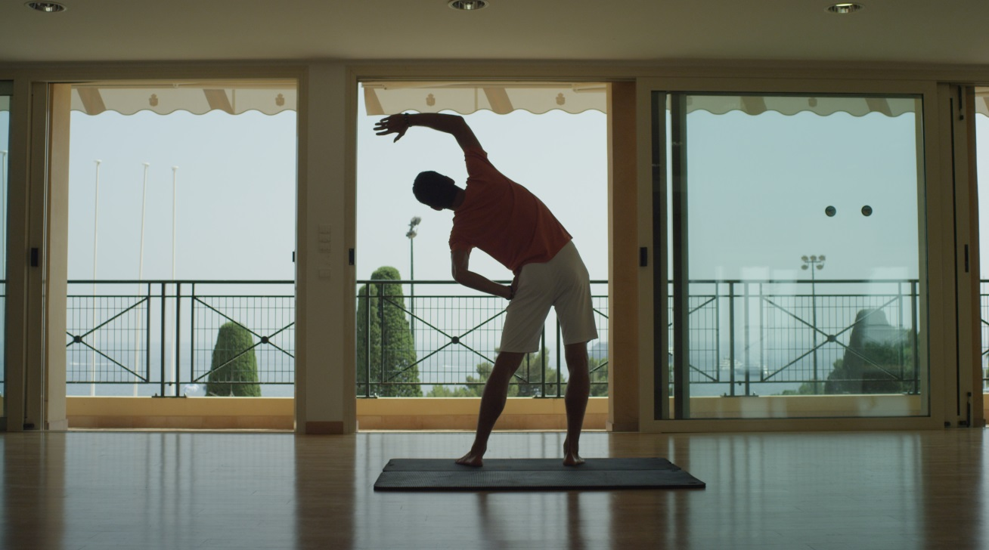

Watch the full video here: http://a.did.as/1fMCgqR

Follow adidas Tennis on Twitter at @adidastennis

- END –
You can secure the embed code from this video when it has gone live. The launch time for the video is 12:00 GMT 2nd October. The video will be live at http://a.did.as/1fMCgqR.

For further information please contact:
Ole Westerholt
Communications Manager Tennis
Email: Ole.Westerholt@adidas.com
Tel: +49 9132 84 5758

