D Rose 4 – Men’s Basketball

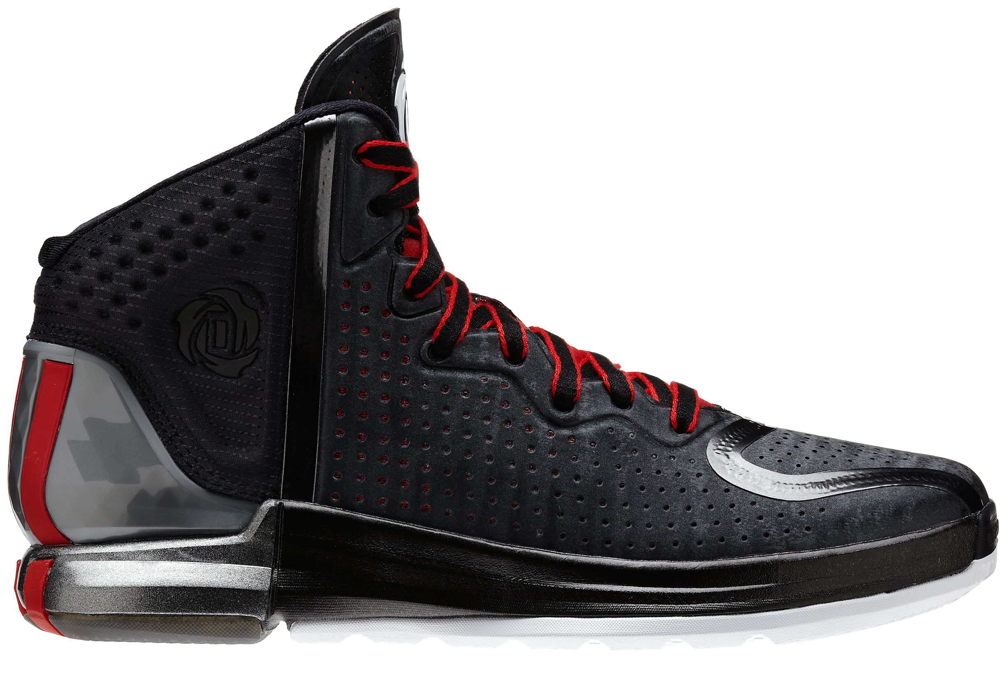

The all-new D Rose 4 signature shoe features premium performance, style and design to elevate Derrick’s on-court play and off-court demeanor. Dropping in eight colorways, the D Rose 4 is the most premium and personal Derrick Rose signature shoe to date.

INSPIRED DESIGN
- Inspired by Derrick’s distinct on and off-the-court personalities, adidas designers worked closely with him to design and develop a shoe tailored specifically for his relentless, attacking style of play and unique style.

- The shoe’s design showcases the two sides of one of the game’s best, with a bold line separating the front and back of the shoe. The back heel highlights Derrick’s competitive fire and explosive, attacking style of play, while the front represents his humble and confident demeanor and understated off-the-court style.

- The D Rose 4’s new design and construction provides stability and support, enhances foot movement and efficiency, comfort and control to make one of the fastest, quickest and most agile players in the league even faster and more explosive.

PERFORMANCE
- The D Rose 4 uses adidas’ most innovative technology – the Crazyquick outsole traction system – to give Derrick maximum control and flexibility for quick moves on the court.

- The SPRINTWEB technology provides support and maximum breathability.

- The SPRINTFRAME provides stability and motion control and the sole features injection molded EVA to ensure the most lightweight, flexible and cushioned ride on the court.

- The shoe’s performance enhancements from previous models include:
  - A filled midfoot area to add support and stability.
  - 3D molded EVA on the collar to enhance comfort.
  - An arch support built from a model of Derrick’s feet to ensure optimum fit.

- The upper features an internal mesh bootie for enhanced fit and comfort which doubles as a functional blend of breathability and fit.

STYLE
- The D Rose 4 upper features a gloss pattern with a modern material finish and smooth synthetic leather in multiple colorways for a clean off-court look.

- The SPRINTFRAME features premium, pearlized finish on select colorways while the midsole features metalized paint circles with multiple shades for a clean, seamless look.

PERSONAL DETAILS
- The shoe again features the distinctive D Rose logo with three petals that revolve around the letter “D” and number “1” in the center

- Derrick and adidas collaborated in 2012 to design and unveil the logo that represents his unique style of play and his family who helped guide him from Englewood to the NBA

- The tongue is a premium, synthetic leather with perforations exposing an eye-catching hologram material and highlighting a welded TPU D Rose logo

- The D Rose logo is also featured on the molded EVA ankle collar in synthetic and reflective black material that shines when photographed

OUTSOLE
- Crazyquick technology on the outsole features an articulated forefoot with two-way flex zones for increased traction

- The three stripes are again featured on the back of the shoe to represent Derrick’s quickness and wrap around the heel outsole so opponents see the stripes when Derrick drives past and over defenders on the court

WEIGHT: 11.9 ounces

SIZES: 6 – 15
SRP: $140.00

MORE INFO: For more information, visit news.adidas.com, adidas Basketball Facebook page, www.adidasbasketball.com or follow us on twitter @adidasHoops, #DRose4

###
Contact:
Madeline Breskin
adidas Basketball PR
971-234-2220 (o)
971-295-6936 (m)
Madeline.Breskin@adidas.com

