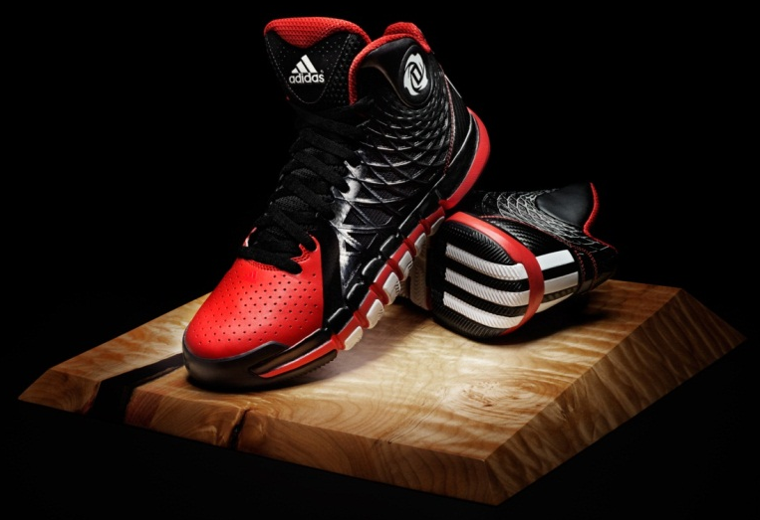

D Rose 773 II – Men’s Basketball

An all-new performance team basketball shoe inspired by previous D Rose models, the D Rose 773 II takes the namesake of Derrick Rose’s home town area code, 773. The shoe features Crazyquick technology elements and will be available in 15 team colorways.

INSPIRED DESIGN: Taking inspiration from the D Rose 3.5, the design features a spiral SPRINTWEB construction and pattern reflecting Derrick’s goal to tighten his game. Functionally, this provides ultimate lockdown, breathability and comfort on the court. Details include the D Rose logo on the sockliner and on the collar.

UPPER: The D Rose 773 II features an aerodynamic SPRINTWEB upper that provides lightweight stability for improved support while keeping the foot cool. Exterior taping provides a seamless bond for optimum comfort while the synthetic leather toe box provides a clean stylish look. It also features a padded ankle collar for support and three stripes branding on the back of the shoe which represents his speed on the court.

MIDSOLE: Injection molded EVA midsole provides lightweight and cushioned ride.

OUTSOLE: Features Crazyquick technology elements including an articulated forefoot with two-way flex zones for increased traction and court feel. miCoach SPEED_CELL compatible.

WEIGHT: 12.1 oz

SIZES: 3.5 – 15, 16 – 19
SRP: $110

PRODUCT ROLLOUT:

COLLEGIATE ROYAL / WHITE / BLACK - G67357 July 1
BLACK / WHITE / LIGHT SCARLET - Q33229 July 1
WHITE / METALIC SILVER / BLACK - Q33230 July 1
BLACK / VIVID YELLOW / BLAST BLUE - Q33231 July 1
BLACK / WHITE / TECH GREY - Q33232 July 1
COLLEGIATE NAVY / WHITE / BLACK - Q33233 July 1
UNIVERSITY RED / WHITE / BLACK - Q33234 July 1
TECH GREY / WHITE / BLACK - Q33235 July 1
LIGHT MAROON / WHITE / BLACK - Q33236 July 1
FOREST / WHITE / BLACK - Q33237 July 1
PRIDE BLUE / WHITE / ELECTRICITY - G99043 July 1
BLACK / LIGHT SCARLET / WHITE - G99329 Sept. 1
ALUMINUM / WHITE / LIGHT SCARLET - G99330 Sept. 1
PRIDE INK / WHITE / INFRARED - G99042 Oct. 1
RAY YELLOW / WHITE / BLAST BLUE - G99070 Oct. 1

MORE INFO: For more information, visit news.adidas.com, adidas Basketball Facebook page, www.adidasbasketball.com or follow us on Twitter and Instagram @adidasHoops with #DRose773.

###

Contacts:
Paul Jackiewicz, Global Basketball PR
971-234-2357 (o)
503-593-5316 (m)
Paul.Jackiewicz@adidas.com

