adidas unveil ground-breaking cricket helmets for improved protection and comfort
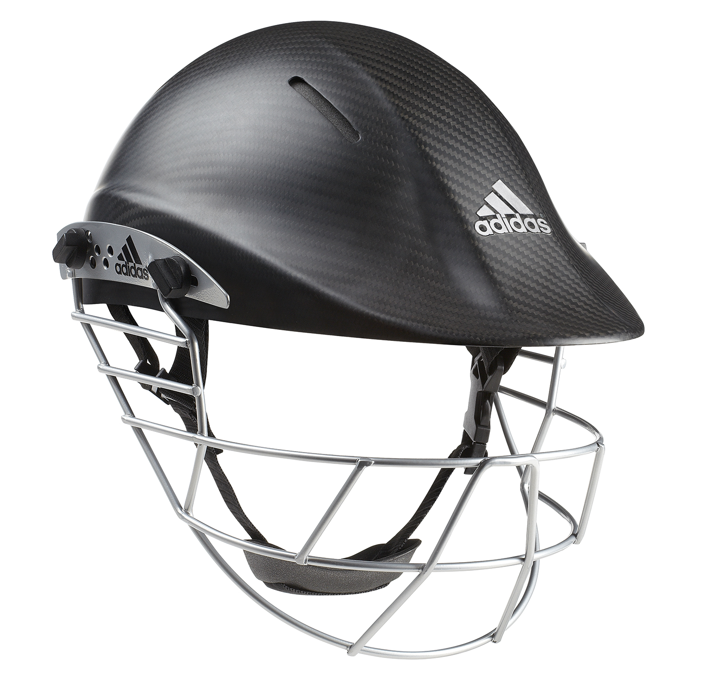
Herzogenaurach, 29th August 2013 – adidas, together with Ayrtek ™ Limited today announced the ground-breaking launch of the adipower cricket helmet range – helmets specifically designed to provide improved comfort and unparalleled protection, reducing the likelihood of injury whilst batting.

About the same time as the ICC (International Cricket Council) and FICA (Federation of International Cricketers’ Association) became increasingly concerned about on-going head and facial injuries suffered by batters, Ayrtek ™ approached adidas with their innovative design to improve the level of safety provided by traditional cricket helmets.

Simon Cartwright (adidas Global VP for Cricket) explains: “Cricket is high velocity sport which requires extreme reaction times, particularly for batsmen who face fast bowling regularly. It’s vital that batsmen feel comfortable and confident in their equipment – particularly an important item like a helmet. At adidas, we are constantly looking for ways to improve the performance and safety of our cricket products, so we were excited to see Ayrtek’s pioneering helmet and to be part of its further development and broader commercialisation.”

Current English international cricketer Michael Carberry says “In international cricket, we’re consistently facing bowling of between 90 and 100mph. It’s vital when batting that your mind is as free from distractions as possible. For me this means that the equipment I use should not only enhance my performance and look good, but should help me feel physically and mentally comfortable so that I can give my full attention to the bowler. The adidas RawTek helmet ticks all three boxes - great protection against ball strikes, and a very comfortable fit with the A.C.I.S™ liner. The peak design offers great vision and the carbon fibre looks outstanding.”

Tom Milsom, co-founder of Ayrtek ™ says the partnership between adidas and Ayrtek ™ has helped redefine the level of safety and comfort cricketers can expect from their helmet. The adipower cricket helmet range follows an intense research, design and testing programme which began with an investigation into the most common causes of head injuries whilst batting.

“Most head injuries suffered whilst batting are caused by the following factors - the ball being able to penetrate the gap between the faceguard and the helmet’s peak; the faceguard making contact with the head or face during ball impact; batters being struck on the relatively unprotected back of the head and; the proximity of a helmet’s grille to the batter’s temple. The adipower cricket helmet range is specifically designed to reduce the likelihood of these occurring,” says Milsom.

Milsom says that with these factors in mind, the adiPower helmet range was designed to achieve the following objective:

- Reducing the likelihood of the ball penetrating between the helmet peak and grill;
- Vastly strengthening the helmet’s faceguard
- Ensuring the helmet shell is made from the strongest material possible
- Ensuring the internal helmet padding provides supreme comfort and protection.
“adidas and Ayrtek ™ carried out rigorous testing at all stages of the helmet’s development in conjunction with the Sports Technology Institute at Loughbrough in England. The objective of testing was simple: to ensure our helmets offer market leading protection, comfort and safety,” Milsom says.

This partnership sees the launch of four new helmets across the adipower range. The flagship model, the RawTek helmet features a unique 100% carbon fibre and Kevlar shell paired with the patented A.C.I.S ™ liner.

The adipower cricket helmet range will launch into retail on 19th September at the Lords Trade Show in London. For further information and imagery visit or contact:

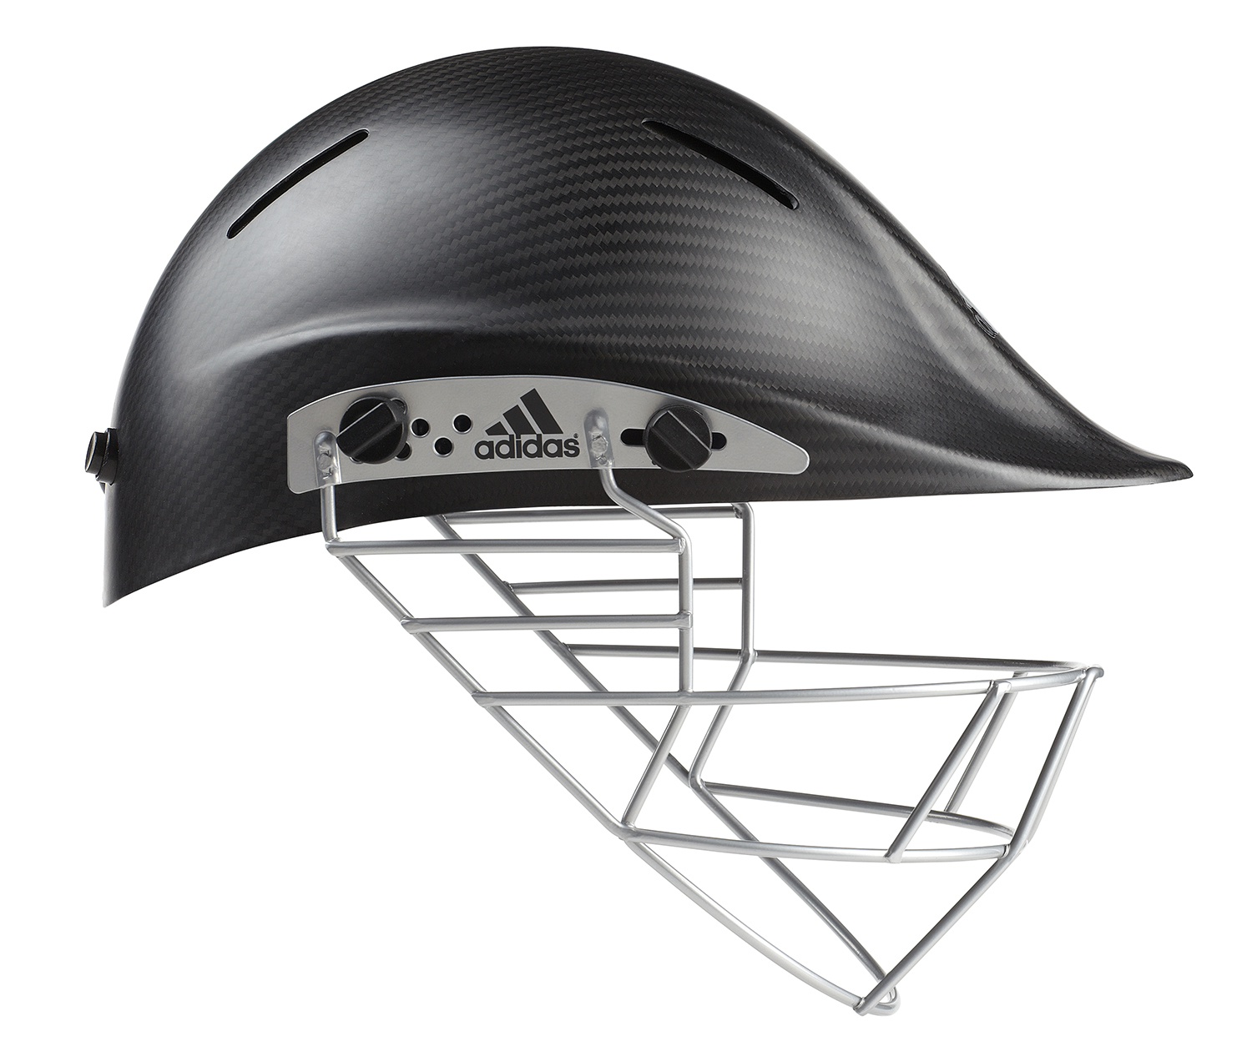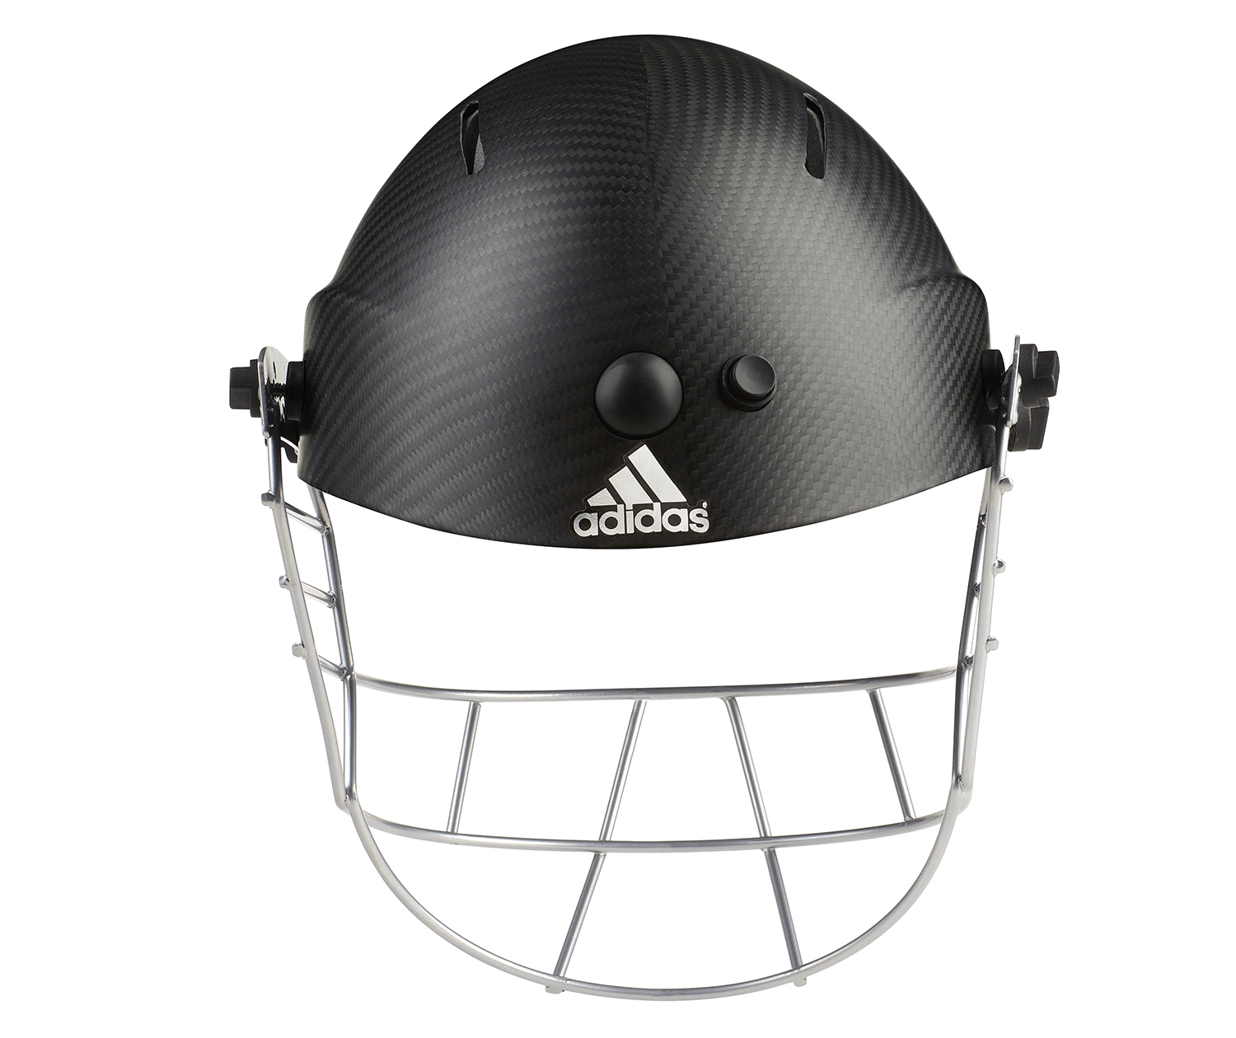
For further information and imagery visit www.adidasnewsstream.com or contact:

Shaun Anastasi (adidas Global Brand Marketing Manager)
+49 9132 84 3913
Shaun.Anastasi@adidas.com

James Read (Ayrtek™ Director)
+44 117 316 0200
james.read@ayrtek.com

About adidas
adidas is a global designer, developer and marketer of athletic footwear, apparel and accessories with the mission to be the leading sports brand in the world. Brand adidas is part of the adidas Group, a corporation that includes brands such as Reebok, TaylorMade and Rockport.

About the adidas Group
The adidas Group is one of the global leaders within the sporting goods industry, offering a broad range of products around the core brands adidas, Reebok, TaylorMade, Rockport and Reebok-CCM Hockey. Headquartered in Herzogenaurach, Germany, the Group has more than 46,000 employees and generated sales of € 14.5 billion in 2012.

About AyrTek
Formed in late 2007, Ayrtek ™ Limited is a sports equipment design company based in Bristol, UK. With the patented Air Cushion Impact System (A.C.I.S), Ayrtek has become widely recognized in the industry as the leader for helmet design and safety.

