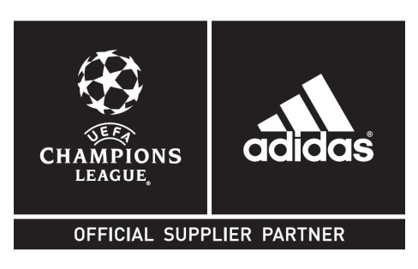
adidas launches the definitive range for
flagship 2013/2014 UEFA European club competitions
– Three new Official Match Ball designs revealed for new season –

Herzogenaurach / Monaco, 29th August, 2013 – adidas is today proud to reveal the range of new Official Match Balls for the 2013/2014 season of the UEFA Champions League™, UEFA Europa League™ and the 2013 UEFA Super Cup™ competition.

The Finale 13 – The Official Match Ball for the 2013/2014 UEFA Champions League™ season
The adidas UEFA Champions League Finale 13 Official Match Ball will be used by Europe’s elite clubs during all group stage matches of the 2013/2014 competition. As with previous Official Match Balls, the new design features an outer coating texture designed to provide optimal grip at the point of impact.
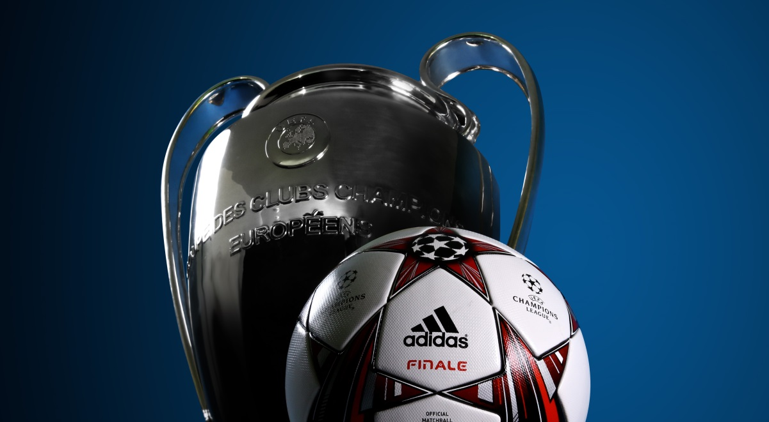
UEFA Champions League Finale 13
Official Match Ball

The artwork within the iconic star panel construction uses distinctive colours (white / infrared / silver / black) and graphics to signify a “ceremony of light” design. The iconic UEFA Champions League logos positioned within the top and bottom star panels and the individual strands spreading from this design represent the vibrant stadiums on match day and resulting light beams emanating across Europe.

This season adidas will launch a social media based campaign for fans enabling them to engage in “real time” and enhance their UEFA Champions League experience. Gamedayplus is a season long interactive platform celebrating the brand’s long association with the UEFA Champions League and is designed to provide fans throughout the world with an enhanced match day experience.

The platform will be hosted predominantly on twitter @adidasfootball and will involve a series of consumer experiences / rewards for taking part. The season-long activation is endorsed by top coaches such as Pep Guardiola (FC Bayern Munich), José Mourinho (Chelsea FC) and Carlo Ancelotti (Real Madrid CF).

From mid-September, fans can access the experience online on www.adidas.com/gamedayplus and @adidasfootball on Twitter.

The Official Match Ball for the UEFA Europa League™
The Official Match Ball for the 2013/2014 season of the UEFA Europa League will see a new distinctive design inspired by the silhouette curves of the famous UEFA Europa League trophy and logo. Incorporating the now iconic UEFA Europa League colours (red/yellow), the Official Match Ball is also inspired by the “ceremony of light” design treatment, similar to the UEFA Champions League Finale 13 Official Match Ball.

adidas are also proud to launch a season long campaign dedicated to the UEFA Europa League called “UEL Away Days”, a YouTube series showcasing fan journeys capturing the sights and sounds of following the UEFA Europa League and following your team across Europe.
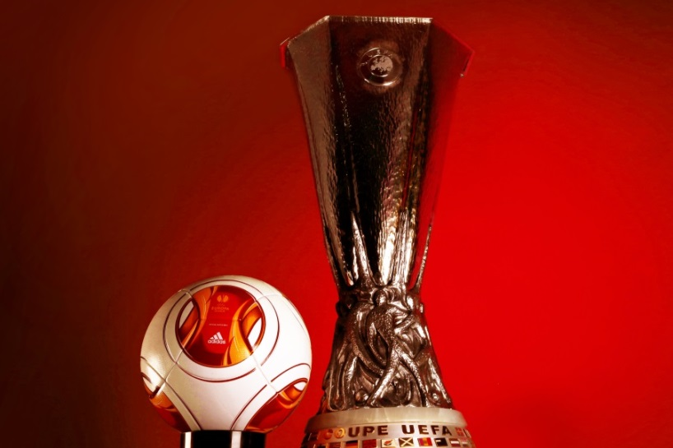
UEFA Europa League 2013/14 season Official Match Ball

The Official Match Ball for the UEFA Super Cup™
Tomorrow, UEFA Champions League winner FC Bayern Munich will play fellow adidas club Chelsea FC, winner of the 2012/13 UEFA Europa League, in the UEFA Super Cup 2013 taking place in Prague. The ball includes the UEFA Super Cup logo at the heart of the design and integrates the blue and red colours of the two finalists.
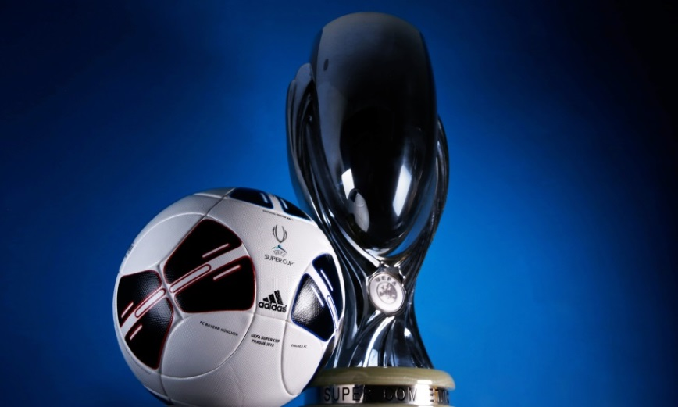
UEFA Super Cup 2013
Official Match Ball

UEFA Champions League Finale 13 and UEFA Europa League Official Match Balls are now available for purchase in adidas retail outlets, associated stockists and via www.adidas.com/football. Join the adidas football conversation at www.facebook.com/adidasfootball or on Twitter: @adidasfootball.

- END -

For further media information please visit http://news.adidas.com/GLOBAL/PERFORMANCE/FOOTBALL or contact:

Robert Hughes  adidas Senior Global Football PR Manager  Email: robert.hughes@adidas.com  Tel: +49/9132/84-6856 | Alan McGarrie  adidas Global Football PR Manager  Email: alan.mcgarrie@adidas.com  Tel: +49/9132/84-4686
Notes to editors:
About adidas Football
adidas is the global leader in football. It is the official sponsor / official supplier partner of the most important football tournaments in the world, such as the FIFA World Cup, the FIFA Confederations Cup, the UEFA Champions League, the UEFA Europa League and the UEFA European Championships. adidas also sponsors some of the world’s top clubs including Real Madrid, FC Bayern Munich, AC Milan, Flamengo and Chelsea. Some of the world’s best players also on the adidas roster are Leo Messi, Gareth Bale, Dani Alves, Oscar, Xavi, Karim Benzema and Bastian Schweinsteiger.

adidas Production of Official Match Balls since 1970
adidas’ experience in football production is unparalleled. adidas has been making footballs since 1963 and is now the world’s leading manufacturer, always at the cutting edge of technology. adidas has supplied the Official Match Balls to all major UEFA and FIFA tournaments since 1970, and since 2006 is also the Official Supplier of the match ball for all UEFA Champions League games. The adidas Finale ball has been used for the UEFA Champions League Final since the 2000/2001 season. This season, adidas will supply over 6,000 Official Match Balls for use during the UEFA Champions League tournament and over 6,500 balls for the UEFA Europa League tournament.

