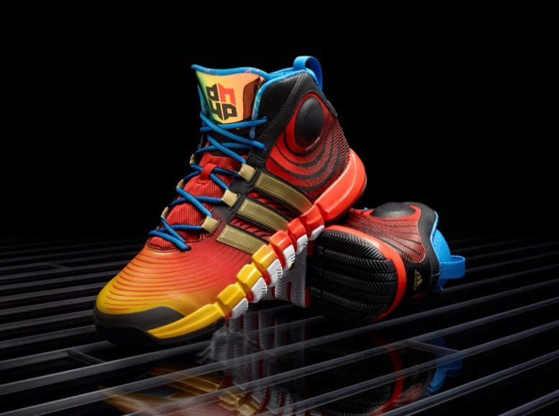
D Howard 4 – Men’s Basketball

This season, one of the NBA’s most dominant big men and a three-time NBA Defensive Player of the Year, Dwight Howard, gets a faster and stronger signature shoe, the D Howard 4. The all-new model features Crazyquick technology elements and has a bold, aggressive design to reflect Dwight’s game and unique style.

SIGNATURE DETAILS: The spiral waves featured on the shoes upper are inspired by Dwight’s playing style and how he circles the paint protecting the rim by blocking shots and grabbing rebounds. Chromed three stripes on the side match the tongue for a reflective pop to stand out on the court. The tongue features Dwight’s signature DH logo, which represents unity.

UPPER: The all-new molded collar provides comfort and support with extra padding to withstand contact from defenders. The SPRINTWEB and TECHFIT upper provides lightweight support and lockdown with maximum breathability.

MIDSOLE: Molded EVA midsole provides lightweight and cushioned ride.

OUTSOLE: Features Crazyquick technology elements including an articulated forefoot with two-way flex zones for increased traction and court feel. miCoach SPEED_CELL compatible.

WEIGHT: 14.2 oz.

SIZES: 6—15, 16—19
SRP: $125.00
MORE INFO: For more information, visit news.adidas.com, adidas Basketball Facebook page, www.adidasbasketball.com or follow us on Twitter and Instragram @adidasHoops with #DHoward4

###

Contacts:
Paul Jackiewicz, Global Basketball PR
971-234-2357 (o)
503-593-5316 (m)
Paul.Jackiewicz@adidas.com

