adidas ENERGY BOOST
Fact Sheet
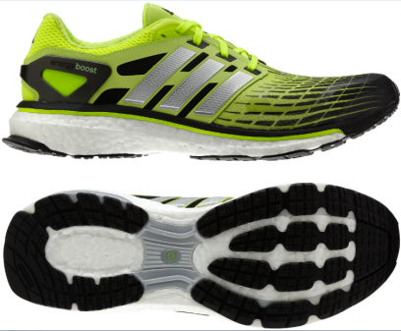
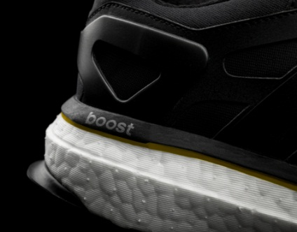

Enhance your run from the first step with the revolutionary adidas Energy Boost. Boost features game-changing cushioning technology – sought out for the past 30 years and in development for more than three years – designed to help you run longer and more comfortably.

 | ENDLESS ENERGY | The first-in-the-industry cushioning is made up of a material that contains thousands of capsules blown together through high pressure steam that provide springy cushioning and act like a trampoline under your feet.  - Created by adidas Innovation Team in partnership with BASF, The Chemical Company.  - The soft lightweight cushioning stores and releases energy efficiently.  - Compared to standard EVA midsole material, Boost three times more temperature-resistant so you can perform consistently in any climate.  - Boost has an energy return unlike any other cushioning.  - The neutral shoe weighs 9.8 ounces.
INNOVATIVE COMFORT |  | Boost combines the benefits of EVA cushioning – comfort, weight and smooth transition – with TPU (Thermoplastic Polyurethane) – energy return, durability and temperature resistance.  - The ultra-snug Techfit upper moves with the foot and four-way stretch air mesh offers the comfort of a sock.  - Engineered power bands provide targeted compression support and stabilize the foot where needed.  - Endured intense biomechanical testing over thousands of steps.
PRODUCT AVAILABILITY | adidas Energy Boost will is available now at adidas.com and at adidas Sport Performance stores, Finish Line, Dick’s Sporting Goods, The Sports Authority, Foot Locker, Champs, Academy Sports, Eastbay and select running specialty stores including Fleet Feet Sports, Paragon Sports, Naperville Running Company, Big Peach Running Company, Luke’s Locker and Skinny Raven.

