adidas SPRINGBLADE
Fact Sheet
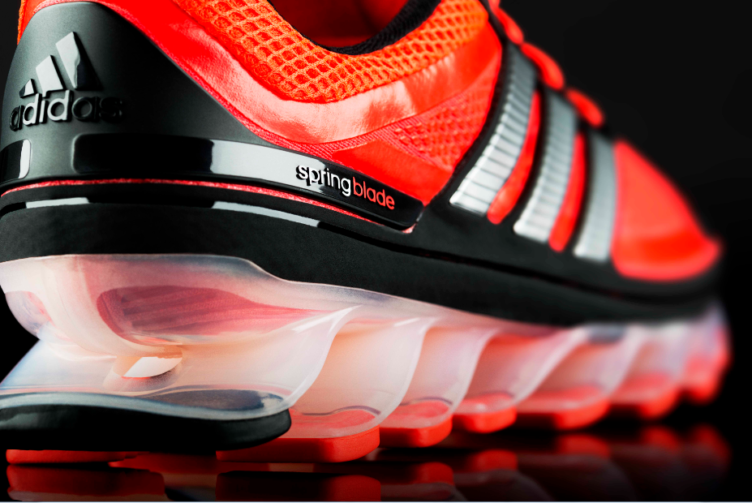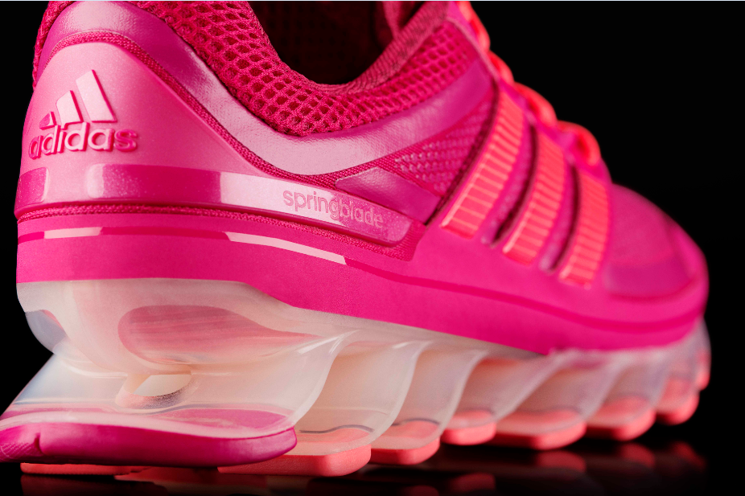

Experience explosive energy in Springblade, adidas’ progressive new running shoe designed to help propel you forward. Unlike anything seen or experienced before, Springblade features unique blades that are individually tuned and highly responsive to help you move forward, delivering an explosive energy sensation and a smooth, responsive ride.

 | FORWARD ENERGY | Each shoe features 16 forward angled blades on the outsole that instantaneously react to any environment, compressing and releasing energy with each step.  - aIT (adidas Innovation Team) tested hundreds of geometries and materials and underwent rigorous ballistics tests to ensure each individually tuned spring produces maximum energy efficiency and withstands any force with every stride.  - Standard EVA midsoles only deliver vertical energy return; whereas Springblade’s precisely engineered blades made out of a highly elastic high-tech polymer are designed to help translate that energy forward with each step.
PIONEERING DESIGN AND TECHNOLOGY |  | Springblade’s radical design combines energy performance benefits with superior cushioning and comfort.  - The nearly transparent design of the blades are inspired by the idea of levitation and the dynamic energy return provides the feeling of springs under your feet.  - Blades are precisely tuned in geometry, thickness and position for each phase of the stride to combine support and flexibility.  - Springblade is seven times more temperature resistant than adidas’ standard EVA cushioning for consistent performance.  - The Techfit upper hugs the top of your foot, locking it in to harness the energy beneath it.
PRODUCT AVAILABILITY | adidas Springblade is available August 1 for $180 in seven energetic colorways on adidas.com, at adidas Sport Performance stores and retailers nationwide including: Finish Line, Foot Locker, Dick’s Sporting Goods, Eastbay and select running specialty stores.

