EMBARGOED UNTIL 0900hrs CET 31 may 2013

adidas and Novak Djokovic partner in long-term footwear deal
Djokovic to wear Barricade 7 shoe at Roland Garros

Herzogenaurach/Paris, 31 May 2013 – adidas revealed a new footwear partnership with the world number one tennis player Novak Djokovic. The Serbian star debuted his Barricade 7 at the French Open this week. The deal follows on from Novak’s personal decision to wear the Barricade shoe for many years; with all six of his Grand Slam titles achieved wearing the adidas shoe.

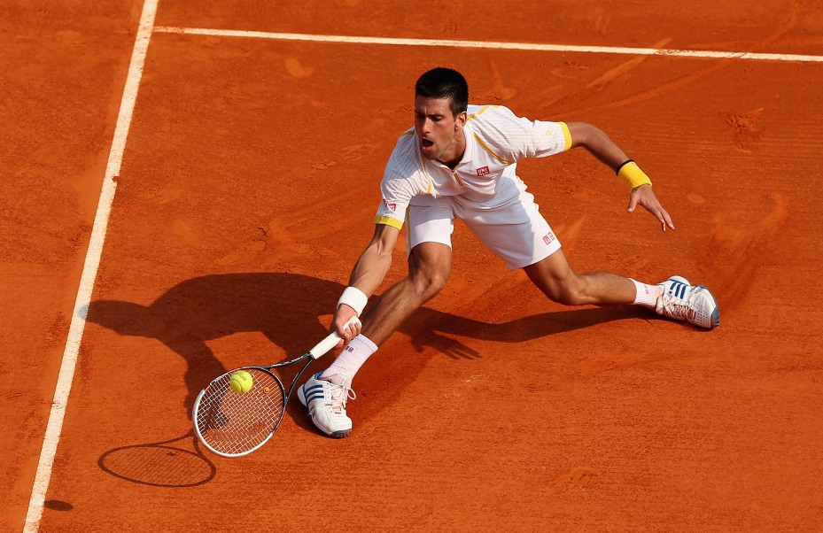

Novak said: “The adidas Barricade is my favourite shoe. I have been wearing it for many years and have worn all the different generations. I have full confidence in the shoe and am very comfortable on the court when I wear it, which is essential for a tennis player. I have very specific dynamic movements, with a lot of splits and slides, so I need to have the right stability in the shoe, but also have an optimal weight and great performance. The Barricade offers me everything - adidas has provided me with the best shoe possible to help me win Roland Garros for the first time.”

"It has been more than impressive to see Novak evolve into the World Number One tennis player today. adidas is proud to partner with Novak and will do all we can to help him win more titles in the future by ensuring his footwear is industry-leading." said Vincent Montalescot, Vice President Global Sports Marketing.

The Barricade 7 has been designed for the needs of the most dynamic tennis players and high performance athletes, ensuring stability and durability on all playing surfaces. The shoe includes the following key features:

- Synthetic leather upper for light weight and durability; Perforated upper for breathability
- adiPRENE®+ in the forefoot maintains propulsion and efficiency; Air mesh tongue for maximum breathability; resilient cushioning used to protect the forefoot and provide a responsive, dynamic toe off
- EXTENDED TORSION® provides adaptive forefoot and midfoot support
- Molded EVA insole for anatomical comfort; Comfortable textile lining; miCoach compatible
- adiPRENE® highly shock absorbent material under the heel for superior cushioning at impact; Stability claws for support during quick cuts and changes in direction
- ADIWEAR™® 6 outsole offers the ultimate in high-wear durability

adidas is an official supplier at Roland Garros, a relationship which celebrates the 40th anniversary this year.

- END -
For further information please contact:
Ole Westerholt
adidas Communications Manager Mens Training & Tennis
Email: Ole.Westerholt@adidas.com
Tel: +49 9132 84 5758

