Embargoed until 1800hrs CET Friday 24th May

Returning to Flamengo, adidas presents the new jersey of the largest club fan base in Brazil

Rio de Janeiro / Herzogenaurach, May 24, 2013 – Following the recent announcement that adidas will once again partner up with Brazilian club Flamengo, the two parties are proud to reveal the much-anticipated kit to be worn on field next season.

After the announcement of the new contract with adidas, the new jerseys sold out in less than 10 days of advance sales. “We made every effort to ensure that the jersey that marks our return would truly be worthy of the giant team that is Flamengo. We believe that the Red and Black Nation will be proud,” stated Fernando Basualdo, president of adidas Brazil.

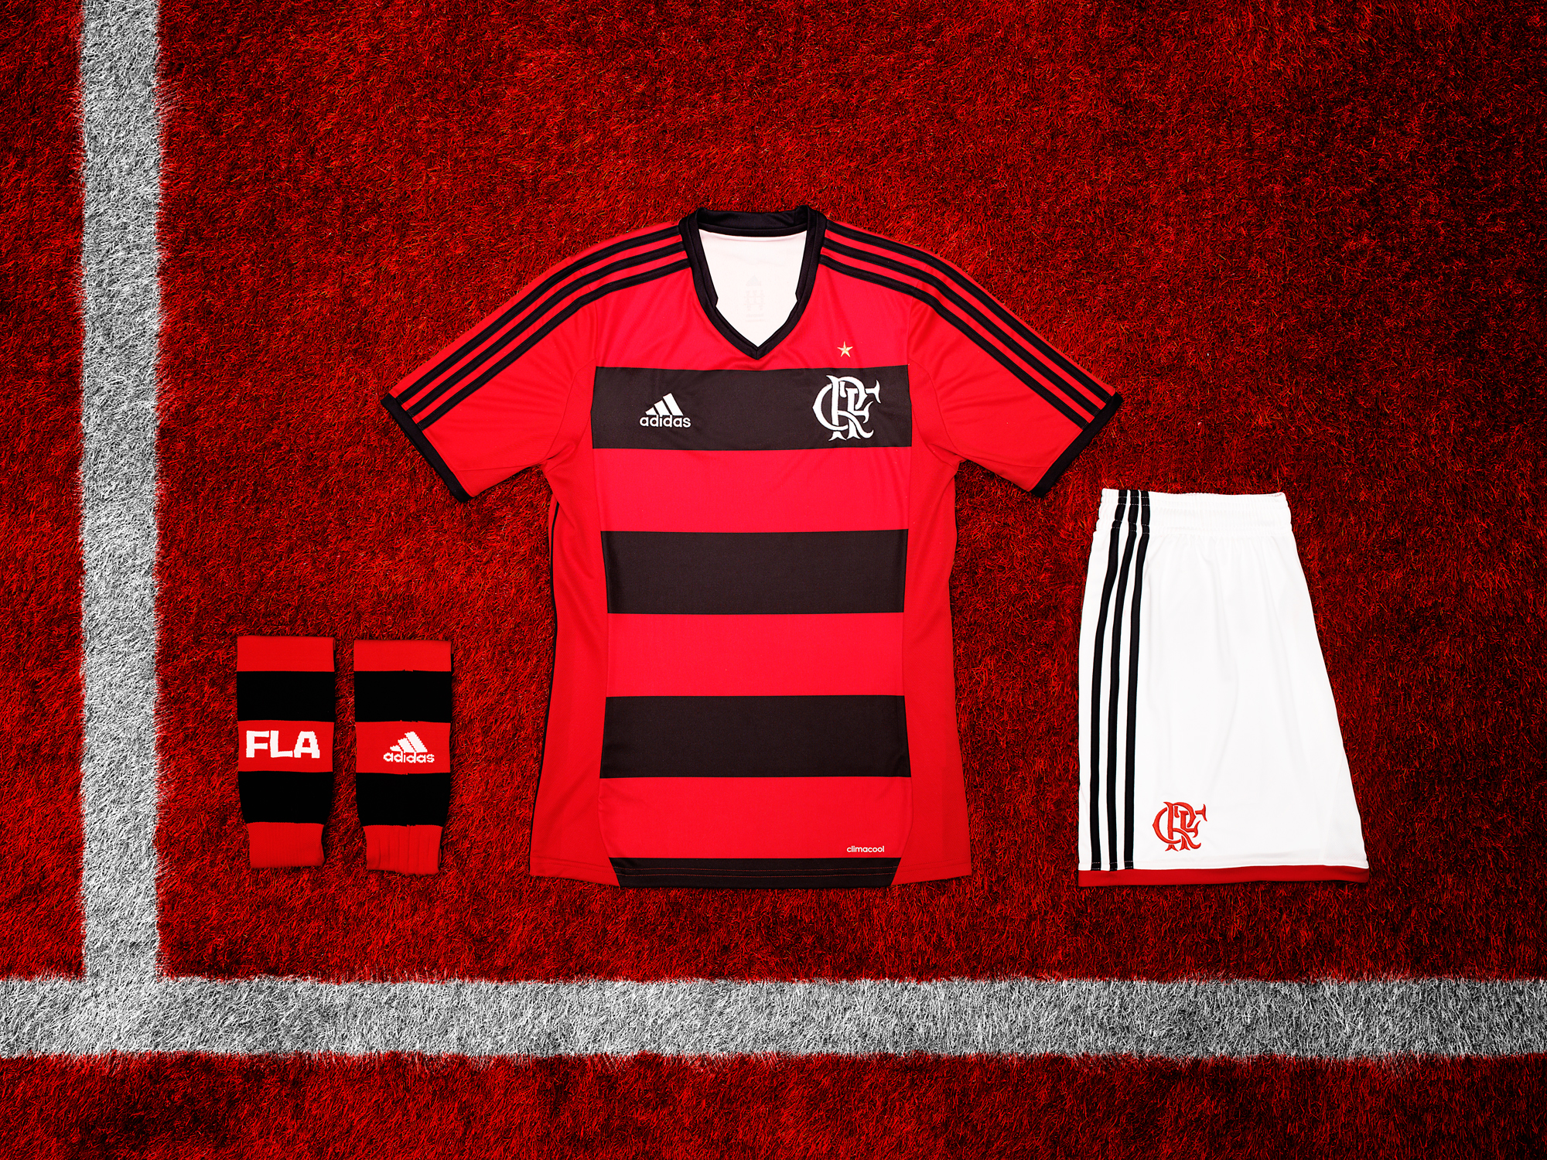
The new adidas Flamengo home kit season 2013

The new adidas Flamengo home shirt has thick black and red stripes, as well as the team’s crest embroidered on one of the black stripes. The away jersey is reminiscent of the one worn when Flamengo won the world title against Liverpool. The design is predominantly white, with details in black and red on the shoulders. Both uniforms sport a detail on the back of the jersey that pays homage to the chorus of the club’s anthem: “once Flamengo, always Flamengo.”

Eduardo Bandeira de Mello, Flamengo’s president, said: “At the beginning of the month, we celebrated the return of this partnership that left its mark in the history of Clube de Regatas do Flamengo. Today, we give the fans what they have long been waiting for: the new Red and Black jersey, made by adidas. I have no doubt that this jersey will bring new glory to Flamengo.”

Both the home and away uniforms employ adidas´ ClimaCool® technology, which takes into account where and how the body produces the most heat and sweat, using specific fabrics in these regions to improve breathability and allow the athlete to maintain his ideal body temperature.

Flamengo will debut the new uniforms this coming Sunday, May 26th, when they play Santos in the new Mané Garrincha stadium. From today (May 24th), the new kit will be available at adidas stores, on the brand's website (www.adidas.com.br) and at the team's official stores.

For more information please see: www.facebook.com/adidasfootball or join the conversation @adidasfootball.

- END -

For further information please contact:

Robert Hughes  adidas Senior Global Football PR Manager  Email: robert.hughes@adidas.com  Tel: +49/9132/84-6856 | Alan McGarrie  adidas Global Football PR Manager  Email: alan.mcgarrie@adidas.com  Tel: +49/9132/84-4686
About adidas Football:
adidas is the global leader in football. It is the official sponsor of the most important football tournaments in the world, such as the FIFA World Cup, the FIFA Confederations Cup, the UEFA Champions League, the UEFA Europa League and the UEFA European Championships. adidas also sponsors some of the world’s top clubs including Real Madrid, FC Bayern Munich, AC Milan, Flamengo and Chelsea. Some of the world’s best players are also on the adidas roster with world class individuals such as Leo Messi, David Beckham, Dani Alves, Kaka, Steven Gerrard, Karim Benzema and Bastian Schweinstegier all sponsored by the German brand.

About adidas’ return to Flamengo:
adidas’ new contract to supply sports gear to Flamengo started in May and will last 10 years. The partnership is the greatest in South American football history and reinforces adidas’ worldwide goal to partner with the teams with the greatest visibility. With this contract, Flamengo joined a select group of top clubs worldwide that are sponsored by adidas, including Milan, Real Madrid, Bayern Munich and Chelsea.

The golden years – Flamengo achieved its greatest glories while wearing adidas. The partnership between the two started in 1980, the same year that the team won its first Brazilian championship title. Zico’s Black and Red team went on to win the Libertadores Cup, the FIFA Club World Cup, the 1982, 1983 and 1987 Brazilian titles, and the 1981 and 1986 Rio championships.

