Crazyquick
Basketball

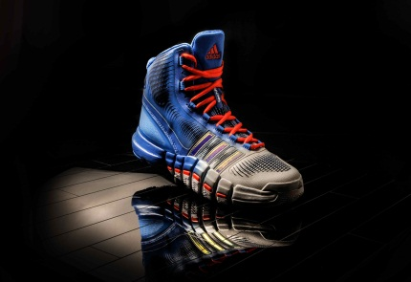

QUICKER | Crazyquick is the first adidas basketball shoe designed specifically to help make players quick on the court. It is a breakthrough innovation that will redefine what it means to be quick.
GREATER  TRACTION  4 QUICK  ZONES  OTHER  QUICK  FEATURES | Crazyquick technology allows greater controlled flexibility, better traction and optimal foot lock-down for quick cuts. Crazyquick increases traction between the shoe and the floor, allowing for quicker cuts in the paint and on the perimeter.  Crazyquick features four unique quick zones in the outsole that work with the upper to provide maximum traction and flexibility for quick movements on court. The flexibility and direction of herringbone traction and 17 unique diverging pods play a specific role in allowing players to be quick:  - Toe zone delivers quick push-off through engineered gradual flex material and forward and backward traction orientation  - Forefoot zone ensures quick cuts and aggressive lateral movements through independent suspension allowed by increased flexibility of outsole, lateral traction orientation and stretch and return of TECHFIT upper  - Midfoot zone provides enhanced support through an increased surface area and lateral traction to provide stability while allowing the foot to flex  - Heel zone allows for quick multi-directional stopping through engineered flexibility and forward and backward traction  -more-  Every element of the shoe works together to support an athlete’s quest to be quick. In addition to the four unique quick zones, Crazyquick provides additional design elements that all work to deliver cutting edge performance:  - First-ever TECHFIT upper built specifically for basketball movements enhances stability while providing stretch and return for comfort and performance  - 3D molded collar to provide contoured fit and comfort  - New heel notch design for greater range of motion during quick movements  - Enlarged, re-engineered SPRINTFRAME moderates movement and provides optimum support  - Lightweight 11.25 oz, one of the lightest mid-cut basketball shoes in the game
QUICK EVALUATION | Crazyquick endured the most extensive research and testing of any adidas basketball shoe. The adidas innovation team examined more than 1,000 discrete basketball movements to develop the technology in crazyquick.  Crazyquick was comprehensively tested by some of the quickest players in the NBA and NCAA teams such as Louisville, Wisconsin, UCLA, Cincinnati and Baylor.
ROLL OUT AND AVAILABILITY | Crazyquick ($140) will be available May 1 at adidas.com and other leading retailers.
MORE INFO | For more information, visit news.adidas.com, adidas Basketball Facebook page, www.adidasbasketball.com , www.adidasfootball.com  Madeline Breskin, adidas PR  (o) 971-234-2220  (m) 971-295-6936  Madeline.Breskin@adidas.com

###

