Crazyquick
Football

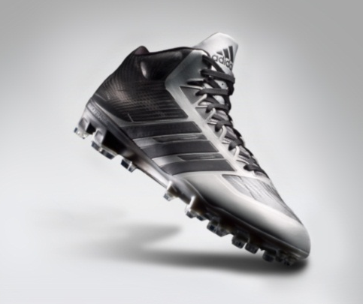

The Crazyquick Mid features the new QUICK FRAME plate designed for cleat stability
during quick cuts and push off so players can change direction and accelerate faster.
The QUICK SKIN upper provides lightweight support and the Techfit tongue improves fit
and lockdown while a new tri-stud system improves traction on all surfaces.

TECHFIT | TECHFIT upper provides a natural fit and locks the foot down, keeping it centered over the top of the plate.
INLAY  QUICKSKIN  QUICKFRAME | Articulated eyestay construction allows upper to flex naturally with the foot.  A combination of sprintskin and sprintweb welded together to make a seamless upper that is light yet supportive in the cutting zones.  A revolution in football cleat traction innovation, the QUICKFRAME plate features:  QuickStuds: for improved traction during cuts and side-to-side movements  SprintStuds: to promote foot rotation for increased traction during push-offs  BladeStuds: helps player stop quicker so they can get out of their cut faster.

ROLL OUT AND AVAILABILITY | Crazyquick ($150) will be available 5/1 at adidas.com and retailers nationwide.
MORE INFO | -more -  For more information, visit news.adidas.com, adidas Football Facebook Page  Michael Ehrlich  (o) 971-234-2214  (m) 503-720-4512  michael.ehrlich@adidas.com

